Review of Small business tax CONCESSIONS
  - Consultation Guide
May 2018
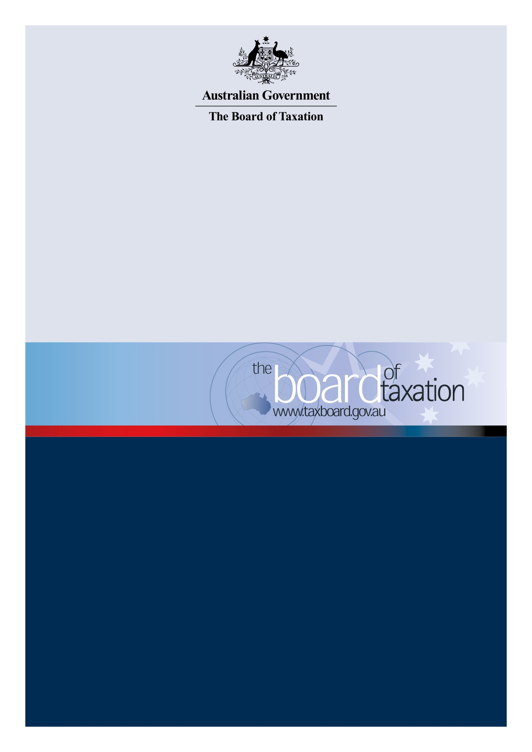

Contents
Contents 2
Reform directions 3
Consultation 4
How the tax system currently assists small business 5
Principles for reform 9
Our goals 13
Consultation questions 14
Membership 16
How to participate 17

Reform directions
The Board of Taxation (the Board) is conducting an independent, self-initiated review of Australia’s small business tax concessions. The Board’s review will involve assessing the effectiveness of existing concessions and, where appropriate, recommending new concessionary approaches to the Government. This Consultation Guide explains how the small business community can take part in the Board’s review.
Small businesses account for approximately 96 per cent of all businesses in Australia, employ 5.6 million Australians, and produce over $330 billion of Australia’s annual economic output.
The Board believes that a well-designed regime of tax concessions and subsidies, targeted to assist with the specific challenges faced by small businesses, can play an important role in helping small businesses at all stages of their business lifecycle, from the crucial start-up phase through to maturity and the retirement of business owners.
Small businesses are currently grappling with fundamental changes to traditional ways of doing business. The pressure is rising for businesses to ‘go digital’ both in the way they interact with consumers and in how they comply with their tax obligations and other regulations. Rapid technological developments, the advent of the ‘gig’ and ‘sharing’ economies, and other business models (including franchising) are creating a myriad of opportunities and challenges. The Government’s Small Business Digital Taskforce is examining ways to assist small businesses in navigating some of these changes.
Achieving a level playing field for small businesses remains a key challenge. Small businesses face competition not only from their larger, more established, counterparts but also from illegitimate operators in the black economy undercutting them on price.
Against this background, the Board is undertaking a review to identify ways to improve small business tax concessions to ensure they remain effective, easily accessible, and well-targeted. This will involve identifying new concessions for small businesses and ways to improve existing concessions. It will also involve identifying areas in which concessions that are less effective, or not well targeted, could be removed or scaled back to generate savings that can be redeployed in areas where they may have a greater impact. Consideration will be given to the broader regulatory framework, including how the small business tax concessions complement retirement savings policy.
In conducting the review, the Board will draw on previous work it has undertaken into small business taxation, work undertaken by the Treasury, as well as international experiences. In addition, a Reference Group of small business, professional and academic stakeholders have also generously volunteered their time and expertise to assist the Board with this review.
This Consultation Guide sets out the current suite of tax concessions applying to small business and the Board’s proposed principles for evaluating and improving the framework of tax relief. It also poses questions for stakeholders to think about when formulating their input to the review.
Most importantly, this guide explains our consultation process and the Board invites small business owners and small business advisers to actively contribute to designing a forward-looking and effective blueprint for the small business tax regime. These contributions will inform the Board’s final advice to Government.

Consultation
The Chair of this review, Dr Mark Pizzacalla, looks forward to working with the small business community in developing the Board’s advice to Government. A Reference Group of small business professionals and academic representatives (see Membership) has been established to guide the project, provide expertise, and assist with consultations. In addition, there will be opportunities for the small business sector and the broader community to participate in the course of the review.
Timetable for consultation
This review will initially take some time to analyse the community’s submissions in relation to previous reviews of small business taxation, including reviews conducted by the Board. Interested parties may contribute to the review through online submissions or by participating in one of the consultation activities conducted by the Chair. The timetable below sets out an indicative timeframe for consultation. Further information will be made available at: www.taxboard.gov.au.
May 2018 | Consultation Guide – released
 | The Consultation Guide is expected to be released in May.
May - July 2018 | Consultation
 | The Chair of the review will conduct roundtable meetings. The Board invites small business owners, representatives of small business associations and small business advisers to participate.
July 2018 | Written submissions
 | Submissions in response to the Consultation Guide and any further material that may be released by the Board will close 20 July 2018.
October 2018 | Final Report
 | The Board will provide its final report to Government in October.

How the tax system currently assists small business
Tax concessions for small business taxpayers are an important feature of the Australian tax system. There are several policy rationales underpinning these concessions. Some are aimed at reducing the tax compliance burden, whilst others provide tax relief to promote business success or to provide business owners with greater access to funds for their retirement. Other concessions are designed to meet a combination of these objectives.
There are a broad range of small business concessions with various eligibility requirements and benefits; some of these are summarised below. A comprehensive list can be found on the Australian Taxation Office’s website.
Concession | Description
Lower company tax rate | In the 2015–16 income year, the company tax rate was reduced to 28.5% for companies with aggregated annual turnover of less than $2m. For the 2016-17 income year, the company tax rate was lowered to 27.5% for companies with a turnover of less than $10m. The reduced rate is available to companies with a turnover of less than $25m in the 2017–18 income year.
Unincorporated small business tax discount | Individual taxpayers with business income from an unincorporated small business that has aggregated annual turnover of less than $5m are eligible for an 8% tax discount on the income tax payable on that business income in the 2016–17 income year. This discount rate will then be increased over time until it reaches 16% in 2026–27. The discount is capped at $1,000 per individual for each income year and is delivered as a tax offset.
Capital gains tax concessions | Small business owners with net assets of no more than $6m or annual turnover of less than $2m are eligible for one or more of four small business capital gains as follows:  - a CGT exemption on active small business assets that have been held continuously for 15 years where the taxpayer is permanently incapacitated or reaches the age of 55 and retires;  - a 50% reduction of capital gains that arises from the sale of active small business assets (in addition to the general CGT discount);  - an exemption, up to a lifetime cap of $500,000, on capital gains arising from the sale of active small business assets, where the proceeds of the sale are used for retirement;  - a CGT roll-over for capital gains arising from the disposal of active small business assets if the proceeds of the sale are used to purchase other active small business assets.
Instant asset write-off and simplified depreciation rules | Small business entities with an aggregated annual turnover of less than $10m are able to access concessional depreciation arrangements for business assets. Under the concessions, small business entities can immediately deduct assets that cost less than a threshold amount. From 12 May 2015 until 30 June 2018, the threshold is $20,000. The Government announced that it would extend the concession for a further year until 30 June 2019 as part of the 2018-19 Budget. The threshold is scheduled to return to $1,000 from 1 July 2019.  In addition to the immediate write-off, assets above the threshold are depreciated through simplified pooling arrangements at a rate of 30% per year (15% in the first year). The general small business pool can also be immediately deducted at the end of the income year if its value is less than the immediate write-off threshold (before deducting depreciation for the year).
Refundable R&D tax | In the 2018-19 Budget the Government announced that for companies with aggregated annual turnover below $20 million, the refundable R&D offset will be a premium of 13.5 percentage points above a claimant’s company tax rate. Cash refunds from the refundable R&D tax offset will be capped at $4 million per annum. R&D tax offsets that cannot be refunded will be carried forward as non-refundable tax offsets to future income years.
Restructure roll-over relief | Owners of small business active assets are eligible for CGT and income tax roll-over relief for a ‘genuine restructure’ of their business, provided the underlying economic ownership of the assets is unchanged. The roll-over is available for businesses with an aggregated annual turnover of less than $10m.
Immediate deduction for professional expenses | Small business entities with an aggregated annual turnover of less than $10m can immediately deduct a range of professional expenses associated with starting a new business, such as professional, legal and accounting advice. Previously, these professional costs were able to be deducted over a five year period.
Simplified trading stock rules | Small business entities with an aggregated annual turnover of less than $10m may choose to use a simplified trading stock regime. Under this regime, small businesses may choose not to account for the changes in the value of stock for an income year if the difference between the opening value of stock on hand and a reasonable estimate of stock on hand at the end of the year does not exceed $5000.
Exemption - tax shelter prepayments for certain passive investments | Small businesses may immediately deduct prepaid expenditure subject to certain rules.
Small business carve-out for debt and equity rules | If a company has a turnover of less than $20 million, there is a carve-out which means related party ‘at call’ loans will be treated as being debt interests rather than equity interests.
PAYG: instalments based on GDP-adjusted notional tax | Small businesses can elect to have their pay as you go instalments calculated for them by the ATO by applying an adjustment to previously reported information.
Two-year amendment period | A small business entity will generally be eligible for a two-year amendment period for tax assessments instead of the standard four years.
Fringe benefits tax: employee car parking exemption | Car parking benefits provided to employees of small businesses are exempt from fringe benefits tax if the parking is not provided in a commercial car park. The employer must not be a government body, listed public company or subsidiary of a listed public company, and the employer’s total income must be less than $10m.
Fringe benefits tax: multiple portable electronic devices | From 1 April 2016, an FBT exemption applies to multiple work-related portable electronic devices provided by a small business to its employees– even if the devices have substantially identical functions. This exemption applies to portable electronic devices mainly for use in the employee’s employment.
GST concessions | Small businesses are entitled to a range of GST concessions including:  - the option to account for GST on a cash basis  - the option to pay GST by quarterly instalments and to lodge an annual return  - the option to lodge a simplified business activity statement to report GST  - the option to apportion GST input tax credits on an annual basis for acquisitions and importations that are partly creditable.  In addition, businesses (other than providers of taxi or limousine services) do not have to register for GST if their turnover is less than $75,000.
Small business superannuation clearing house | A free superannuation clearing house service is available to businesses with aggregated turnover of less than $10m or where the business has 19 or fewer employees.
Small business excise concession | Eligible businesses can apply to defer settlement of excise duty and excise equivalent customs duty from a weekly to monthly reporting cycle.
In addition to the concessions listed above, the tax system also delivers favourable outcomes to the small business sector by making it easier to attract investors. For example, investors in ‘early-stage’ innovation companies are granted a tax offset of 20% of the investment up to $200,000 and entitled to a CGT exemption where the shares are held for more than 12 months.
Furthermore, to incentivise employees of start-up companies, concessional tax treatment is afforded to shares provided under an ‘employee share scheme’ to an employee of an unlisted start-up company with a turnover of less than $50m. This enables employees to share in, and benefit from, the future growth of the business and allows small business owners to invest more of the company’s cash in growing the business.
There are also thresholds throughout the tax system which, while broadly available, are particularly beneficial for small businesses. For example, entities whose total debt deductions are less than the de-minimise threshold of $2 million for the income year are not affected by the thin capitalisation rules.

Principles for reform
Designing a tax system for the small business sector presents substantial challenges in striking a balance between the broad and, at times, competing objectives of simplicity, fairness and efficiency. Ideally, Australia’s small business tax policy would reflect a holistic approach, such that the range of small business policies developed are viewed as being interdependent. This would create an overall public policy support system in favour of small business, of which tax is one of the vital components.
Ultimately, the aim is to strive for a tax system that best allows business owners to get on with doing business. This means that the tax system should be responsive to the unique challenges faced by small businesses, taking into account their needs and requirements. However, it also means assistance to small business should, as far as possible, avoid the creation of distortions or complexities in the tax system, so that that business decisions are motivated by commercial, rather than tax, considerations. Judgments need to be made in weighing up these competing priorities.
To assist in making such judgments, the Board, together with the Reference Group, has developed a set of principles to evaluate the current and future suite of tax concessions for small business and to identify opportunities for improvement.
- Concessions should be designed having regard to the small business life cycle
Small businesses typically move through successive stages from inception or start-up, through a period of growth to maturity, and ultimately to an exit stage when the proprietors will either sell or wind up. A business will value differently the various forms of tax relief available to it, depending on the stage it is at in terms of its business lifecycle.
Accordingly, the business life cycle principle provides a valuable benchmark for evaluating the current suite of concessions and for identifying opportunities for improvement. Our aim is not to have a ‘one size fits all’ approach but to have a co-ordinated ‘package’ of concessions that provide meaningful assistance during the course of the small business’ life cycle.
- Concessions can assist with small business cash flow
Cash flow is a crucial concern for many small businesses, especially when they are at the most critical phases in their life cycle. It is particularly important during the inception stage and can also impact whether a business is able to survive a temporary downturn.
The challenges faced by small businesses in managing cash flow can often reflect a lack of financial literacy or limited access to relevant tools or expertise.
The tax system can also affect small business cash flow in a more direct way. For example, some of the most valuable concessions operate to reduce tax payable through concessional rates or increased (or accelerated) tax deductions. However, for a business in the start-up phase or undergoing a temporary setback, these concessions may merely add to the stock of tax losses rather than providing an immediate cash flow benefit.
There is scope to complement the existing suite of concessions with specific relief designed to provide targeted cash flow assistance in specific temporary situations. However, if it is identified that better solutions may be available outside the operation of the tax system, these solutions will also be explored.
- Concessions should relieve the compliance burden for small business
The Australian tax system is complex and imposes significant compliance costs on business. It is widely accepted that small businesses, lacking the economies of scale and in-house expertise of their larger counterparts, are disproportionately affected by the cost of compliance. This is not helped by the apparent tendency among many small businesses to adopt complex business structures, often comprising multiple entities of different types.
As the Board has previously observed, the costs of complying with tax obligations are not just measured in dollars. Small business owners can also suffer significant non-financial costs in the form of stress and lost time. Accordingly, easing the compliance burden for small business should be a primary concern in the design of concessions.
- Concessions should promote growth and innovation
An important goal of the tax system is to ensure that businesses that wish to expand and innovate are encouraged to do so.
Under Australia’s current tax system, it has been observed that the design of concessions may sometimes make small business owners reluctant to grow their businesses. This is because small business tax concessions in Australia typically operate on an ‘all-or-nothing’ basis depending on whether the size of the business, measured in net assets or annual turnover, exceeds certain thresholds. Businesses that ‘outgrow’ these thresholds do so at the expense of forgoing these concessions.
The practical extent of the problems associated with ‘hard’ cut-off thresholds is untested and should be reviewed further. However, subject to the outcome of that review, there is merit in exploring ways to design eligibility criteria for tax concessions that remove disincentives to growth.
In terms of the broader tax environment, barriers to capital investment remain a key challenge for small business. Ideally, the tax system should be designed to reduce disincentives for investing in both physical capital and technological innovation. It should also reflect the importance of human capital, by helping new businesses to take on employees, and established businesses to expand their workforce.

- Concessions should be targeted and affordable
Tax concessions involve a significant commitment of public funds and the community expects that they will be administered responsibly, be enjoyed only by their intended recipients, and go only as far as necessary for them to meet their policy objectives.
Concessions should be monitored with a view to identifying situations where concessions are being exploited, are more generous than they need to be, or are otherwise not producing the desired policy outcome originally intended.
Revenue savings generated by better targeting concessions can be redeployed in ways that will provide more meaningful assistance to small business. This will also help to ensure that the measures do not increase complexity or introduce distortions that are inconsistent with broader policy objectives.
- Concessions should not incentivise complex structuring
Tax outcomes for business income in Australia are highly dependent on the business structure. The choice to operate a business as a sole trader, in partnership or through a trust or company involves the consideration of a myriad of commercial and tax trade-offs. The Board has noted that private businesses increasingly adopt complex structures designed to overcome these trade-offs, combining the advantages of different entity types whilst minimising any downsides to their business operations.
The incentives associated with eligibility criteria for tax concessions can be a driver of complex business structuring. Other tax considerations influencing business structuring include the tax rate on earnings, flexibility of distributions, and the tax cost of reinvesting profits as working capital. Such considerations must be weighed up against personal and family considerations, including asset protection and succession planning.
Tax concessions should be designed with the aim of reducing incentives for complex structuring.

Our goals
This is a Board-initiated review. Set out below is the Board’s objective in undertaking this review, the scope of work, and the timing of deliverables.
Objectives
- The Board will make recommendations on how to efficiently target tax relief to small business, consistent with the functions set out in the Board’s Charter, including:
- To advise on the quality and effectiveness of tax legislation; and
- to advise on improvements to the general integrity and functioning of the taxation system.
- The Board should take account of the revenue implications of various options and, where appropriate, suggest approaches that minimise any revenue cost.
Scope of work
In undertaking the review, the Board will:
- Determine the effectiveness of the current small business tax concessions available to the small business sector.
- Examine whether the current mix of small business tax concessions:
- represents the best distribution of current Government expenditure on small business tax concessions; and
- are commercially appropriate in the context of the various stages of the small business life-cycle.
- Consult the small business community to gauge views on the current suite of small business tax concessions and gain relevant insights, experience and expertise.
- Consider relevant international experience, identifying best practice initiatives which may be applicable to Australia’s tax system.
Timing
The Board will provide the Government with a final report in October 2018.

Consultation questions
The Board encourages you to reflect on the core consultation questions to assist you when formulating your input in the review. Following these are more detailed questions about the overall design of the tax system relating to small business. However, if you believe there are important small business tax issues not covered by the questions, we encourage you to raise them.
Core questions
- What tax issues are of particular concern for small businesses?
- What do you regard as the most useful or effective small business tax concessions? Why?
- What opportunities do you see for improving existing small business concessions?
- Which current small business concessions are not working and/or should be removed? Why?
- What ideas do you have for new concessions that could help small businesses?
Detailed discussion questions
- Do you agree with the reform principles outlined in this document? Are there any other principles that should be considered? Why?
- Should certain principles be prioritised over others? Why?
- What are the objectives of small businesses using a particular legal structure (companies, trusts, partnership, sole trader)?
  - What are the main objectives businesses have when they seek structuring advice (for example, reducing tax liabilities, succession planning, asset protection, etc.)?
  - Relative to other factors, how important is reducing tax liabilities?
- Are small business tax concessions skewed to specific parts of the small business lifecycle? If so, should they be refocused and in what way?
- Generally, tax concessions are broadly based and apply across different sectors of the economy. Should there be small business tax concessions for specific sectors? If so, why?
- Does the small business eligibility criteria (for example, the $2m turnover threshold for small business CGT concessions) influence you to not want to grow your business?
  - Are there alternative mechanisms to phase-out small business tax concessions as opposed to a hard cut-off?
- What changes to the tax system would make it simpler and reduce the compliance burden for small business?
- Should the definition of small business for tax purposes be changed? If so, how?
- Does technology make it easier to comply with your tax obligations and access small business concessions? Why or why not?

Membership
The Board has appointed Board members Dr Mark Pizzacalla and Mr Peter Quiggin PSM to lead this review. The Board is working in close partnership with the following small business tax experts appointed to the Reference Group.
Dr Mark Pizzacalla - Chair | Mr Peter Quiggin PSM
Mark Pizzacalla has been a Board member since 2015. He is Partner-in-Charge of the Business Services practice at BDO Melbourne.  Mark completed his PhD in relation to the taxation of small and medium enterprises, and is a regular expert commentator and presenter on tax issues. | As head of the Office of Parliamentary Counsel (OPC) since 2004, Peter Quiggin is an ex officio member of the Board. Peter is responsible for drafting all principal legislation, all regulations and a range of legislative instruments for the Australian Government.

Mr Tony Greco | Senior Tax Adviser | Institute of Public Accountants
Mr Michael Carruthers | Tax Director | Knowledge Shop
Ms Shannon Smit | Director | Smart Business Solutions
Mr Michael Parker | Partner | Hall & Willcox
Professor Chris Evans | Professor | School of Taxation & Business Law, UNSW
Ms Susan Franks | Senior Tax Advocate | Chartered Accountants Australia and New Zealand
Mr Chris Wookey | Principal | Deloitte Private
Dr Brett Freudenberg | Associate Professor | Griffith Business School, Griffith University

How to participate
The Board invites comment on the consultation questions set out in this consultation guide and looks forward to engaging further with the small business community throughout the course of this review.
Consultations
The Chair will be holding public forums/meetings. Please check in at www.taxboard.gov.au for the most up to date information relating to time and location.
If you would like to participate in discussions on the small business tax concessions, please express your interest at taxboard@treasury.gov.au, and let us know where you are located.
Submissions
The Board invites interested parties to make written submissions to this review until Friday 20 July. Submissions can be made to taxboard@treasury.gov.au or addressed to the Treasury’s Melbourne office below.
Contact information
The Board is supported by a secretariat based in the Treasury.
Board of Taxation Secretariat
The Treasury – Melbourne Office
Level 6, 120 Collins Street
Melbourne VIC 3121
taxboard@treasury.gov.au
Phone: (02) 6263 4366

