The Board’s Bulletin

September 2026

Message from the Acting Chair, Andrea Laing
It is a privilege to write my first message as Acting Chair of the Board of Taxation (the Board). Having been a member of the Board since 2021, I have seen firsthand the value of the Board’s independent contribution to tax policy and administration. I am honoured to take on this role and look forward to working with my fellow Board members, stakeholders and government representatives as we continue the Board’s important work.
I have been appointed to the role of acting Chair of the Board for a three-month period from
1 September 2026 and am pleased to provide leadership continuity as the Board progresses its current program of reviews, engagement and advice while arrangements for a substantive Chair are settled.
I would like to take this opportunity to acknowledge the contributions of the Hon David Bradbury during his tenure as Chair from 1 April 2026. Under David’s leadership, the Board delivered a substantial body of work and continued its strong tradition of engaging constructively with government, industry and the tax profession to support a more effective and efficient tax system. David resigned from Chair following his appointment as Deputy Chair of the Australian Prudential Reporting Authority, effective 31 August 2026.
July marked an important milestone for the Board, with the celebration of its 250th meeting, highlighting more than two decades of independent advice and engagement on Australia's tax system. The Board also welcomed Darren Kennedy as Secretary to the Board, following Paul Korganow's departure from the role earlier in July.
This edition of the Bulletin highlights several important developments in the Board's work program. Following extensive consultation with business, industry and professional stakeholders, the Board completed its Red Tape Reduction Review and submitted its final report to Government on 30 June 2026. The Board also commenced the statutory review of Australia’s thin capitalisation reforms to assess whether the recent legislative changes are achieving their intended policy objectives while operating effectively in practice.
In addition, the Board recently published its 2025-26 Annual Report, which provides a comprehensive overview of our activities, reviews and stakeholder engagement over the past year.
I would like to acknowledge and thank the stakeholders who have contributed to the Board's work throughout the year. The Board greatly values the time, expertise and practical insights shared through submissions, consultation meetings and ongoing engagement. These contributions are integral to our work and help ensure our advice to Government is informed, evidence-based and grounded in real-world experience.
I look forward to working with stakeholders across the community and to continuing the Board's collaborative approach as we progress our work program throughout the remainder of the year.

Work of the Board

Finalisation of the Red Tape Reduction Review
On 30 June 2026, the Board delivered its final report on the Red Tape Reduction Review to Government, culminating months of consultation with stakeholders across the tax system. The review identified opportunities to reduce compliance burdens and improve the operation of the tax system, supporting the Government's productivity and regulatory reform agenda.
The Board's recommendations were informed by extensive engagement across the tax community, including:
- 52 submissions received
- 10 roundtable consultation sessions held
- 100+ stakeholders engaged
- 9 major market segments represented
This broad engagement, together with targeted consultation on specific proposals, helped ensure the Board's recommendations were practical, evidence-based and informed by real-world experience.
The Board thanks all stakeholders who contributed their insights and expertise throughout the review. Further information is available on the Board's website.

Commencement of the Statutory Review of Australia’s
Thin Capitalisation Reforms
On 1 February 2026, the Board commenced a statutory review of Australia’s thin capitalisation reforms.
Recent amendments to Australia’s thin capitalisation rules were introduced in Schedule 2 of the Treasury Laws Amendment (Making Multinationals Pay Their Fair Share—Integrity and Transparency) Act 2024 (Amending Act).
In accordance with Section 4 of the Amending Act, the Government requested the Board to undertake an independent review of the operation of the amendments to the thin capitalisation rules.
In conducting the review, the Board will assess whether the amendments are operating in a manner consistent with the policy intent, which was to strengthen Australia’s thin capitalisation regime to address risks arising from the use of excessive debt deductions, informed by the OECD’s best practice guidance.
The Board received written submissions in May and held public consultation sessions during August in Melbourne and Sydney, with targeted engagements planned for September. Thank you to those who have engaged with the Board during this process.
Board members Andrea Laing, Ian Kellock and Andrew Mills are overseeing the review.
Further information, including the review Terms of Reference, is available on the Board's website.

Publication of the Board’s 2025-2026 Annual Report
The Board’s 2025-26 Annual Report was published on 31 August 2026. The report highlights the Board’s key achievements, activities and stakeholder engagement throughout the year, underscoring its commitment to providing practical, evidence-based advice on tax policy and administration.
Key highlights mentioned in the 2025-2026 Annual Report include:
- Engagement with over 120 stakeholders from over 110 organisations
- Completion of the redesign of the Board’s Voluntary Tax Transparency Code
- Completion of the Board’s Red Tape Reduction Review
- Commencement of the Statutory review of Australia’s thin capitalisation reforms
The 2025-2026 Annual Report is available on the Board’s website.

250th Meeting Celebrations
A significant milestone was celebrated at the 30 July 2026 Board meeting, which was the Board’s 250th meeting since the Board’s debut meeting in 2000.
Members marked the occasion with suitably themed celebrations and a look back at the Board’s journey, including a presentation recognising Board alumni and reflecting on key moments that have shaped its history.
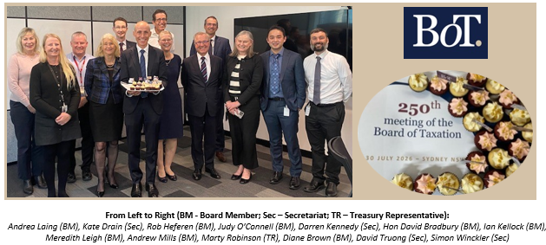

CPA Australia Tax Forum 2026
The Hon David Bradbury recently delivered a keynote address and participated in a panel session at the CPA Australia 2026 Tax Forum. The forum brought together senior leaders from across the tax profession to explore the evolving tax landscape and share insights on the opportunities and challenges ahead.
David presented alongside Mr Rob Heferen, the Commissioner of Taxation, Ms Ruth Owen, Taxation Ombudsman and Ms Diane Brown, Deputy Secretary, Revenue, Small Business and Law Group, Treasury to share insights into the evolution of tax administration, oversight and policy development.
Later in the morning, David shared insights into reframing tax reform for Australia’s future by improving productivity, simplicity and building trust in the tax reform process.
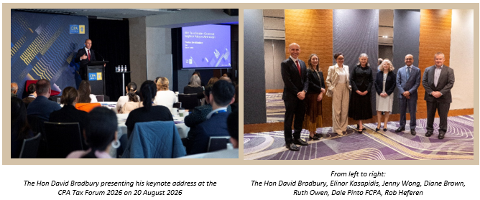

2026 Board Meeting Dates
The meeting dates for the remainder of the 2026 year are included below. The 2027 dates will be announced later in the year.
Meeting Number | Date | Location
251 | 24 September 2026 | Melbourne
252 | 4 November 2026 | Sydney (TBC)
253 | 10 December 2026 | Canberra (TBC)

Andrea Laing  Acting Chair, Board of Taxation | Website  LinkedIn  Subscribe

