
Annual Report 2025–26
© Commonwealth of Australia 2026
ISSN: 2204-096X
This publication is available for your use under a Creative Commons Attribution 4.0 International licence, with the exception of the Commonwealth Coat of Arms, the Board of Taxation logo, photographs, images, third party materials, materials protected by a trademark, signatures and where otherwise stated. The full licence terms are available from creativecommons.org/licenses/by/4.0/legalcode.
Use of Commonwealth of Australia material under a Creative Commons Attribution 4.0 International licence requires you to attribute the work (but not in any way that suggests that the Commonwealth of Australia endorses you or your use of the work).
Commonwealth of Australia material used ‘as supplied’
Provided you have not modified or transformed Commonwealth of Australia material in any way including, for example, by changing the Commonwealth of Australia text; calculating percentage changes; graphing or charting data; or deriving new statistics from published Commonwealth of Australia statistics – then the Commonwealth of Australia prefers the following attribution:
Source: The Board of Taxation 2025–26 Annual Report. The Commonwealth of Australia does not necessarily endorse the content of this publication.
Derivative material
If you have modified or transformed Commonwealth of Australia material, or derived new material from those of the Commonwealth of Australia in any way, then Commonwealth of Australia prefers the following attribution:
Based on the Board of Taxation, 2025–26 Annual Report. The Commonwealth of Australia does not necessarily endorse the content of this publication.
Use of the Coat of Arms
The terms under which the Coat of Arms can be used are set out on the Department of the Prime Minister and Cabinet website (see https://www.pmc.gov.au/honours-and-symbols/commonwealth-coat-arms).
Other uses
Enquiries regarding this licence and any other use of this document are welcome at:
Manager
Media Unit
The Treasury
Langton Crescent
Parkes ACT 2600
Email: media@treasury.gov.au
A copy of this document appears on the Board of Taxation website: http://www.taxboard.gov.au.
In the spirit of reconciliation, the Board of Taxation acknowledges the Traditional Custodians of country throughout Australia and their connections to land, sea and community. We pay our respect to their Elders past and present and extend that respect to all Aboriginal and Torres Strait Islander peoples.

Contents
2025–26 Board overview 1
Message from the Chair 2
The Board 4
Stakeholder communication and engagement 10
Sounding Board + 12
Activities of the Board in 2025–26 13
The year ahead – 2026‍–‍27 reporting year 20
Appendix A: The Board’s Charter 21
Appendix B: Membership of the Board 23
Appendix C: Attendance at Board meetings 24
Appendix D: Board Meetings, Stakeholder Events and Review Consultations 25
Appendix E: Financial Statements 26
Contact details 27
Glossary of terms 28

2025–26 Board overview
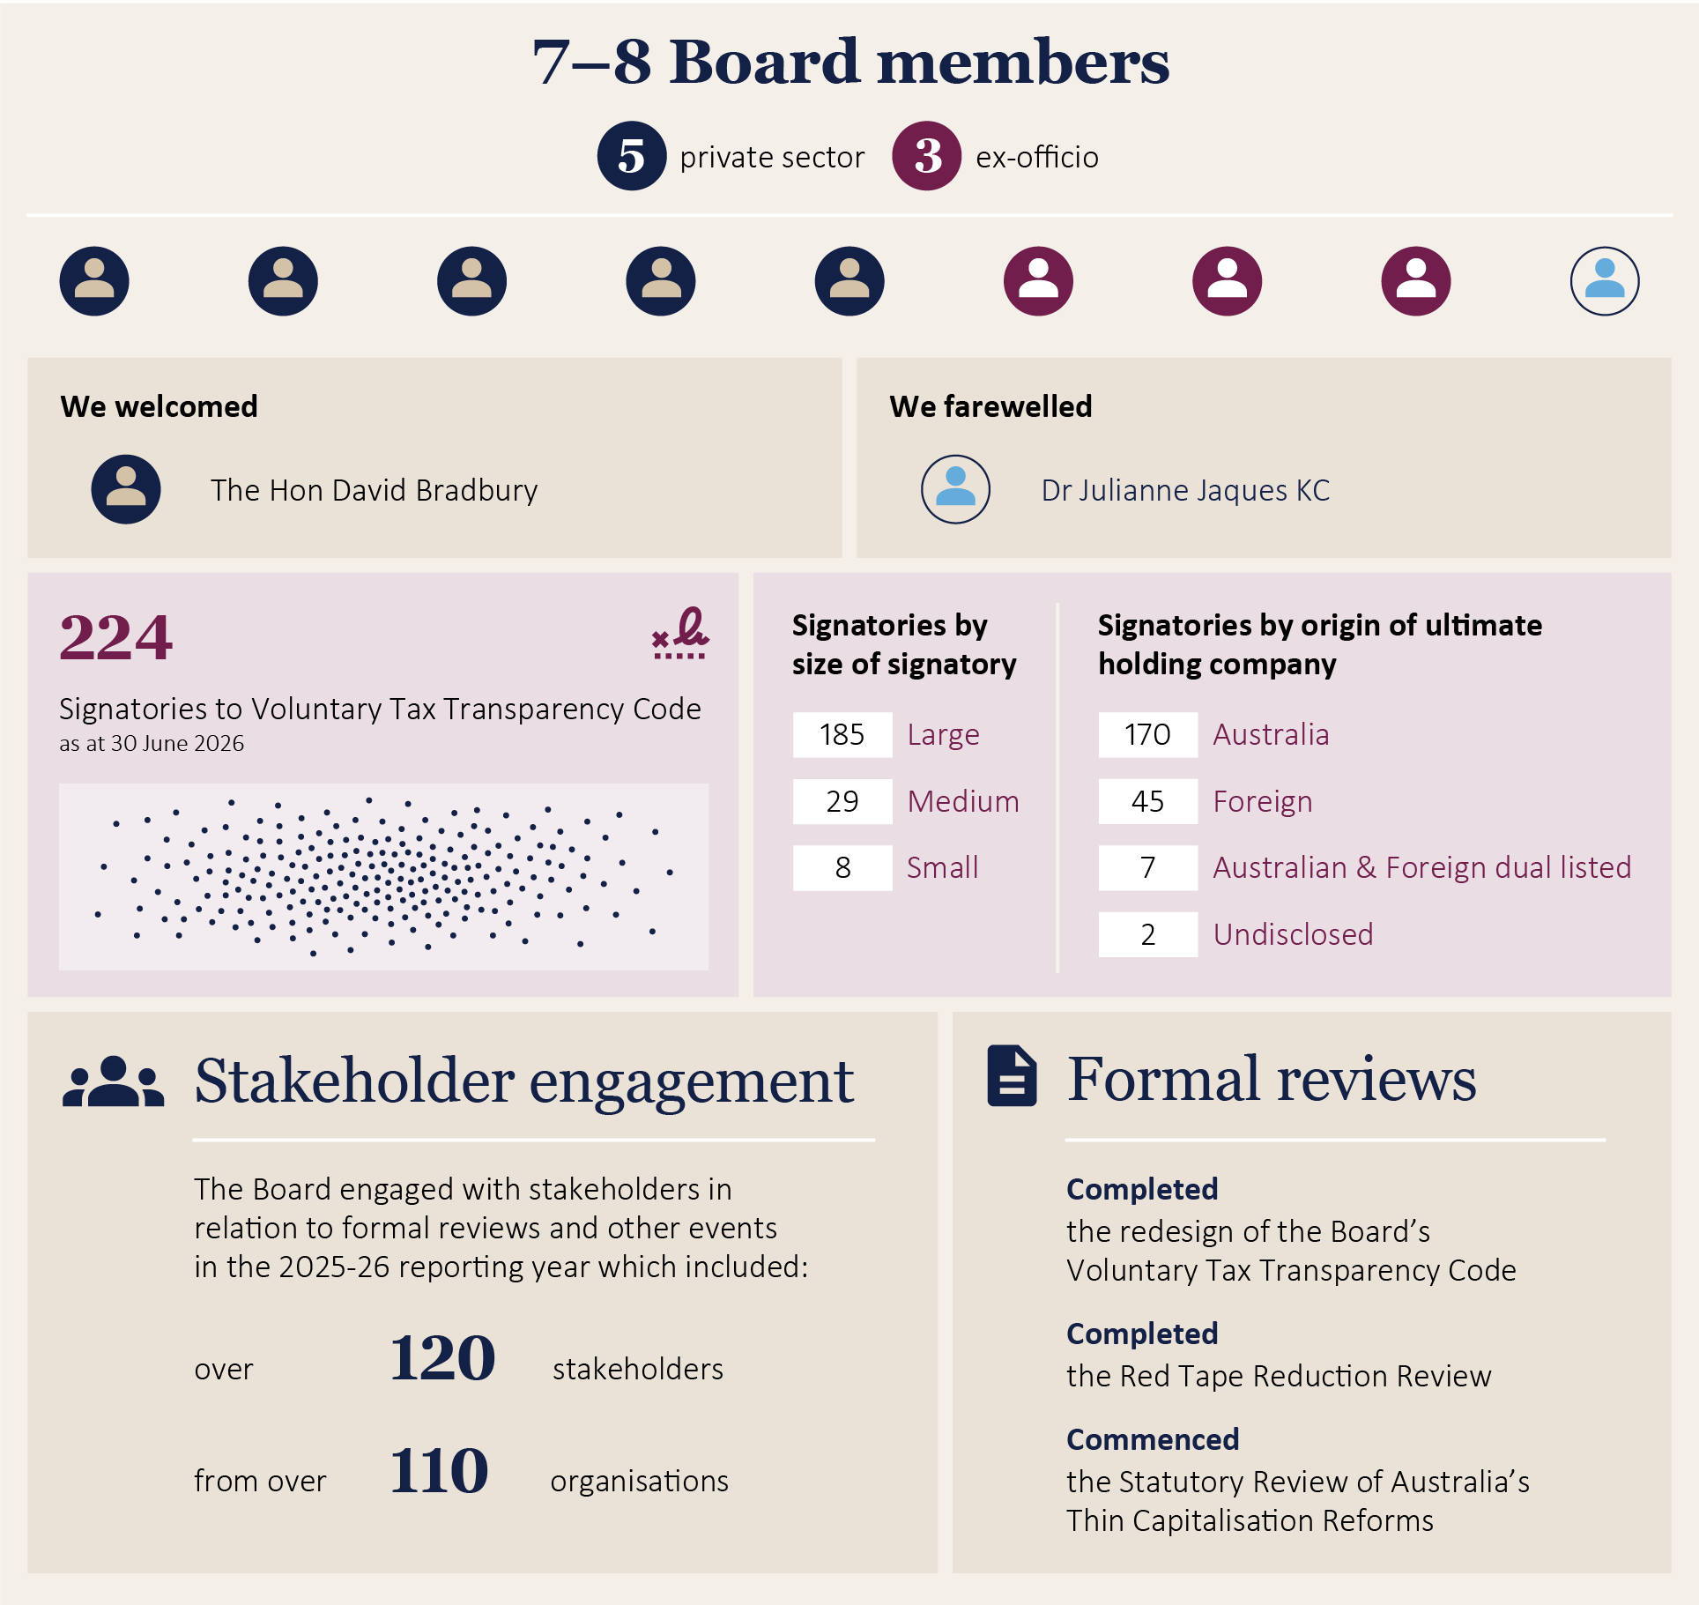

Message from the Chair

The Honourable David Bradbury
It is my pleasure to present the Annual Report for the Board of Taxation (the Board) for 2025–26.
This has been a year of significant activity, transition and renewal for the Board. Throughout the year, the Board has continued to fulfil its role as a trusted adviser to government, bringing a business and broader community perspective to the development and operation of Australia’s taxation system.
To begin with, I would like to acknowledge the significant contributions of our former Acting Chairs, Dr Julianne Jaques KC and Andrew Mills. During the reporting period, Julianne served as Acting Chair for part of the year before concluding her term on the Board, bringing to a close 9 years of valued service to the Board across 3 terms. During that time, she made a substantial contribution to the Board’s work through her deep expertise, sound judgement and unwavering commitment to improving Australia’s tax system. Her leadership, particularly during a period of transition, ensured the Board remained focused on delivering practical and considered advice to Government. Following Julianne’s departure, Andrew Mills assumed the role of Acting Chair and successfully guided the Board until my appointment. His steady leadership ensured continuity in the Board’s work program and stakeholder engagement activities during this transitional period. Their commitment, professionalism and dedication ensured the continuity of the Board’s work and the delivery of high-quality advice to Government. On behalf of the Board, I thank both Julianne for her outstanding service and lasting contributions and Andrew for generously assuming the responsibilities of Chair during this transition.
I would also like to recognise the departure of Paul Korganow from his role as Secretary and Tax Counsel (S&TC). Paul provided sound leadership of the Secretariat and played a central role in supporting the Board’s work and fostering strong relationships across government, business and the broader tax community. The Board extends our sincere thanks to Paul for his commitment, expertise and service, and we wish him every success in his future endeavours.
During the reporting year, the Board continued to place a strong emphasis on engagement with the business, tax and broader community. Meaningful consultation is fundamental to the Board’s work, and we have sought to broaden and deepen our engagement with taxpayers, professional advisers, industry groups, academics, civil society organisations and government agencies. These conversations have provided invaluable insights into the challenges and opportunities facing Australia’s tax system and have strengthened the quality of the Board’s contributions to public policy.
The year also marked the completion of the Board’s review into opportunities to reduce red tape within the tax system through its Red Tape Reduction Review. This important work was informed by extensive consultation and practical insights from stakeholders, with a focus on identifying measures to reduce compliance costs and improve the experience of taxpayers interacting with the system. In addition, the Board commenced the statutory review of Australia’s thin capitalisation reforms, an important project that will consider the operation and effectiveness of these provisions and their impact on taxpayers and Australia’s investment environment.
Finally, I would like to express my sincere appreciation to the many stakeholders who engaged with the Board throughout the year. Whether through formal consultations, roundtables, stakeholder meetings, written submissions or ongoing dialogue, your willingness to share your knowledge, experience and perspectives has been critical to our work. The Board’s effectiveness depends on these relationships, and we are grateful for the time, expertise and support that so many individuals and organisations continue to provide.
As this Annual Report is being finalised, I am concluding my tenure as Chair of the Board of Taxation on 31 August 2026 following my appointment as Deputy Chair of the Australian Prudential Regulation Authority. I would like to express my gratitude to my fellow Board members, the Secretariat and the many stakeholders who have contributed to the Board’s work. It has been a privilege to serve the Board and support its mission of improving Australia’s taxation system through independent and practical advice to Government. I am confident that the Board will continue to make a valuable contribution in the years ahead.


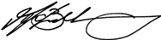
The Hon David Bradbury
Chair,
Board of Taxation
August 2026

The Board
The Board is a non-statutory advisory body charged with contributing a business and broader community perspective to improving the design of taxation laws and their operation.
The Treasurer appoints members of the Board from the business and wider community. Private sector members are appointed in their personal capacity.
Throughout the 2025–26 reporting year, the Board comprised between 7 and 8 members, including 3 ex officio members being the Secretary to the Treasury, the Commissioner of Taxation, and the First Parliamentary Counsel with the remaining members serving in a private capacity.
The Board is supported by a Secretariat which is primarily employed by the Treasury and supplemented with secondees from the ATO. The S&TC led the Secretariat and worked closely with the Chair and the Deputy Secretary of Revenue, Small Business and Law Group in Treasury.
The Charter, which sets out the Board’s mission, governs the operations and functions of the Board as set out below. The Charter is included at Appendix A: The Board’s Charter.

The Board’s mission and function
The Board provides an independent source of advice to government, from a business and broader community perspective, on taxation matters. In doing so the Board provides advice to the Treasurer and Assistant Treasurer on:
- the quality and effectiveness of tax legislation and the processes for its development, including the processes of community consultation and other aspects of tax design;
- improvements to the general integrity and functioning of the taxation system;
- research and other studies commissioned by the Board on topics approved or referred by the Treasurer and/or the Assistant Treasurer; and
- other tax matters referred to the Board by the Treasurer and/or the Assistant Treasurer.
The Board’s activities during the 2025–26 reporting year are detailed in section: Activities of the Board in 2025–26.

Board members

Changes to Board memberships
As of 30 June 2026, the Board was comprised of 8 Board members: 5 private members and 3 ex officio members.
Dr Julianne Jaques KC’s term ended on 30 September 2025, following 3 terms with the Board. During her tenure, Dr Jaques served twice as acting Chair, from 11 July 2019 to 10 January 2020, and from 1 April 2025 to 30 September 2025.

Chair of the Board
Dr Julianne Jaques KC was appointed as acting Chair from 1 April 2025 to 30 September 2025.
Following the conclusion of Dr Jaques’ term, the Treasurer appointed Mr Andrew Mills as acting Chair from 1 October 2025 to 31 March 2026.
The Honourable David Bradbury was subsequently appointed as Chair of the Board for a 3-year term commencing 1 April 2026.

Board membership as of 30 June 2026

Private Board members
  The Hon David Bradbury  Chair  Term start date: 1 April 2026 | Mr Bradbury has over 25 years’ experience in law, government, tax policy and administration and public policy more broadly. He brings substantial domestic and international experience.  Between 2014 and 2024, Mr Bradbury was a senior executive at the Organisation for Economic Cooperation and Development (OECD) in Paris. where he was the Head of the Tax Policy and Statistics Division and the Deputy Director of the Centre for Tax Policy and Administration.  Mr Bradbury was a member of the House of Representatives in the Australian Parliament between 2007 and 2013. He served as a Minister in the Australian Government between 2010 and 2013, holding a range of portfolios, including Assistant Treasurer.  In these roles, he was responsible for overseeing some of Australia’s key economic and financial regulators. He held portfolios in areas such as taxation policy, competition policy and consumer affairs, financial services and superannuation, foreign investment policy and corporate governance.  Before entering parliament, Mr Bradbury was a lawyer at Blake Dawson (now Ashurst) between 2002 and 2007. He has qualifications in law and taxation.  Mr Bradbury is an Honorary Professor at the Crawford School of Public Policy at the Australian National University. He is also the Chair of the Tax and Transfer Policy Institute Advisory Committee and is a member of the e61 Institute’s Policy Advisory Committee.  Mr Bradbury is a former partner in KPMG Australia’s Consulting Division.  Mr Bradbury was appointed as a part time member and Chair of the Board for a 3-year period from 1 April 2026.

  Ian Kellock  Private Board member  Term start date: 12 May 2021 | Mr Kellock is a Tax Partner at Ashurst and has over 25 years’ experience as a taxation professional. Mr Kellock’s practice deals with all aspects of Australian income tax, with a focus on mergers and acquisitions transactions in the financial services, healthcare, property, and resources sectors.  Mr Kellock is a Chartered Accountant and a Chartered Tax Adviser. He holds a Bachelor degree in law and commerce from the University of Melbourne and a Masters degree in law from Monash University.  Mr Kellock was appointed as a part time member of the Board from 12 May 2021 and was re-appointed for an additional term until 11 August 2027.

  Andrea Laing  Private Board member  Term start date: 21 October 2021 | Ms Laing has many years of experience in taxation, working in the ATO, Chartered Accounting and the extractive/energy industry. She spent more than 2 decades at Shell in various roles specialising in indirect tax, employment tax and tax policy. Ms Laing was Head of Tax for Shell Australia for 5 years and led a global project on the tax ramifications of Energy Transition and Climate Change.  Ms Laing was a member of the OECD task team that developed International VAT Guidelines published in 2014. She spent 4 years on the Corporate Tax Association Executive and is a member of Certified Practicing Accountants (CPA) Australia.  Ms Laing was appointed as a part time member of the Board from 21 October 2021 and was re-appointed for an additional term to 20 October 2027.  On 12 March 2025, Ms Laing was appointed as a part-time member of the National Library of Australia Council, for a 3-year term commencing on 4 April 2025.

  Andrew Mills  Private Board member  Term start date: 8 December 2023 | Mr Mills has over 40 years’ experience in senior commercial, accounting and legal practice, government and academic roles.  He is currently Chair of the Financial Reporting Council, Chair of the NSW Independent Planning Commission and a Senior Fellow of the University of Melbourne Law School.  Mr Mills is also a member of the Tax and Transfer Policy Institute Advisory Committee and of the executive committee of the International Fiscal Association, Australia Branch.  Previously, Mr Mills served as Second Commissioner of Taxation at the Australian Taxation Office. He was also a Director-Partner at Greenwoods & Freehills for over 20 years.  Mr Mills has qualifications in business and law. He is a Fellow of CPA Australia, a Chartered Tax Adviser (Life), a Graduate of the Australian Institute of Company Directors, a Fellow of the Governance Institute of Australia and a member of the International Fiscal Association.  Mr Mills was appointed as a part-time Board member from 8 December 2023 and was appointed acting Chair of the Board from 1 October 2025 to 31 March 2026.

  Judy O’Connell  Private Board member  Term start date: 8 December 2023 | Ms O’Connell has extensive domestic and global experience in tax administration, having worked at the ATO for 35 years.  She was appointed Assistant Commissioner from 2005 to 2016 and was a key executive driving the changes to improve the experience for small business owners when dealing with the ATO.  Ms O’Connell was the former Victorian Small Business Commissioner between 2016 and 2021.  She also worked at the Organisation for Economic Co-operation and Development (OECD) in Paris as Head of Unit at the Fiscal Affairs Division, where she led the development of an online international tax dialogue between tax administrations.  Ms O’Connell works as a short-term Tax Expert in the Fiscal Affairs Department of the IMF, providing technical assistance to tax administrations. She has a Bachelor of Economics from the University of Melbourne.  Ms O’Connell was appointed as a part-time Board member for a 3-year period from 8 December 2023.  On 13 November 2024, Ms O’Connell was appointed the independent Lead reviewer for the Statutory Review of the Australian Small Business and Family Enterprise Ombudsman.

Ex officio members
  Rob  Heferen  Commissioner of Taxation,  Ex officio Board member  Term start date: 1 March 2024 |   Jenny  Wilkinson PSM  Secretary to the Treasury,  Ex officio Board member  Term start date:  16 June 2025 |   Meredith  Leigh  First Parliamentary Counsel, Ex officio Board member  Term start date: 11 October 2021

Stakeholder communication and engagement
The Board plays an important role as an independent advisory body to Government, bringing a business and broader community perspective to the design, administration and operation of Australia’s tax system. Through its work, the Board seeks to provide practical, informed and implementable advice on taxation issues, supported by active engagement with taxpayers, industry representatives, professional associations, academics, civil society organisations and government stakeholders. The Board’s stakeholder engagement activities underpin its ability to develop evidence-based advice and ensure that its work is informed by a diverse range of experiences and perspectives.
During the 2025–26 reporting year, the Board continued to strengthen its communications and engagement activities across a number of channels. Stakeholder consultation remained central to the Board’s review work. Stakeholders were encouraged to participate through written submissions, roundtable discussions, targeted consultations and ongoing engagement. This approach enabled the Board to gather practical feedback from a broad cross-section of the community and ensure that emerging issues and stakeholder concerns were reflected in its work.
Stakeholder engagement underpins the Board’s ability to deliver practical, implementable and credible tax policy advice.
The Board also expanded its broader outreach activities through regular social media posts, website updates and publication of The Board’s Bulletin. These communication channels provided stakeholders with timely information on the Board’s work program, current reviews, consultation opportunities and stakeholder engagement activities.
The Hon David Bradbury was appointed as Chair of the Board in April 2026. Following his commencement, the Chair embarked on an extensive program of stakeholder meetings and engagements with government, industry bodies, professional associations, business representatives and members of the tax community. These discussions were undertaken to gain a broad understanding of stakeholder expectations, the Board’s strengths and opportunities for future development. The Chair also began developing a vision for the Board that emphasises stronger engagement with business, practitioners and the broader community, recognising that diverse perspectives are critical to ensuring the Board continues to fulfil its role as a trusted adviser to Government.
Consistent with this vision, the Board commenced a review of its stakeholder engagement framework during the reporting year, with a focus on broadening participation, strengthening relationships across the tax community and improving the Board’s ability to identify emerging tax issues. Through a combination of targeted stakeholder forums, consultation activities, publications and digital engagement, the Board continued to build awareness of its work and reinforce its role as an independent source of practical tax policy advice informed by the experiences of the wider community.
The Board extends its appreciation to the many stakeholders who engaged with its work during 2025–26. The valuable feedback, perspectives and practical insights provided through consultations, targeted engagement sessions, stakeholder meetings and written submissions strengthened the Board’s understanding of emerging issues and informed the advice provided to Government. The Board looks forward to continuing these important relationships and fostering broader engagement with the tax community in the years ahead.
A full list of Stakeholder events and review consultations held by the Board are included at
Appendix D: Board Meetings, Stakeholder Events and Review Consultations

Engagement with the Government, Treasury and the ATO
Over the 2025–26 reporting year, the Board has continued to play an important role as a trusted advisor to Government, Treasury and the ATO, contributing informed perspectives across its work program.
During the year, the Chair and acting Chairs, met with the Treasurer the Hon Dr Jim Chalmers MP on numerous occasions. These discussions provided the opportunity to outline the Board’s priorities and offer advice on tax issues affecting the tax and business community.
The Board maintained regular contact with senior officials from Treasury and the ATO. In addition, the ex officio members of the Board and their representatives participated at Board meetings and were actively involved throughout review processes, supporting ongoing collaboration, transparency and the effective exchange of insights.

Sounding Board +
The Board encourages stakeholder participation through Sounding Board +, a web–based collaboration platform available on the Board’s website. The platform provides members of the broader community with an opportunity to submit ideas aimed at improving the administration and operation of the Australian taxation system.
Where new ideas are submitted through Sounding Board+ they are reviewed by the Board. Where appropriate, the Board can advocate pathways for implementation through either legislative or administrative means.
Sounding Board + is intended to support practical improvements to the taxation system and is not a forum for substantive tax policy proposals, such as changes to tax rates, alterations to the tax mix or the abolition of existing taxes. Nor is it designed to consider proposals requiring significant structural reform of the tax system. Nevertheless, community members occasionally submit ideas of this nature. To acknowledge these contributions, the platform includes a dedicated category for policy-related suggestions which remain matters for Government consideration.
To assist in the assessment of community submissions and to better manage stakeholder expectations, ideas can be submitted on Sounding Board + into one of 5 categories.
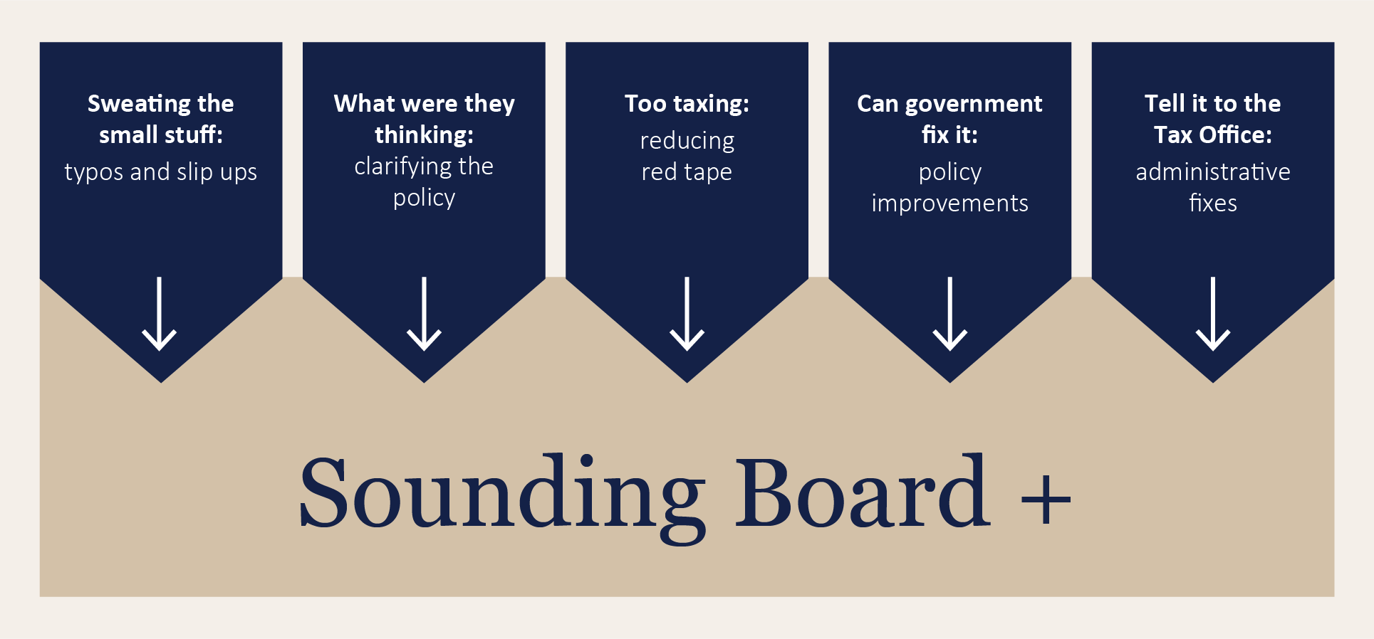
Ideas for taxation system improvement can be submitted via Sounding Board + on the Board’s website.

Activities of the Board in 2025–26

Finalised reviews

Red Tape Reduction Review
On 24 March 2025 the Government announced the Board would review ways to reduce red tape in the tax system.
Red tape reduction and better regulation is a key reform focus of the Government to enhance productivity. In the tax system this involves reducing compliance burdens where appropriate, particularly for business taxpayers (both small and large).
Compliance costs can be driven by complexity in the design of the tax system, as well as how tax laws are administered.
In the lead up to the Economic Reform Roundtable (ERR), the Treasurer wrote to Commonwealth regulators, asking for actions each regulator could implement to reduce compliance burdens to support productivity.
The Commissioner of Taxation responded to the Treasurer’s request. Along with other things, the ATO has indicated that it will develop a compliance costs framework to help the ATO better understand how regulation and compliance impact taxpayers.

Terms of reference
To complement and support the ATO’s work, the Board was requested to:
- engage with the business community to identify areas of business tax law and administration where there are opportunities for red tape reduction that are substantial, material, measurable and directly support productivity.
- Where opportunities are identified:
  - If involving administrative changes, provide the examples to the ATO to support their red tape work, including indicating the benefits that may be possible from reducing compliance costs; and
  - If involving legislative changes, provide recommendations to Government for potential improvements. Any recommended improvements should consider the benefits to productivity, be revenue neutral and consider any potential integrity risks.
As part of the review, the Board carried out a stock-take of tax-related compliance and red tape reduction recommendations from the ERR public submissions, as well as previous Board reviews and recent stakeholder engagement by the Board which discussed tax compliance burden.

Progress of the review
The review public consultation phase was commenced in November 2025. Written submissions were received by the end of 2025. The Board:
- received 52 written submissions to the review
- held 10 roundtable consultation sessions
- met with over 100 stakeholders
- covered 9 major market segments.
The Board also undertook targeted engagement with stakeholders to explore specific proposals in greater depth, seek clarification, and assess feasibility and potential impact. This further analysis helped inform the development of the Board’s recommendations.
Board members, the Hon. David Bradbury, Andrew Mills, Ian Kellock, Andrea Laing and Judy O’Connell were appointed to oversee the review.
The Board sincerely thanks everyone who took the time to provide feedback and contribute ideas.
On 30 June 2026, the Board submitted the review final report to Government.
More information on the review can be found on the Board’s website.

Redesign of the Voluntary Tax Transparency Code
During the 2025–26 reporting year, the Board continued its review of the Voluntary Tax Transparency Code (VTTC), which commenced in August 2024 following a request from the Treasurer. The review was undertaken in response to significant changes in the domestic and international tax transparency landscape since the VTTC was first introduced in 2016. The Board concluded that, while the VTTC continues to play an important role in promoting greater tax transparency and community confidence in the tax system, there was an opportunity to simplify and modernise the Code to ensure it remains relevant and effective.
Board members Andrea Laing and Andrew Mills were appointed to oversee the review.
Building on the findings of the initial review phase, the Board commenced the redesign of the VTTC in January 2025. The redesigned framework sought to reduce duplication with other tax transparency regimes, particularly public Country-by-Country reporting requirements, while maintaining the Code’s objective of encouraging meaningful tax transparency disclosures.
Consultation remained a central component of the redesign process. In June 2025, the Board released the draft redesigned VTTC for public consultation and published a consultation guide seeking stakeholder views on the proposed changes. Feedback was gathered through virtual consultation sessions, written submissions and stakeholder surveys. Stakeholders generally supported the Board’s approach, noting the importance of reducing duplication, improving alignment with existing reporting obligations and providing clearer guidance for participants. The Board also received encouraging feedback from existing participants regarding their intention to continue reporting under the redesigned Code.
The Board finalised its recommendations during the reporting year and provided its findings to Government. The redesigned VTTC establishes a contemporary framework for organisations wishing to transparently communicate their tax affairs, demonstrate good tax governance and build trust with investors and the broader community.
The redesigned VTTC started on 1 July 2026. Early adoption is optional.
The Board remains committed to monitoring developments in tax transparency and reviewing the VTTC over time to ensure it continues to meet the needs of businesses, investors and the Australian community.
The Board extends its sincere appreciation to all stakeholders who contributed to both phases of the review. The insights provided through consultation sessions, written submissions, surveys and direct engagement were instrumental in shaping the redesigned VTTC and ensuring it reflects practical experience across a diverse range of businesses, professional bodies, investors, advisers, academics and government agencies.
Key changes to the redesigned VTTC are outlined in the table below.
Table 1: Key Changes to the Voluntary Tax Transparency Code
Part of 2016 VTTC | Changes in 2025 VTTC
Format, design and structure | - Updated and simplified.
Objectives | - Updated.  - New ‘Why adopt’ section.  - Guidance for the new VTTC participants.
Disclosure classification | - Updated – different reporting requirements for a ‘public CbC reporter’ and a ‘non-public CbC reporter’. Previously based on the entity’s size and aggregated turnover.  - Removed duplication for public CbC reporters.  - Included more optional elements largely based on the Global Reporting Initiatives (GRI) 207. They differ based on CbC reporter classification.
Part A – Qualitative information | - Replaced with ‘Tax data’.  - Added optional elements (largely based on the GRI 207).
Part b – Quantitative information | - Replaced with ‘Overall approach to tax’.  - Approach to tax aligned with:  - GRI 207-2 – tax governance, control and risk management  - GRI 207-3 – Stakeholder engagement and management of tax concerns.  - Added optional elements.
Guidance | - More guidance added throughout, including:  - document navigation  - guidance on completion timing  - example template format of VTTC report based on fictitious ‘public CbC reporter’ and a ‘non-public CbC reporter’ (Appendix A)  - self-assessment VTTC checklist (Appendix B)  - glossary (Appendix C).

Reviews commenced

Statutory review of Australia’s thin capitalisation reforms
On 1 February 2026, the Board commenced a statutory review of Australia’s thin capitalisation reforms.
Recent amendments to Australia’s thin capitalisation rules were introduced in Schedule 2 of the Treasury Laws Amendment (Making Multinationals Pay Their Fair Share—Integrity and Transparency) Act 2024 (Amending Act).
In accordance with Section 4 of the Amending Act, the Government requested the Board to undertake an independent review of the operation of the amendments to the thin capitalisation rules.
Board members the Hon David Bradbury, Ian Kellock and Andrew Mills were appointed to oversee the review.

Terms of Reference
The Board of Taxation (Board) is requested to examine the operation of the amendments to Australia’s thin capitalisation rules made by Schedule 2 to the Treasury Laws Amendment (Making Multinationals Pay Their Fair Share—Integrity and Transparency) Act 2024. This review is a statutory requirement contained in section 4 of that Act.
In conducting the review, the Board will assess whether the amendments are operating in a manner consistent with the policy intent, which was to strengthen Australia’s thin capitalisation regime to address risks arising from the use of excessive debt deductions, informed by the OECD’s best practice guidance. In considering the operation of the amendments, the Board is requested to consider:
- The overall performance of the amendments in strengthening Australia’s thin capitalisation regime to address risks arising from the use of excessive debt deductions.
- Any minor and technical drafting changes which are necessary for the practical administration of the laws, with a particular focus on the third-party debt test provisions and related undefined legislative terms.
- If the $2 million exemption threshold should operate as a net debt deduction concept.
- Whether the default tax EBITDA calculation operates to appropriately reflect an entity’s economic activity in the income year and across multiple income years, as intended.
- The practical impact on the cost of complying with the debt deduction creation rules after restructures, including whether the rules have effectively discouraged debt creation schemes.
The Board’s review should clearly address the importance of any recommendations and how they would be implemented to achieve a substantially similar practical effect to those intended by Schedule 2 of the Act, including consideration of complexity and tax integrity trade-offs.
The Board should undertake public consultation processes and engage closely with the Treasury and the Australian Taxation Office. The Board is requested to prepare a written report for Government within 12 months from commencement.

Progress of the review
The Board prepared a consultation guide, to explain the review process and outline the consultation process, including how stakeholders can contribute and questions to consider.
Written submissions were received by the Board until end June 2026.
The Board plans on holding stakeholder consultation sessions commencing in August 2026 and continuing into the next reporting period.
The Board has been requested to provide its final written report to the Government within 12 months of the review starting, that is by 31 January 2027.

Other ongoing work

Trusted advisor to Treasury and the ATO
The Board has continued to embrace its role as a trusted advisor to Government, the Treasury, and the ATO by providing regular ad hoc advice throughout the year.
During the 2025–26 year the Board was pleased to support Treasury and the ATO by providing consultation and feedback in relation to a number of tax and administrative measures and guidance products.

Voluntary Tax Transparency Code and Register
The VTTC is a Board developed set of principles and minimum standards to guide disclosure of tax information by businesses. The VTTC encourages taxpayers to publicly disclose information regarding their tax affairs to promote community confidence that they are paying their fair share of tax and not engaging in aggressive tax avoidance behaviours. The Board is responsible for maintaining the register of signatories to the VTTC.
There were 224 signatories to the VTTC as of 30 June 2026. Of these 224 signatories, 222 signatories had notified of at least one published report as of 30 June 2026.
As reported in the ATO’s Voluntary Tax Transparency statistics for 30 June 2026, the 224 signatories are represented as follows:
Table 2: Signatories by size of signatory:
Size of signatory | Number | Percentage
Large | 185 | 83%
Medium | 29 | 13%
Small | 8 | 4%
Table 3: Signatories by origin of ultimate holding company:
Origin of ultimate holding company | Number | Percentage
Australia | 170 | 76%
Foreign | 45 | 20%
Australia & Foreign dual listed | 7 | 3%
Undisclosed | 2 | 1%

The year ahead – 2026‍–‍27 reporting year
The 2026–27 reporting year presents an important opportunity for the Board to build on the strong foundations established over the past year. The Board will continue to focus on its role as a trusted adviser to Government, bringing practical business and broader community perspectives to taxation policy and administration. The Board will seek to strengthen its contribution to national tax policy discussions through increased engagement, greater visibility and a continued focus on delivering practical, evidence-based advice.
A key priority for the year ahead will be the completion of the Board’s statutory review of Australia’s thin capitalisation regime. Through consultation with taxpayers, advisers, industry representatives, civil society and other stakeholders, the Board will continue its work to identify opportunities to improve the operation of the rules and ensure they remain effective, practical and fit for purpose. The Board is scheduled to deliver its final report and recommendations to Government during the 2026–27 reporting period, informed by stakeholder experience and the evidence gathered throughout the review.
The Board will also renew its focus on stakeholder engagement. Building on the vision for a more outward-facing and connected Board, engagement activities will continue to evolve to ensure a broader range of voices are heard. This will include targeted stakeholder forums, consultation activities, meetings with professional associations and industry groups, and greater engagement with the wider community. These activities will support the Board’s ability to identify emerging issues, understand stakeholder experiences and ensure its advice reflects practical, real-world perspectives.
Increasing the visibility and awareness of the Board’s work will also be a priority during 2026–27. By providing greater transparency about its work program, consultation opportunities and key insights from stakeholder engagement, the Board aims to strengthen understanding of its role and encourage broader participation in its activities. Through these efforts, the Board will continue to promote informed discussion of taxation matters and reinforce its position as an independent and trusted source of advice on the Australian tax system.

Appendix A: The Board’s Charter

The Charter

Mission
Recognising the Government’s responsibility for determining taxation policy and the statutory roles of the Commissioner of Taxation and the Inspector General of Taxation, the Board’s mission is to contribute a business and broader community perspective to improving the design of taxation laws and their operation.

Membership
Members of the Board will be appointed by the Treasurer, for a term of up to 3 years, in their personal capacity. It is expected that members will be appointed from within the business and wider community having regard to their ability to contribute at the highest level to the development of the taxation system. The Chair will be appointed by the Treasurer from among these members of the Board. If the Treasurer decides to appoint a Deputy Chair, he or she will also be appointed from among these members of the Board. Members may be re-appointed.
In addition, the Secretary to the Department of the Treasury, the Commissioner of Taxation and the First Parliamentary Counsel will also be members of the Board. Each may be represented by a delegate.

Function
The Board will provide advice to the Treasurer on:
- the quality and effectiveness of taxation legislation and the processes for its development, including the processes of community consultation and other aspects of taxation design
- improvements to the general integrity and functioning of the taxation system
- research and other studies commissioned by the Board on topics approved or referred by the Treasurer
- other taxation matters referred to the Board by the Treasurer.

Relationship to other boards and bodies
From time to time the Government or the Treasurer may establish other boards or bodies with set terms of reference to advise on aspects of the taxation law. The Treasurer will advise the Board on a case-by-case basis of its responsibilities, if any, in respect of issues covered by other boards and bodies.

Report
The Chair of the Board will report to the Treasurer, at least annually, on the operation of the Board during the year.

Secretariat
The Board will be supported by a Secretariat provided by the Treasury who may engage secondees from the private sector or other government agencies to fill certain roles.

Other
Members will meet regularly during the year as determined by the Board’s work program and priorities.
Non-government members will receive remuneration and allowances to cover travelling and other expenses, at rates in accordance with Remuneration Tribunal determinations for part time public offices.
The Government will determine an annual budget allocation for the Board.

Appendix B: Membership of the Board

Terms of Board members
The terms of members of the Board during the 2025–26 year are set out in the following table.
Table 4: Terms of Board members
Member | Initial term commenced | Term expires/ceased
The Hon David Bradbury^{(a)} | 1 April 2026 | 31 March 2029
Dr Julianne Jaques KC^{(b)} | 1 July 2017 | 30 September 2025
Ian Kellock | 12 May 2021 | 11 August 2027
Andrea Laing | 21 October 2021 | 20 October 2027
Andrew Mills^{(c)} | 8 December 2023 | 7 December 2026
Judy O’Connell | 8 December 2023 | 7 December 2026
Rob Heferen | 1 March 2024 | Ex officio
Jenny Wilkinson PSM | 16 June 2025 | Ex officio
Meredith Leigh | 11 October 2021 | Ex officio
- Hon David Bradbury resigned from the position of Chair of the Board of Taxation effective 31 August 2026.
- Dr Julianne Jaques KC was appointed as acting Chair from 1 April 2025 to 30 September 2025.
- Andrew Mills was appointed as acting Chair of the Board from 1 October 2025 to 31 March 2026.

Appendix C: Attendance at Board meetings
Table 5: Attendance at Board meetings, 2025–26
Member | Number of meetings eligible to attend | Number of meetings attended
The Hon David Bradbury, Chair | 2 | 2
Dr Julianne Jaques KC | 2 | 2
Ian Kellock | 8 | 8
Andrea Laing | 8 | 8
Andrew Mills | 8 | 7
Judy O’Connell | 8 | 8
Rob Heferen^{(#)} | 8 | 8 – including via delegate
Jenny Wilkinson PSM^{(#)} | 8 | 8 – including via delegate
Meredith Leigh^{(#)} | 8 | 8
(#) The Board’s Charter allows for ex officio members of the Board to be represented by a delegate at Board meetings.

Appendix D: Board Meetings, Stakeholder Events and Review Consultations
The Board met 8 times in the 2025–26 reporting year in locations throughout Australia.
Table 6: Board meetings and stakeholder events, 2025–26
Date | Location | Board Meeting | Engagement type
25 July 2025 | Treasury, Kent Street, Sydney, NSW | Yes | Stakeholder event - Simplifying GST administration and compliance
25 September 2025 | Treasury, Collins Street, Melbourne, VIC |  | Red tape reduction for Small Businesses
23 October 2025 | Treasury, Collins Street, Melbourne, VIC | Yes | Treasury presentation
13 November 2025 | Treasury, Collins Street, Melbourne, VIC |  | Red Tape Reduction Review consultation sessions
14 November 2025 | Treasury, Kent Street, Sydney, NSW |  | Red Tape Reduction Review consultation sessions
21 November 2025 | Virtual |  | Red Tape Reduction Review consultation sessions
5 December 2025 | Treasury, Collins Street, Melbourne, VIC | Yes | ATO presentation
29 January 2026 | Treasury, Collins Street, Melbourne, VIC | Yes | ATO presentation
25 March 2026 | Treasury, Collins Street, Melbourne, VIC | Yes | Fringe Benefits Tax
30 April 2026 | Treasury, Langton Crescent, Parkes, ACT | Yes | ATO presentation  Treasury presentation
11 June 2026 | Treasury, Collins Street, Melbourne, VIC | Yes | No stakeholder event held

Appendix E: Financial Statements
Table 7: Revenue, expenses, and operating result
Description | 2024–25  $ | 2025-26  $
Revenue
Revenue – Department of the Treasury budget allocation | 1,530,864 | 1,177,706
Revenue – Other^{(a)} | 148,370 | 144,968
Total revenue | 1,679,233 | 1,322,674
Expenses
Employee expenses
Wages | 575,332 | 492,734
Superannuation | 153,161 | 134,829
Other employee expenses | 493,067 | 437,624
Total employee expenses | 1,221,559 | 1,065,187
Other expenses
Travel | 112,811 | 71,076
Conferences and training | 3,942 | 7,174
Seconded Employees | 340,448 | 164,128
Office supplies | - | -
Other supplier expenses | 473 | 15,109
Total operating expenses | 457,674 | 257,487
Total expenses | 1,679,233 | 1,322,674
Operating surplus | - | -
- Revenue – Other includes Secondees to the Board of Taxation Secretariat provided under the ATO Secondment program
Table 8: Remuneration paid to non-government Board members
Board members 2025–26 | $
Total* | 410,094
*Total remuneration paid to non-government Board members, 2025–26 includes allowances and superannuation guarantee.

Contact details
Inquiries regarding this report may be directed to:
Board Of Taxation Secretariat
C/O – The Treasury
Langton Crescent
Parkes ACT 2600
Email: taxboard@taxboard.gov.au

Glossary of terms
The following abbreviations and acronyms are used throughout this report.
Abbreviation | Definition
ACT | Australian Capital Territory
ATO | Australian Taxation Office
The Board | The Board of Taxation
CbC | Country-by-Country
CPA | Certified Practicing Accountant
EBITDA | Earnings Before Interest, Tax, Depreciation, Amortization
ERR | Economic Reform Roundtable
GRI | Global Reporting Initiative
GST | Goods and Services Tax
Hon | Honourable
IMF | International Monetary Fund
KC | King’s Counsel
MP | Member of Parliament
NSW | New South Wales
OECD | Organisation for Economic Co-operation and Development
OPC | Office of Parliamentary Counsel
PSM | Public Service Medal
RTRR | Red Tape Reduction Review
S&TC | Secretary and Tax Counsel
VTTC | Voluntary Tax Transparency Code

The Board had 8 members during the period from 1 July 2025 to 30 September 2025 when Dr Julianne Jaques KC, Acting Chair, term ended. From 1 October 2025 to 31 March 2026, Mr Andrew Mills was Acting Chair and there were 7 Board members. From 1 April 2026, when Hon David Bradbury was appointed as Chair, to 30 June 2026, there were 8 Board members.
Sounding Board + website: https://taxboard.gov.au/sounding-board-plus
The Economic Reform Roundtable (ERR) was led by the Treasurer and supported by other key ministers. It focused on lifting living standards for Australians by looking at 3 main themes: making our economy more productive; building resilience in the face of global uncertainty; strengthening the budget and making it more sustainable. The ERR was held between 19 to 21 August 2025 at Parliament House, Canberra and brought together a mix of leaders from business, unions, civil society, government and other experts. Attendance was by invitation only. More information can be found on the Treasury website.
‘Voluntary Tax Transparency Code’, Australian Government data.gov.au (Web Page, online 30 June 2026).

