
Annual Report 2024–25

© Commonwealth of Australia 2025
ISSN: 2204-096X
This publication is available for your use under a Creative Commons Attribution 4.0 International licence, with the exception of the Commonwealth Coat of Arms, the Board of Taxation logo, photographs, images, third party materials, materials protected by a trademark, signatures and where otherwise stated. The full licence terms are available from creativecommons.org/licenses/by/4.0/legalcode.
Use of Commonwealth of Australia material under a Creative Commons Attribution 4.0 International licence requires you to attribute the work (but not in any way that suggests that the Commonwealth of Australia endorses you or your use of the work).
Commonwealth of Australia material used ‘as supplied’
Provided you have not modified or transformed Commonwealth of Australia material in any way including, for example, by changing the Commonwealth of Australia text; calculating percentage changes; graphing or charting data; or deriving new statistics from published Commonwealth of Australia statistics – then the Commonwealth of Australia prefers the following attribution:
Source: The Board of Taxation 2024–25 Annual Report. The Commonwealth of Australia does not necessarily endorse the content of this publication.
Derivative material
If you have modified or transformed Commonwealth of Australia material, or derived new material from those of the Commonwealth of Australia in any way, then Commonwealth of Australia prefers the following attribution:
Based on the Board of Taxation, 2024–25 Annual Report. The Commonwealth of Australia does not necessarily endorse the content of this publication.
Use of the Coat of Arms
The terms under which the Coat of Arms can be used are set out on the Department of the Prime Minister and Cabinet website (see https://www.pmc.gov.au/honours-and-symbols/commonwealth-coat-arms).
Other uses
Enquiries regarding this licence and any other use of this document are welcome at:
Manager
Media Unit
The Treasury
Langton Crescent
Parkes ACT 2600
Email: media@treasury.gov.au
A copy of this document appears on the Board of Taxation website: http://www.taxboard.gov.au.
In the spirit of reconciliation, the Board of Taxation acknowledges the Traditional Custodians of country throughout Australia and their connections to land, sea and community. We pay our respect to their Elders past and present and extend that respect to all Aboriginal and Torres Strait Islander peoples.

Contents
2024–25 Board overview 1
Message from the Acting Chair 2
Message from the Secretary and Tax Counsel 4
The Board 6
Stakeholder communication and engagement 11
Activities of the Board in 2024–25 15
The year ahead – 2025‍–‍26 reporting year 19
Appendix A: The Board’s Charter 20
Appendix B: Membership of the Board 22
Appendix C: Attendance at Board meetings 23
Appendix D: Board Meetings and Stakeholder Events 24
Appendix E: Financial Statements 25
Contact details 27
Glossary of terms 28

2024–25 Board overview
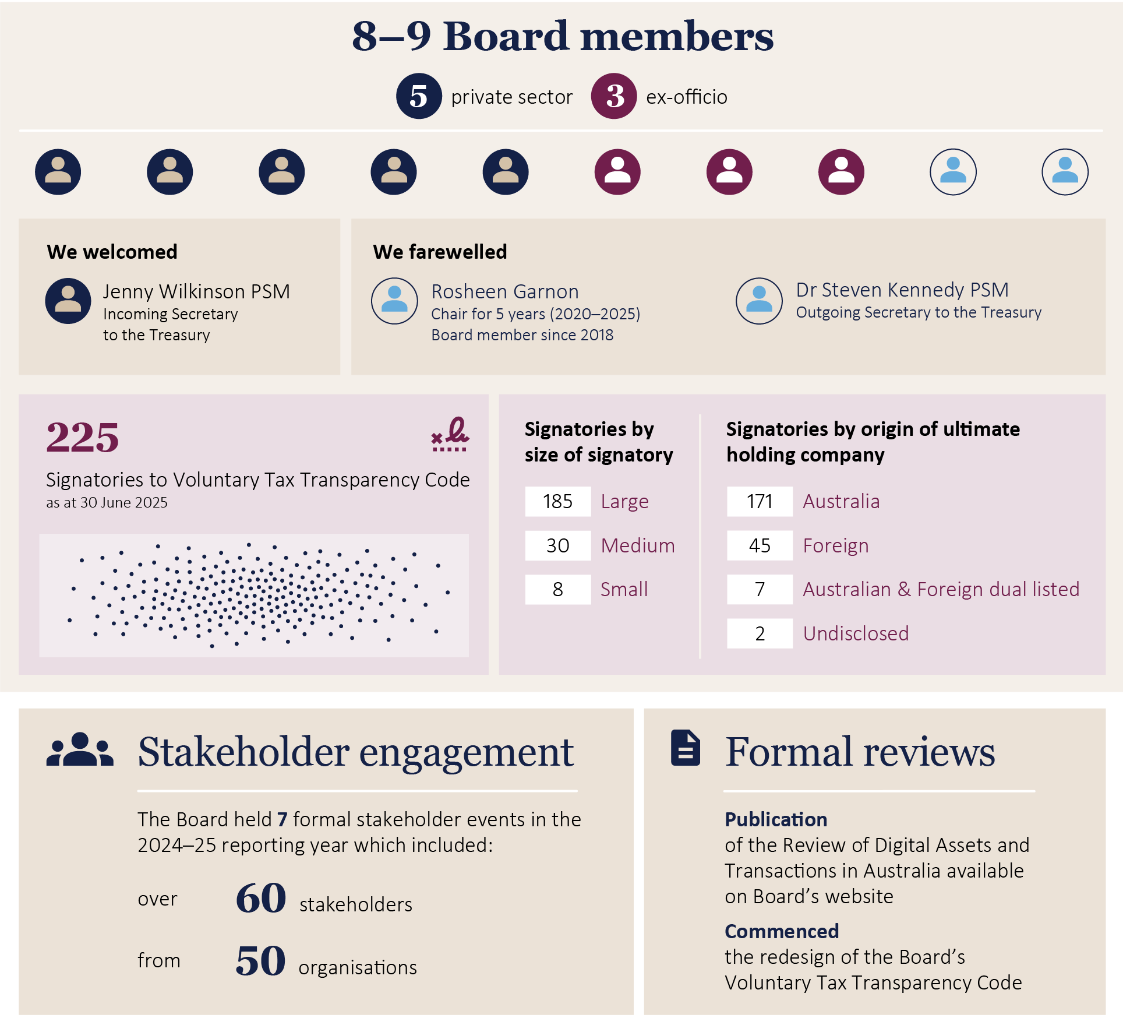

Message from the Acting Chair

Andrew Mills
It is a privilege to present the 2024-25 Annual Report for the Board of Taxation (the Board). This reporting year reflects a period of significant progress and transition for the Board.
At the outset, I would like to acknowledge and thank our former Chair, Mrs Rosheen Garnon, whose leadership, strategic vision and dedication have made a profound and lasting contribution to the Board. Rosheen was a member of the Board from 2017 and held the role as the Chair from 2020 to 31 March 2025. Both as a member of the Board and as Chair, Rosheen contributed to and led a number of significant reviews and provided disciplined, evidenced based approaches to complex issues. Rosheen was highly collaborative, respectful and supportive in her approach to stakeholders and to her fellow members. Rosheen’s impact will continue to subsist in the ongoing work of the Board.
I would also like to extend my sincere thanks to Dr Julianne Jaques KC who led the Board with integrity and steadiness over the last three months of the reporting period. Her leadership ensured continuity and focus during this transitional phase, enabling the Board and Secretariat sustain momentum and continue to deliver strong outcomes.
Dr Jaques KC was a member of the Board since 2017 and held the role as acting Chair from 1 April 2025 until her term end on 30 September 2025. Julianne contributed her extensive knowledge with the Board on many projects and reviews across both large and private business, charities and not-for-profits, GST and most recently on the Taxation of Digital Assets and Transactions.
Julianne’s dedication, attention to detail and unique perspective together with her loyalty and professionalism have all been greatly valued by her fellow Board members.
The Board is truly thankful to Rosheen and Julianne for their valuable contributions and wishes them both the very best for the future.
Throughout the reporting year, the Board has deepened and diversified our engagement with stakeholders, broadening the range of voices we collaborate with and the forums in which we operate. By fostering more inclusive and meaningful partnerships, the Board has enhanced our ability to identify emerging issues faced by the business and tax communities and deliver insights that reflect their thoughts on the Australian tax system. The Board’s increased presence and visibility have strengthened our role as a trusted advisor to the Australian Government.
The Board achieved significant milestones in relation to its work program during the reporting year. The government published the Board’s final report for the Review of Digital Assets and Transactions in Australia in March 2025. The publication of the report was long anticipated by stakeholders who showed a keen interest in the government’s response to the review. Details of the outcomes are provided further in the Annual Report, with full details available on the Board’s website.
Additionally, during the reporting period, the Board reviewed and redesigned the Voluntary Tax Transparency Code (VTTC). The VTTC was developed by the Board in 2016 and at that time was world leading. However, many domestic and global changes in the transparency landscape resulted in the need for a refresh. The Board held public consultations with a diverse range of stakeholders to ensure that the VTTC would remain relevant for the next decade. Such consultation is invaluable and gives me great comfort that our redesign of the VTTC will be welcome and the reports even more useful into the future.
The Board delivered the redesigned VTTC to the government in August 2025 and we look forward to it being published in the next reporting period.
As we look forward, our focus remains on transparency, collaboration, and lasting impact—working alongside our stakeholders to deliver meaningful outcomes that stand the test of time. The achievements captured in this report reflect the dedication of the Board, the Secretariat and our valued stakeholders, working collaboratively towards improving the design of taxation laws and their operation.
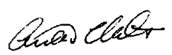
Andrew Mills
Acting Chair,
Board of Taxation
October 2025

Message from the Secretary and Tax Counsel

Paul Korganow
The 2024–25 reporting year has been a busy and productive year for the Board.
The Board and I met with a diverse range of external stakeholders. Consultation is at the forefront of everything we do at the Board. The Board adds value through the ongoing, two-way dialogue it maintains with stakeholders across industries, the professions, and the community.
From my perspective, the key highlights for this year include:
- Our formal stakeholder engagement sessions: We’ve hosted a series of -theme-based stakeholder events around the country. These sessions are a great way to connect with different parts of the business and wider community to hear about current issues and emerging trends.
Stakeholder groups the Board engaged with included Private Wealth, Academics, the Oil & Gas industry, Professional Associations, Digital Service Providers and the Superannuation Industry. A highlight of the event schedule was meeting with the Noongar Chamber of Commerce and Industry in Perth who raised awareness about the issues faced by indigenous business communities across Western Australia. What we hear from these stakeholder sessions informs the Board’s future work program and allows it to provide timely feedback to government as part of the Board’s role as a trusted advisor.
- Voluntary Tax Transparency Code: The Board commenced a review of the Voluntary Tax Transparency Code (VTTC). The VTTC was developed by the Board in 2016. At that time, the VTTC was the most comprehensive and advanced corporate tax transparency measure globally. However, the Australian and global tax transparency landscape has evolved significantly since 2016, and the Board realised that it needed to modernise the VTTC. The Board redesigned the VTTC (simplifying and streamlining to reduce duplication and compliance burden) and delivered the finalised product to the Treasurer in August 2025. The finalised VTTC is expected to be published in the 2025–26 reporting period.
- Communications and Transparency: The Board and I have also found new ways to promote the work of the Board. In August 2024, I was invited to appear on CPA Australia’s Podcast series where I shared with listeners the role of the Board and the importance of our work. The Board’s rebranded newsletter, ‘the Board Bulletin’, is also available on the Board’s website and shares the themes raised in our formal stakeholder engagements.
- Publication of the ‘Crypto Report’: The government published the Board’s review of the taxation of digital assets and transactions in Australia final report, on 21 March 2025. A significant amount of work went into preparing the final report after an extensive consultation process with domestic and international stakeholders. The final report, including the government’s response, is available on the Board’s website
Lastly, during the later months of the reporting year, we farewelled our former Chair Mrs Rosheen Garnon. Rosheen played a significant role in shaping the Board’s direction and development of the forward work program and I feel privileged to have been able to work alongside her. Following on from Rosheen’s departure, Dr Julianne Jaques KC was appointed as acting Chair from 1 April 2025. Dr Jaques was also a long-standing member of the Board who first was appointed in 2017. Dr Jaques’ term ended on 30 September 2025. The Secretariat and I wish both Rosheen and Julianne well in their future endeavours.
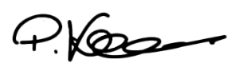
Paul Korganow
Secretary and Tax Counsel,
Board Secretariat
October 2025

The Board
The Board is a non-statutory advisory body charged with contributing a business and broader community perspective to improving the design of taxation laws and their operation.
The Treasurer appoints members of the Board from the business and wider community. Private sector members are appointed in their personal capacity.
Throughout the 2024–25 reporting year, the Board comprised between eight and nine members, including three ex officio members being the Secretary to the Treasury, the Commissioner of Taxation, and the First Parliamentary Counsel with the remaining members drawn from the private sector.
The Board is supported by a Secretariat which is a group primarily employed by the Treasury and supplemented with secondees from the ATO. The Secretary and Tax Counsel (S&TC) leads the Secretariat and works closely with the Chair and the Deputy Secretary of Revenue Group in Treasury.
The Charter, which sets out the Board’s mission, governs the operations and functions of the Board as set out below. The Charter is included at Appendix A: The Board’s Charter.

The Board’s mission and function
The Board provides an independent source of advice to the Australian Government, from a business and broader community perspective, on taxation matters. In doing so the Board provides advice to the Treasurer and Assistant Treasurer on:
- the quality and effectiveness of tax legislation and the processes for its development, including the processes of community consultation and other aspects of tax design;
- improvements to the general integrity and functioning of the taxation system;
- research and other studies commissioned by the Board on topics approved or referred by the Treasurer and/or the Assistant Treasurer; and
- other tax matters referred to the Board by the Treasurer and/or the Assistant Treasurer.
The Board’s activities during the 2024–25 reporting year are detailed in section: Activities of the Board in 2024–25.

Board members

Changes to Board memberships
As of 30 June 2025, the Board was comprised of eight Board members: five private sector and three
ex officio members.

Chair of the Board
Mrs Rosheen Garnon’s role as Chair and Board member ceased on 31 March 2025 following the Treasurer accepting her resignation from the Board.
Mrs Garnon’s resignation letter is available on the Board’s website and highlights her impressive career with the Board.
In response to Mrs Garnon’s resignation, the Treasurer appointed Dr Julianne Jaques KC as acting Chair from 1 April 2025 to 30 September 2025.

Board member appointments
During the 2024–25 reporting year, the following Board members were reappointed:
- Mr Ian Kellock was re-appointed for an additional term from 12 August 2024 to 11 August 2027.
- Ms Andrea Laing was re-appointed for an additional term from 21 January 2025 to 20 October 2027.

Ex officio membership changes
During the 2024–25 reporting period, Dr Steven Kennedy PSM was the Secretary to the Treasury from 1 July 2024 to 15 June 2025. Ms Jenny Wilkinson PSM was appointed as the 20th Secretary to the Treasury on 16 June 2025.
As a result of this appointment, Jenny also commenced as an ex officio member of the Board.

Board membership as of 30 June 2025

Private sector Board members
  Dr Julianne Jaques KC  Private sector Board member  Term start date: 1 July 2017 | Dr Julianne Jaques KC is a barrister at the Victorian Bar specialising in taxation with over 25 years experience as a taxation professional. She maintains chambers in both Melbourne and Sydney and has appeared in all higher Federal, Victorian and New South Wales courts.  Dr Jaques is a Chartered Accountant and a Chartered Tax Adviser, and in 2020 was awarded Chartered Tax Adviser of the Year by The Tax Institute. Prior to going to the Bar, Julianne worked as a solicitor, Chartered Accountant and ministerial tax adviser. She is a current member of the Independent Parliamentary Expenses Authority (reappointed 1 July 2022) and a former member of the Tax Practitioners Board (2016–2022).  Dr Jaques was appointed as a part time member of the Board from 1 July 2017. Dr Jaques was Acting Chair of the Board from 11 July 2019 to 10 January 2020, and from 1 April 2025 to 30 September 2025.

  Ian Kellock  Private sector Board member  Term start date: 12 May 2021 | Mr Kellock is a Tax Partner at Ashurst and has over 25 years experience as a taxation professional. Mr Kellock’s practice deals with all aspects of Australian income tax, with a focus on mergers and acquisitions transactions in the financial services, healthcare, property, and resources sectors.  Mr Kellock is a Chartered Accountant and a Chartered Tax Adviser. He holds a bachelor’s degree in law and commerce from the University of Melbourne and a master’s degree in law from Monash University.  Mr Kellock was appointed as a part time member of the Board from 12 May 2021 and was re-appointed for an additional term until 11 August 2027.

  Andrea Laing  Private sector Board member  Term start date: 21 October 2021 | Ms Laing has many years of experience in taxation, working in the ATO, Chartered Accounting and the extractive/energy industry. She spent more than two decades at Shell in various roles specialising in indirect tax, employment tax and tax policy. Ms Laing was Head of Tax for Shell Australia for five years and led a global project on the tax ramifications of Energy Transition and Climate Change.  Ms Laing was a member of the OECD task team that developed International VAT Guidelines published in 2014. She spent four years on the Corporate Tax Association Executive and is a member of Certified Practicing Accountants (CPA) Australia.  Ms Laing was appointed as a part time member of the Board from 21 October 2021 and was re-appointed for an additional term to 20 October 2027.  On 12 March 2025, Ms Laing was appointed as a part-time member of the National Library of Australia Council, for a 3-year term commencing on 4th April 2025.

Andrew Mills  Private sector Board member  Term start date: 8 December 2023 | Mr Mills has over 40 years experience in senior commercial, accounting and legal practice, government and academic roles.  He is currently Chair of the Financial Reporting Council, Chair of the NSW Independent Planning Commission and a Principal Fellow of the University of Melbourne Law School.  Mr Mills is also a member of the Tax and Transfer Policy Institute Advisory Committee and of the executive committee of the International Fiscal Association, Australia Branch.  Previously, Mr Mills served as Second Commissioner of Taxation at the Australian Taxation Office. He was also a Director--Partner at Greenwoods & Freehills for over 20 years.  Mr Mills has qualifications in business and law. He is a Fellow of CPA Australia, a Chartered Tax Adviser (Life), a Graduate Member of the Australian Institute of Company Directors, a Fellow of the Governance Institute of Australia and a member of the International Fiscal Association.  Mr Mills was appointed as a part-time Board member from 8 December 2023 and was appointed acting Chair of the Board from 1 October 2025.

  Judy O’Connell  Private sector Board member  Term start date: 8 December 2023 | Ms O’Connell has extensive domestic and global experience in tax administration, having worked at the ATO for 35 years.  She was appointed Assistant Commissioner from 2005 to 2016 and was a key executive driving the changes to improve the experience for small business owners when dealing with the ATO.  Ms O’Connell was the former Victorian Small Business Commissioner between 2016 and 2021.  She also worked at the Organisation for Economic Co-operation and Development (OECD) in Paris as Head of Unit at the Fiscal Affairs Division, where she led the development of an online international tax dialogue between tax administrations.  Ms O’Connell works as a short-term Tax Expert in the Fiscal Affairs Department of the IMF, providing technical assistance to tax administrations. She has a Bachelor of Economics from the University of Melbourne.  Ms O’Connell was appointed as a part-time Board member for a three-year period from 8 December 2023.  On 13 November 2024, Ms O’Connell was appointed the independent Lead reviewer for the Statutory Review of the Australian Small Business and Family Enterprise Ombudsman.

Ex officio members
  Rob  Heferen  Commissioner of Taxation, Ex officio Board member  Term start date: 1 March 2024 |   Jenny  Wilkinson PSM  Secretary to the Treasury, Ex officio Board member  Term start date:  16 June 2025 |   Meredith  Leigh  First Parliamentary Counsel, Ex officio Board member  Term start date: 11 October 2021

Stakeholder communication and engagement
The role of the Board is to be a trusted adviser to the government, and to bring a business and community perspective on the tax system. Our role is to operate as an independent advisory voice, providing an informed and practical lens to the formulation, administration and implementation of tax laws.
During the 2024–25 reporting year, the Board focused on improving our transparency and communications to stakeholders and the broader business community. We increased our digital presence through more regular social media posts on LinkedIn, updates to the Board’s website, and updated our newsletter (now titled ‘The Board’s Bulletin’).
At the beginning of the reporting year, the S&TC appeared on the CPA Australia’s podcast series where he explained the role of the Board, our key focus areas and work program. Other podcast appearances are planned.
The latest edition of The Board’s Bulletin and more information about the latest Podcast appearances are available on the Board’s website.
Throughout the reporting year, the Board maintained its new strategy for stakeholder engagement, meeting with numerous stakeholder groups at our regular Board meetings around the country. In addition, the Board held several out of session meetings with the CPA Australia, The Tax Institute and the Corporate Tax Association, to name a few. These engagements allowed the Board to connect with a diverse range of stakeholder groups to hear about current trends and issues impacting their industries, and in turn provide real-time advice to the government which helps inform our future work program.
The timeline below outlines the Board’s formal stakeholder engagements held during the 2024–25 reporting year.
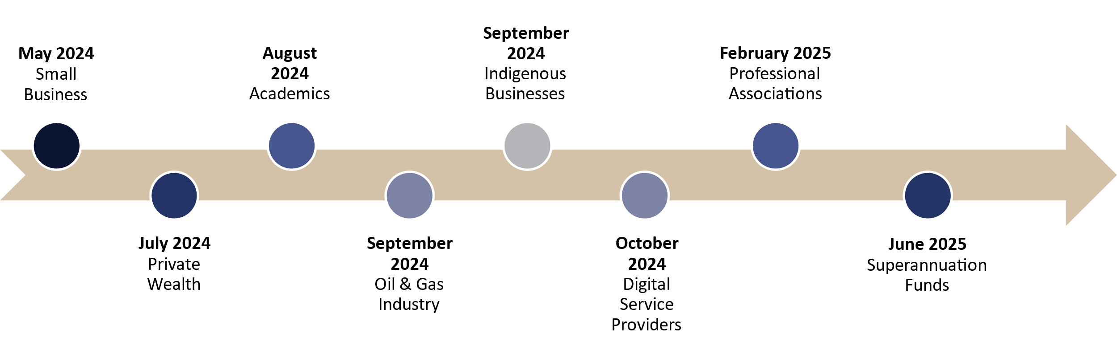
The Board would like to thank stakeholders who engaged with us over the course of the 2024–25 reporting year. We appreciate stakeholders taking the time to provide insights and share experiences with the Board, which makes a tangible difference in the quality of our discussions, recommendations and overall progress in shaping the future of tax reform in Australia.
A full list of Stakeholder events hosted by the Board is included at Appendix D: Board meetings and stakeholder events.

Review consultations
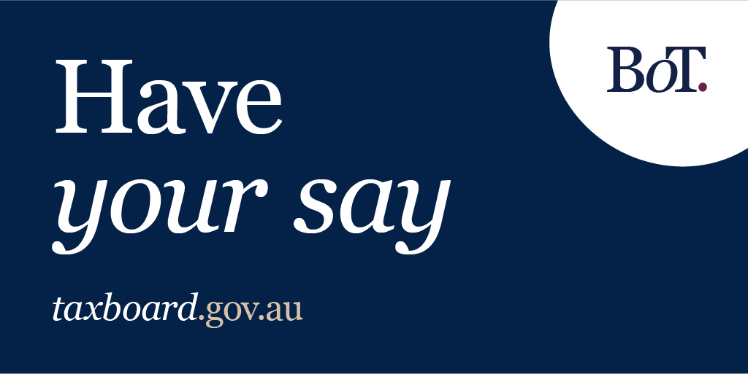
Image: a graphic for ‘Have your save’ relating to consultation for the Board of Taxation.
During a review the Board will canvass stakeholder views to inform its work. Upon commencement, the Board typically publishes a consultation paper seeking feedback from a broad cross section of stakeholders to help inform its views on the particular terms of reference. Consultation papers are published on the Board’s website and promoted through the Board’s social media platform on LinkedIn. The Board seeks feedback through written submissions as well as through roundtable meetings, which are open to all interested stakeholders.
In addition to the formal consultation process, for each review the Secretariat manages a functional mailbox, and interested parties are encouraged to engage with the Board throughout the course of the review. This information is promoted through the Board’s website and social media channels.
To support the Board in addressing the terms of reference for a review, the Board utilises a working group model. Subject matter experts are generally identified by the Board through the consultation process and invited to become part of the working group for the duration of the review project.

Engagement with the Australian Government, Treasury and the ATO
The Board has continued to embrace its role as a trusted adviser to government, Treasury, and the ATO by providing advice throughout the 2024–25 reporting year.
Throughout the reporting year, the Chair met with the Treasurer, the Hon Dr Jim Chalmers MP and the former Assistant Treasurer, the Hon Stephen Jones MP to discuss the Board’s work program and provide advice on the tax issues that are important to the business and wider community. Additionally, during the reporting year, the Chair had a number of meetings with the Commissioner of Taxation, along with other senior ATO and Treasury representatives.

Sounding Board +
The Board invites contributions from stakeholders through Sounding Board +, a web–based collaborative platform where stakeholders from the broader community can submit ideas to improve the Australian taxation system. At each of the regular Board meetings, the Board looks at all new ideas submitted to Sounding Board +. Where suitable, the Board will advocate a pathway for their implementation via legislative or administrative means.
Sounding Board + is not a forum for substantive tax policy proposals (e.g. altering tax rates, changing the tax mix or removing certain types of taxes altogether) or ideas that would require significant changes to the tax system. However, inevitably some ideas of this nature are advanced by the community and accordingly we have included a category for these policy ideas – which remain matters for government.
To make it easier to review the ideas that have been contributed by the community and to better manage community expectations, the Board collects ideas on Sounding Board + under one of five categories.
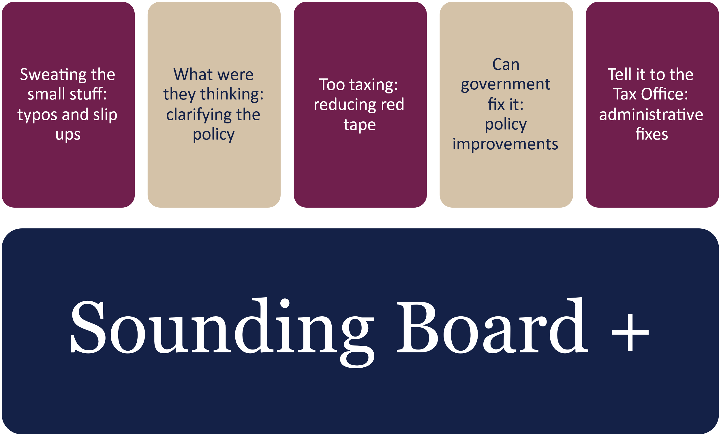
While the Board continued to promote the platform through social media and at stakeholder meetings and speaking engagements during the reporting year, the Board is in the process of evaluating the suitability of the Sounding Board + to collect stakeholder feedback and ideas from the broader tax community.
Ideas for taxation system improvement can be submitted via Sounding Board + on the Board’s website.

Activities of the Board in 2024–25

Announced publication of review/project reports

Review of the Tax Treatment of Digital Assets and Transactions in Australia
On 21 March 2022, the former government released the Terms of Reference for a review of the taxation treatment of digital assets (crypto assets) and transactions in Australia, which were confirmed by the current government in August 2022.
The purpose of the review was to consider the appropriate framework for the taxation of digital assets and transactions. The review analysed the characteristics of digital assets and transactions in the market, their Australia’s tax treatment, investor awareness of that treatment, the international experience in the taxation of these assets and whether any changes to Australian taxation laws and/or their administration were required.
The Board held consultations throughout September 2022 attended by representatives from:
- the tax profession
- academia
- crypto exchanges and platforms
- software providers
- retail and wholesale investors.
Following the initial public consultation process, the Board undertook extensive consultation in Australia and with international revenue authorities.
The Board delivered its 289-page final report to government on 23 February 2024.
On 21 March 2025, the government announced the publication of the final report.
The Board reached four broad conclusions:
- The taxation of crypto assets and transactions can generally be accommodated by Australia’s current taxation law.
- New legislation to deal with the taxation of crypto asset transactions should not be introduced at this time.
- At the present time, any uncertainties about how the taxation law applies to crypto assets and transactions are best managed administratively by taxpayers and the ATO working cooperatively within the current law.
- In some areas, taxpayers require more comprehensive information and guidance (including examples and case studies) from the ATO upon which they can rely to ensure that their tax disclosures will be acceptable to the ATO.
  - In response, the ATO has agreed to form a bespoke and time limited crypto working group which will consult with industry and tax professionals to develop a package of publicly available crypto tax advice.
These four conclusions are supported by 29 recommendations and 20 observations.
The government’s response addresses the recommendations directed at the government. The remainder of the recommendations are directed to the Australian Taxation Office (ATO) as the administrator of Australia’s taxation laws.
The government full response is available on the Treasury’s website.

New formal reviews/projects

Redesign of the Voluntary Tax Transparency Code
The Board, at the government’s request, developed the Voluntary Tax Transparency Code (VTTC), in 2016. More background about the VTTC and its operation are detailed on the Board’s website and in the section below about the Board’s ongoing work.
In August 2024, the Treasurer tasked the Board with reviewing the Voluntary Tax Transparency Code (VTTC). The review includes how to supplement policy developments in global tax transparency and encourage best practice tax transparency reporting for business.
The Board set up a working group to undertake the review and appointed Board members Andrew Mills and Andrea Laing to oversee this work.
Phase one of the review involved the Board hosting targeted consultation from August to October 2024, to engage with a range of stakeholders including:
- large business
- professional and industry bodies
- investor and finance groups
- advisors
- academics
- civil society groups
- government bodies.
The Board heard from stakeholders that the VTTC continues to play an important role in encouraging greater tax transparency and promoting community confidence in the tax system.
The Board concluded that the VTTC should be simplified and updated to minimise duplication with other tax transparency regimes. This helps align with policy developments.
In January 2025, the Board commenced phase two of the review to redesign the VTTC. In June 2025, the Board published the draft redesigned VTTC for public consultation. A consultation guide was published on the Board’s website which posed a number of questions for stakeholders to consider.
Submissions to the redesign of the VTTC closed on 11 July 2025.
The findings from the review were presented to the government in the next reporting period.
The Board thanks all stakeholders who were involved in the consultation processes for the initial review and redesign phases.

Other ongoing work

Trusted advisor to Treasury and the ATO
The Board has continued to embrace its role as a trusted advisor to government, the Treasury, and the ATO by providing regular ad hoc advice throughout the year.
During the 2024–25 year the Board was pleased to support Treasury and the ATO by providing consultation and feedback in relation to a number of tax and administrative measures and guidance products.

Voluntary Tax Transparency Code and Register
The VTTC is a Board developed set of principles and minimum standards to guide disclosure of tax information by businesses. The VTTC encourages taxpayers to publicly disclose information regarding their tax affairs to promote community confidence that they are paying their fair share of tax and not engaging in aggressive tax avoidance behaviours. The Board is responsible for maintaining the register of signatories to the VTTC.
There were 225 signatories to the VTTC as of 30 June 2025, an increase of 6 from the 219 reported in the Board’s 2023–24 Annual Report. Of these 225 signatories, 223 signatories had notified of at least one published report as of 30 June 2025.
As reported in the ATO’s Voluntary Tax Transparency statistics for 30 June 2025, the 225 signatories are represented as follows:
Signatories by size of signatory:
Size of signatory | Number | Percentage
Large | 185 | 83%
Medium | 30 | 13%
Small | 8 | 4%
Signatories by origin of ultimate holding company:
Origin of ultimate holding company | Number | Percentage
Australia | 171 | 76%
Foreign | 45 | 20%
Australia & Foreign dual listed | 7 | 3%
Undisclosed | 2 | 1%

The year ahead – 2025‍–‍26 reporting year
The 2025–26 reporting year presents an important opportunity for growth and connection for the Board. We will focus on strengthening our engagement with stakeholders, ensuring their perspectives continue to shape the advice we provide government and guide our priorities.
The redesigned VTTC to is expected to be announced by the government during the 2025–26 reporting year and will provide a clear foundation for corporates wishing to provide a comprehensive explanation of their tax affairs, build public trust via good governance and strengthen investor confidence.
The Board is committed to monitoring international and domestic tax transparency, and to revisiting the VTTC in the future to ensure its continued relevance.
In September 2025, the government announced that the Board will undertake a red tape reduction review to help ease the compliance burden on businesses and make our economy more productive.
As part of the review, the Board has been requested to engage with the business community to identify areas of business tax law and administration where there are opportunities for red tape reduction that are substantial, material, measurable and directly support productivity.
The Board will consult with a wide range of stakeholders to help the Board understand where the impacts of compliance and regulation on business taxpayers could possibly be reduced through changes in business tax law and administration.
More information on the review is available on the Board’s website.
The red tape reduction review along with the redesigned VTTC mark an exciting chapter for the Board as we build stronger relationships, reinforce trust and continue to deliver real time advice to the government.

Appendix A: The Board’s Charter

The Charter

Mission
Recognising the government’s responsibility for determining taxation policy and the statutory roles of the Commissioner of Taxation and the Inspector General of Taxation, the Board’s mission is to contribute a business and broader community perspective to improving the design of taxation laws and their operation.

Membership
Members of the Board will be appointed by the Treasurer, for a term of up to three years, in their personal capacity. It is expected that members will be appointed from within the business and wider community having regard to their ability to contribute at the highest level to the development of the taxation system. The Chair will be appointed by the Treasurer from among these members of the Board. If the Treasurer decides to appoint a Deputy Chair, he or she will also be appointed from among these members of the Board. Members may be re-appointed.
In addition, the Secretary to the Department of the Treasury, the Commissioner of Taxation and the
First Parliamentary Counsel will also be members of the Board. Each may be represented by a delegate.

Function
The Board will provide advice to the Treasurer on:
- the quality and effectiveness of taxation legislation and the processes for its development, including the processes of community consultation and other aspects of taxation design
- improvements to the general integrity and functioning of the taxation system
- research and other studies commissioned by the Board on topics approved or referred by the Treasurer
- other taxation matters referred to the Board by the Treasurer.

Relationship to other boards and bodies
From time to time the government or the Treasurer may establish other boards or bodies with set terms of reference to advise on aspects of the taxation law. The Treasurer will advise the Board on a case-by-case basis of its responsibilities, if any, in respect of issues covered by other boards and bodies.

Report
The Chair of the Board will report to the Treasurer, at least annually, on the operation of the Board during the year.

Secretariat
The Board will be supported by a Secretariat provided by the Treasury who may engage secondees from the private sector or other government agencies to fill certain roles.

Other
Members will meet regularly during the year as determined by the Board’s work program and priorities.
Non-government members will receive remuneration and allowances to cover travelling and other expenses, at rates in accordance with Remuneration Tribunal determinations for part time public offices.
The government will determine an annual budget allocation for the Board.

Appendix B: Membership of the Board

Terms of Board members
The terms of members of the Board during the 2024–25 year are set out in the following table.
Table 1: Terms of Board members
Member | Initial term commenced | Term expires/ceased
Rosheen Garnon, Chair^{(a)} | 26 March 2020 | 31 March 2025
Dr Julianne Jaques KC^{(b)} | 1 July 2017 | 30 September 2025
Ian Kellock^{(c)} | 12 May 2021 | 11 August 2027
Andrea Laing^{(d)} | 21 October 2021 | 20 October 2027
Andrew Mills | 8 December 2023 | 7 December 2026
Judy O’Connell | 8 December 2023 | 7 December 2026
Rob Heferen | 1 March 2024 | Ex officio
Dr Steven Kennedy PSM^{(e)} | 2 September 2019 | Ex officio – 16 June 2025
Jenny Wilkinson PSM^{(f)} | 16 June 2025 | Ex officio
Meredith Leigh | 11 October 2021 | Ex officio
- Mrs Rosheen Garnon term as Chair and Board member ceased on 31 March 2025 following the Treasurer accepting her resignation.
- Dr Julianne Jaques KC was appointed as acting Chair from 1 April 2025 to 30 September 2025.
- Ian Kellock was re-appointed for an additional term to 11 August 2027.
- Andrea Laing was re-appointed for an additional term to 20 October 2027.
- Dr Steven Kennedy PSM occupied the role of Secretary to the Treasury from 2 September 2019 until 16 June 2025.
- Jenny Wilkson PSM was appointed as the 20th Secretary to the Treasury on 16 June 2025 and as a result also became an ex officio member of the Board.

Appendix C: Attendance at Board meetings
Table 2: Attendance at Board meetings, 2024–25
Member | Number of meetings eligible to attend | Number of meetings attended
Rosheen Garnon, Chair^{(a)} | 5 | 4
Dr Julianne Jaques KC | 7 | 7
Ian Kellock | 7 | 7
Andrea Laing | 7 | 6
Andrew Mills | 7 | 7
Judy O’Connell | 7 | 6
Rob Heferen^{(#)} | 7 | 7 – including via delegate
Dr Steven Kennedy PSM^{(#)} | 7 | 7 – including via delegate
Jenny Wilkinson PSM^{(b)(#)} | 0 | 0
Meredith Leigh^{(#)} | 7 | 7 – including via delegate
- Rosheen Garnon’s role as Chair and Board member ceased on 31 March 2025, following the Treasurer’s acceptance of her resignation
- Jenny Wilkinson commenced as Secretary to the Treasury on 16 June 2025.
(#) The Board’s Charter allows for ex officio members of the Board to be represented by a delegate at Board meetings.

Appendix D: Board Meetings and Stakeholder Events
The Board met seven times in the 2024–25 reporting year in locations throughout Australia.
Mostly, the Board hosted Stakeholder events in conjunction with these Board meetings, aside from two occasions in August and September.
Table 3: Board meetings and stakeholder events, 2024–25
Date | Location | Board Meeting | Stakeholder event
26 July 2024 | ATO  Franklin Street, Adelaide, SA | Yes | Private Wealth
14 August 2024 | Treasury,  Kent Street, Sydney, NSW | No | Academics
5 September 2024 | Host venue: Stakeholder event  5 September 2025  Noongar Chamber of Commerce and Industry (NCCI)  St Georges Terrace, Perth, WA | No | Indigenous Businesses
6 September 2024 | Host venue: Board meeting  6 September 2025  Chartered Accountant Australia and  New Zealand (CA ANZ)  Mill Street, Perth, WA | Yes | Oil & Gas Industry
25 October 2024 | ATO  Elizabeth Street, Brisbane QLD | Yes | Digital Service Providers
6 December 2024 | Treasury  Collins Street, Melbourne, VIC | Yes | No stakeholder event held
7 February 2025 | Treasury  Collins Street, Melbourne, VIC | Yes | Professional Associations
1-2 May 2025 | Treasury  Langton Crescent, Parkes, ACT | Yes | No stakeholder event held
13 June 2025 | Treasury  Collins Street, Melbourne, VIC | Yes | Superannuation Funds

Appendix E: Financial Statements
Table 4: Revenue, expenses, and operating result
 | 2023–24  $ | 2024–25  $
Revenue
Revenue – Department of the Treasury budget allocation | 1,270,678 | 1,530,864
Revenue – Other | 192,525 | 148,370
Total revenue | 1,463,203 | 1,679,233
Expenses
Employee expenses
Wages | 504,166 | 575,332
Superannuation | 144,074 | 153,161
Other employee expenses | 507,667 | 493,067
Total employee expenses | 1,155,907 | 1,221,559
Other expenses
Travel^{(a)} | 60,962 | 112,811
Conferences and training | 3,550 | 3,942
Seconded Employees^{(b)} | 228,470 | 340,448
Office supplies | 432 | -
Other supplier expenses | 13,881 | 473
Total operating expenses | 307,296 | 457,674
Total expenses | 1,463,203 | 1,679,233
Operating surplus | - | -
Notes the Financial Statements
- During the 2024–25 reporting year, the Board held seven Board meetings, all in-person. These meetings were hosted in Adelaide, Perth, Canberra, and Melbourne (Table 3 refers). This resulted in an increase of travel costs in comparison to the 2023–24 reporting year where the Board held two virtual meetings and five in-person meetings. These five meetings were hosted in Canberra, Sydney and Melbourne.
- The increase in seconded employees expenses in the 2024-25 reporting year relates to an increase in secondee employees to the Secretariat in comparison to the 2023-24 year where seconded employees’ contracts ended during the prior period.

Table 5: Remuneration paid to non-government Board members
Board members 2024–25 | $
Total* | 467,781
*Total remuneration paid to non-government Board members, 2024–25 includes allowances and superannuation guarantee.

Contact details
Inquiries regarding this report may be directed to:
Board Of Taxation Secretariat
C/O – The Treasury
Langton Crescent
Parkes ACT 2600
Email: taxboard@taxboard.gov.au

Glossary of terms
The following abbreviations and acronyms are used throughout this report.
Abbreviation | Definition
Ashurst | Ashurst Australia
ATO | Australian Taxation Office
The Board | The Board of Taxation
CA ANZ | Chartered Accountants Australia and New Zealand
CPA | Certified Practicing Accountant
CTA | Corporate Tax Association
DAO | Decentralised Autonomous Organisations
DeFi | Decentralised Finance
GameFi | Gaming Finance
GST | Goods and Services Tax
Hon | Honourable
IMF | International Monetary Fund
KC | King’s Counsel
LBSG | Large Business Stewardship Group
MP | Member of Parliament
NCCI | Noongar Chamber of Commerce and Industry
NFTs | Non-Fungible Tokens
OECD | Organisation for Economic Co-operation and Development
OPC | Office of Parliamentary Counsel
PSM | Public Service Medal
S&TC | Secretary and Tax Counsel
VTTC | Voluntary Tax Transparency Code

The Board had nine members during the period from 1 July 2024 to 31 March 2025 when Mrs Rosheen Garnon resigned from as Chair and Board member. From 1 April 2025 to 30 June 2025, there were eight Board members.
The Hon Stephen Jones was the Assistant Treasurer from 1 June 2022 to 13 May 2025.
Sounding Board + website: https://taxboard.gov.au/sounding-board-plus
‘Voluntary Tax Transparency Code‘, Australian Government data.gov.au (Web Page, online 30 June 2025).

