The Board’s Bulletin

September 2025

Work of the Board

Finalisation of the redesigned Voluntary Tax Transparency Code
In August 2024, at the request of the Treasurer, the Board commenced reviewing the Voluntary Tax Transparency Code (VTTC) in light of changes in the global and domestic tax transparency landscape.
The Board has since redesigned the VTTC to update, simplify and reduce reporting duplication. The most notable changes include:
Updated objectives, design and format | 
Separation of reporting requirements based on whether a business reports under the public country-by-country reporting regime and removal of duplication | 
Alignment with global reporting standards, such as the GRI 207: Tax | 
The inclusion of additional optional elements for entities who wish to provide more comprehensive disclosures | 
Additional guidance such as an example template format for VTTC reporting based on fictitious businesses and a self-assessment reporting checklist | 
The Board has recently concluded public consultation on the draft redesigned VTTC.
Feedback was collected via virtual consultation sessions with targeted stakeholders, written feedback, and a short survey to understand the percentage of current VTTC participants that intend to continue producing reports under the redesigned VTTC. The Board thanks all stakeholders who were involved in the consultation.
In August, the Board finalised the redesigned VTTC for delivery to the Treasurer. The Board has worked hard to listen to all stakeholders, to eliminate duplication, and balance various competing views and interests.
The Board will publish the finalised VTTC later this year.

Stakeholder Engagement– Superannuation industry
On 13 June 2025, the Board met with representatives from the superannuation industry to discuss the international competitiveness of Australian superannuation funds.
The size of Australia’s superannuation industry has grown significantly since the introduction of Australia’s superannuation framework. Australian funds hold approximately $4 trillion in assets, with an increasing number of investments made offshore to ensure diversification. To put this in context, the total market capitalisation of all companies listed on the Australian Stock Exchange is around $3 trillion.

There was discussion around the fact that Australia’s taxation treatment of superannuation (TTE – taxable contributions and earnings, but exempt withdrawals) is relatively unique compared to other OECD countries (predominantly EET – exempt contributions and earnings, but taxable withdrawals). Below are some key themes which were raised by the stakeholder group:
- The current Australian superannuation taxation framework is largely unchanged since its inception, was designed for corporate taxpayers, and pre-dates current levels of global investment, creating disparate outcomes and level playing field issues.
- Superannuation funds (funds) don’t get access to non-assessable non-exempt (NANE) income treatment in the same way that corporates do and are encouraged to adopt flow through structures, to access Foreign Investment Tax Offsets (FITO) in order to mitigate double taxation risks. However, the FITO calculation and cap can cause inadvertent outcomes and uncertainty for funds and their members.
- Unlike corporates, funds have limited access to reorganisation relief under the current tax rules. Consequently, many funds are left with complicated and duplicative structures, such as a web of legacy trusts. This is contrary to expectations for funds to rationalise wherever possible to minimise costs for members.
- There are unnecessary complexities and compliance burdens associated with various legislative provisions, including but not limited to the foreign hybrid rules in Division 830.

Stakeholder Engagement – GST
On 25 July 2025, the Board met with GST professionals to discuss ways in which GST administration and compliance can be simplified, with a focus on digitalisation, characterisation of financial supplies and GST grouping.
The following key themes were raised by the group:
- There was a shared sentiment amongst stakeholders that the current system was designed for a different era (utilising paper-based concepts) and needs substantial coordinated whole of government consideration and redesign to future-proof.
- Real-time, digitally integrated GST administration can help reduce compliance costs, close the tax gap, improve productivity and support economic growth.
- An increase in the current GST registration threshold would remove many small businesses from the system and thereby might reduce compliance burden and integrity risks.
- The GST grouping rules are overly restrictive and outdated, thereby causing undue compliance burden for no system gain.
These sessions are a great way to connect with different parts of the business and wider community to hear about current issues and emerging trends. We are grateful for stakeholder interest and the level of deep engagement in our sessions.
What we hear from you informs our future work program and allows us to provide timely feedback to Government as part of our role as a trusted advisor.

The Board Out and About

University Study Tours
In June, Board member Mr Andrew Mills was busy presenting on the role of the Board, its unique positioning in the Australian tax landscape, and the Board’s current work program as part of two separate university study tours:
- A UNSW led study tour for a small group from the Mongolia Ministry of Finance; and
- A Curtin University Tax Study Tour, supported by Secretariat members Ms Stephanie Tran and Ms Ainslie Batterham (pictured below).
There was excellent engagement and discussion in both sessions, and a keen interest in the Board’s work program, and the business and community perspective the Board brings to influencing tax law design, administration and implementation. Andrew generously shared reflections on his own careeer, and opportunities available for students seeking a career in tax.
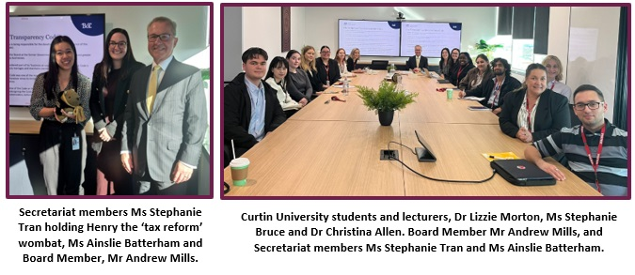

CPA Tax Forum
The Board’s Secretary and Tax Counsel, Mr Paul Korganow, recently presented a keynote address at the CPA Tax Forum 2025 on 13 August. Paul presented alongside Mr Rob Heferen, the Commissioner of Taxation and Ms Ruth Owen, Taxation Ombudsman to members of the tax profession on shaping the future, providing the audience with key insights on tax policy and administration.
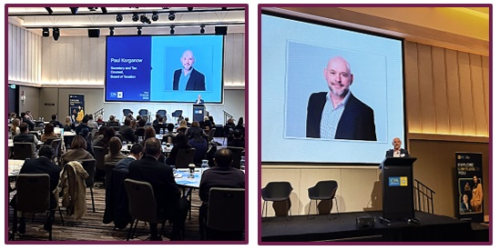
Paul shared an inside look at the Board, including where the Board sits in the tax ecosystem, its work, the importance of business and wider community consultation and how the Board shapes a more effective tax system. The ATO’s Second Commissioner, Jeremy Hirschorn, often describes the ATO as the ‘bricklayer’ and not the ‘architect’ when asked about policy matters. Expanding this analogy, Paul described the Board as the ‘Project Manager and Building Inspector’ depending on the context and the Board’s supporting role in designing new tax laws and evaluating current law that is not up to specification or that requires renovation.
Paul shared the importance of the Board’s positioning as the bridge between Government and business and the broader community and highlighted themes the Board has heard from stakeholders recently, including:
- the compliance burden and tax complexity,
- digitalisation and leveraging technology; and
- public demand for transparency.
Held a week before the Treasurer’s Economic Reform Roundtable, Paul outlined how the Board has traditionally added value in tax reform processes by consulting with business and community and delivering real-time feedback to Government to ensure the delivery practical and workable tax policy and legislation.
The Board awaits with interest the outcomes from the roundtable and continuing its work to contribute to Australia’s tax system into the future.
Paul Korganow  Secretary and Tax Counsel – Board of Taxation Secretariat | Website  LinkedIn  Subscribe

