Chief Executive Newsletter
December 2023
Dear Stakeholders,
I have had the pleasure of acting in the role of Chief Executive, leading the Board’s Secretariat team since February 2023. This year has been another productive year with the Secretariat supporting the Board in bringing together the views of the business and wider taxation community to deliver independent advice to the Government.
The Board held its meetings for the first half of 2023 on 10 February in Sydney, 31 March in Brisbane and 19 May in Adelaide. The Board would like to thank Chartered Accountants Australia and New Zealand, BDO and Deloitte for their generous hospitality in hosting the meetings and stakeholder lunches. It was great to connect with stakeholders and hear about tax issues that are important to them.
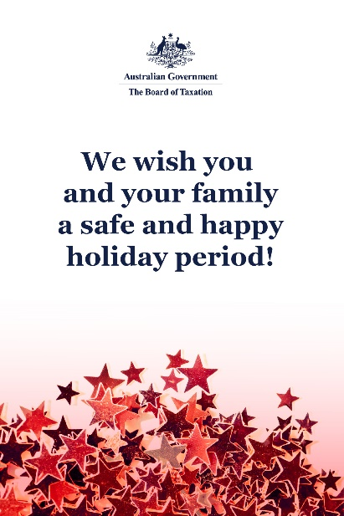
For the second half of the year, the Board held a virtual meeting on 21 July, and met with Senior Executives from Treasury and the ATO on 9 September. For the final two meetings of the year, the Board piloted a new theme-based approach and welcomed stakeholders from the Financial Services Industry to the Sydney Treasury offices on 27 October. On 8 December, the Board met with members of the Victorian Tax Bar Association and separately heard from the ACNC, Treasury and the ATO on matters impacting the Charities and Not-for-Profit industry. We thank the Victorian Bar Association for their generosity in providing the venue for the December Board meeting.
I would like to take the opportunity to thank all our stakeholders who have taken the time to engage with the Board over the past twelve months and for their continued support and contributions towards our reviews and consultation processes.

I am looking forward to continuing to engage with all our stakeholders in the new year and would love to hear from you. Please feel free to reach out if you have any input, feedback or comments in relation to the Board’s work.

Board memberships
On 15 December, the Board welcomed two new Board members, Judy O’Connell and Andrew Mills for a three-year term to the Board.
The Board was also pleased with the further extension of terms for Rosheen Garnon as Chair until March 2026 and Dr Julianne Jaques until September 2025.
With the addition of the new Board members, the Board is looking forward to expanding its future work program in the New Year.

Update on current work program

Review of the Tax Treatment of Digital Assets and Transactions
The Board has continued to progress the Tax Treatment of Digital Assets and Transactions Review. The purpose of this review is to consider the policy framework for taxation of digital assets and if any changes are required to taxation laws and/or their administration.
Throughout the consultation period, the Board met with approximately 45 interested stakeholder groups including tax advisers, crypto exchanges and platforms, software developers, investors and industry organisations and received over 40 written submissions to the review. Feedback provided through consultation meetings and written submissions has provided the Board with a broad range of views in relation to the taxation issues impacting the digital assets industry.
The Board has continued engagement with regulatory bodies including the ATO, international revenue authorities and treasury agencies over the past months. The Board also leads a Working Group comprising academics, tax advisors, industry participants, together with Treasury and ATO representatives, which meets regularly to explore issues raised by the review. Additionally, the Treasurer confirmed an extension of the report date to 29 February 2024.
The Board has also been engaged with complementary pieces of work being undertaken in relation to digital assets, including with Treasury on the Token Mapping project and appearing at a Senate Inquiry in February in relation to the proposed legislative amendment to clarify that crypto is not taxed as foreign currency.
Once again, the Board appreciates the level of engagement that has been received by the tax and crypto asset community to date. If you would like further information in relation to the review, please contact the Board of Taxation Secretariat at TaxDigitalAssets@taxboard.gov.au.

2024 Board Meeting Dates
The Board is looking forward to continuing our in-person meetings and stakeholder engagements in 2024. Tentative dates and planned locations for the meetings for the 2024 calendar year are as follows:
- 9 February Sydney
- 22 March Melbourne
- 24 May Canberra
- 26 July Perth
- 6 September Brisbane
- 25 October Adelaide
- 6 December Sydney

Sounding Board+
Do you have an idea to improve the tax system? The Board would love to hear it. The Board’s streamlined Sounding Board+ makes it easier than ever to contribute, without needing to go through a registration and log-on process.
At each of its Board Meetings, the Board considers all new additions to Sounding Board+. Although it is not always possible to respond on Sounding Board+ with the steps the Board is taking in relation to every suggestion, all ideas are actively considered in relation to the Board’s current and future work.
To contribute your own suggestions and to view previously submitted ideas please visit: https://taxboard.gov.au/sounding-board-plus
We encourage you to join the conversation and would really value your input.

Tax Transparency Code
The Tax Transparency Code plays an important role to help educate the public in relation to business compliance with Australia’s tax laws. The Tax Transparency Code provides a framework for large and medium businesses to follow when developing their disclosures. The flexible nature of the code allows organisations to highlight contributions, by way of taxes, to the Australian community.
As of 1 December 2023, there were approximately 217 signatories to the Transparency Code and of these, around 209 have published at least one report. A full list of signatories and more information about the Tax Transparency Code can be found on the Board’s website. Links to published reports can be found here.
For organisations wishing to sign up to the Tax Transparency Code, you can email taxboard@treasury.gov.au stating the name of your organisation and the financial year you intend to first publish a tax transparency report. Your organisation will be recorded on our register of signatories as having committed to applying the principles and details of the Code.
The ATO is responsible for the centralised hosting of published reports for businesses who have adopted the Tax Transparency Code. If you have published a report (or changed where you house your historic reports on your company’s website) – please remember to notify the ATO by emailing ttc@ato.gov.au.

Keep up to date with the latest news
You can keep up to date with the latest from the Board via our website or follow us on LinkedIn.
Also, if you wish to receive email notifications about Board updates, you can subscribe on our website.

Contact us
If you have any questions relating to the Board’s work, please feel free to contact the Board of Taxation Secretariat on taxboard@taxboard.gov.au or call 02 6263 4366.
As always, we value your feedback, so please stay in touch.
Kind regards
Michelle Calder
Acting Chief Executive – Board Secretariat

