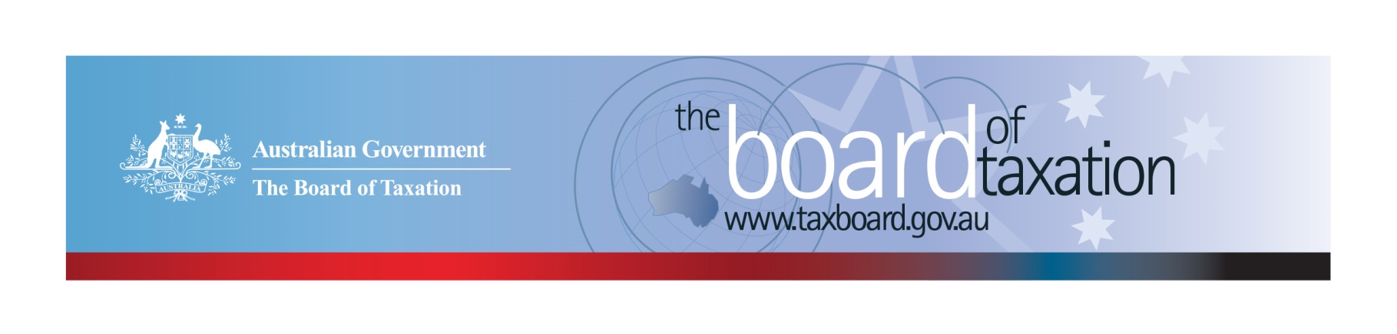
CEO Update – December 2022
Dear Stakeholders,
As I reflect on the last 12 months, I am pleased to share that we have had another successful year and are set for another busy start to the new year. As Australia welcomed a new Federal Government and continued to deal with the effects of the COVID-19 pandemic, the Board continued to deliver on a comprehensive work program.
During the year, the former Government publicly released the Board’s Reports on the post implementation review of Goods and Services Tax on low value imported goods and the review of the dual-agency administration model of the Research and Development Tax Incentive. It was fantastic to see that a number of the recommendations outlined in these reviews have already been implemented by the Government. The Board also finalised the Report on the Review of Capital Gains Tax (CGT) Roll-overs, which was delivered to the Government during the year.
Early in the year, the Board commenced the review of the Taxation of Digital Assets and Transactions in Australia (Digital Assets Review). The Terms of Reference for the review have since been supported by the Government, noting that the review is in line with their commitment to improve transparency in our tax system.
The Board will hold its final Board meeting for the year on 20 December in Melbourne. The focus of the meeting will be for the Board to receive an update on the Digital Assets Review and to ensure that all administrative matters for the 2022 calendar year have been closed out.
On behalf of the Board, I would like to thank all of our stakeholders for your continued support and valuable contributions during the 2022 year. Delivering on our work program would not be possible without the active support and engagement from our stakeholders. The contributions from our stakeholders really do make a difference!
Wishing you all a safe and wonderful holiday season and new year. We look forward to working with you again in 2023.
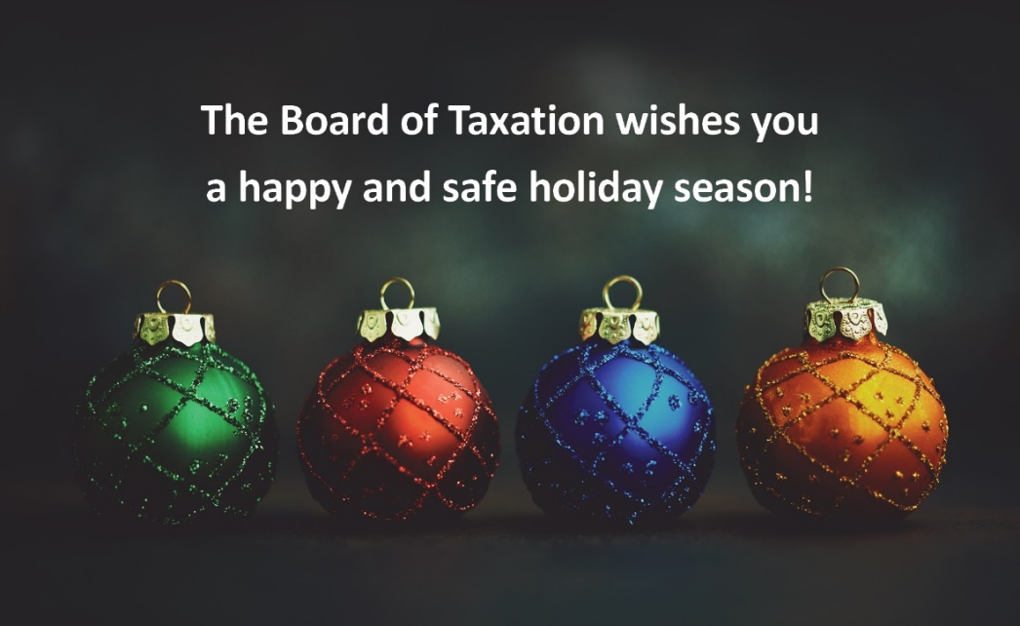

Update on current work program
Review of CGT Roll-overs
The Board has now finalised its review of CGT Roll-overs and submitted the final report to the Government on 11 November 2022. The public release of the final report is now a matter for the Government.
Review of the Tax Treatment of Digital Assets and Transactions
The Board has continued to progress the Digital Assets Review. As mentioned in my previous update, the purpose of this review is to consider the policy framework for taxation of digital assets and if any changes are required to taxation laws and/or their administration. The review will analyse the characteristics of digital assets and transactions in the market, Australia’s taxation treatment of them, investor awareness of that treatment and look at the international experience in the taxation of these assets.
The Board has met with around 45 interested stakeholder groups to date including tax advisers, crypto exchanges and platforms, software developers, investors and industry organisations and received over 40 written submissions to the review. Feedback provided through consultation meetings and written submissions have provided the Board with a broad range of views in relation to the taxation issues impacting the digital assets industry..
The Board has continued to engage with regulatory bodies throughout November and December 2022, including the ATO, international revenue authorities and treasury agencies.
Once again, the Board appreciates the level of engagement that has been received by the tax community to date and looks forward to engaging with interested parties throughout the remainder of the review.
If you would like further information in relation to the review, please contact the Board of Taxation Secretariat at TaxDigitalAssets@taxboard.gov.au.
2023 Board Meeting Dates

The Board is looking forward to continue our in-person meetings and stakeholder engagements in 2023. The dates and planned locations for the meetings in the 2023 calendar year are as follows:
- 10 February - Sydney
- 31 March - Brisbane
- 19 May - Canberra
- 21 July - Adelaide
- 8 September - Melbourne
- 27 October - Perth
- 8 December - Sydney

Sounding Board+
Do you have an idea to improve the tax system? The Board would love to hear them. The Board’s streamlined Sounding Board+ makes it easier than ever to contribute, without needing to go through a registration and log-on process.
At each of its Board Meetings, the Board considers all new additions to Sounding Board+. Although it is not always possible to respond on Sounding Board+ with the steps the Board is taking in relation to every suggestion, all ideas are actively considered in relation to the Board’s current and future work.
To contribute your own suggestions and to view previously submitted ideas please visit: https://taxboard.gov.au/sounding-board-plus
We encourage you to join the conversation and would really value your input.

Tax Transparency Code
The Tax Transparency Code plays an important role to help educate the public in relation to business compliance with Australia’s tax laws. The Tax Transparency Code provides a framework for large and medium businesses to follow when developing their disclosures. The flexible nature of the code allows organisations to highlight contributions, by way of taxes, to the Australian community.
As of 30 November 2022, there were approximately 206 signatories to the Transparency Code and of these, around 202 have published at least one report. A full list of signatories and more information about the Tax Transparency Code can be found on the Board’s website. Links to published reports can be found here.
For organisations wishing to sign up to the Tax Transparency Code, you can email taxboard@treasury.gov.au stating the name of your organisation and the financial year you intend to first publish a tax transparency report. Your organisation will be recorded on our register of signatories as having committed to applying the principles and details of the Code.
The ATO is responsible for the centralised hosting of published reports for businesses who have adopted the Tax Transparency Code. If you have published a report (or changed where you house your historic reports on your company’s website) – please remember to notify the ATO by emailing ttc@ato.gov.au.

Keep up to date with the latest news
You can keep up to date with the latest from the Board via our website or follow us on LinkedIn| Twitter.
Also, if you wish to receive email notifications about Board updates, you can subscribe here.

Contact us
If you have any questions relating to the Board’s work, please feel free to contact the Board of Taxation Secretariat on taxboard@treasury.gov.au or call 02 6263 4366.
You are also more than welcome to contact me directly on the details below. As always, we value your feedback, so please stay in touch.
Kind regards
Christina Sahyoun
 | Christina Sahyoun  Chief Executive Officer  Board of Taxation | phone: +61 2 6263 3988  email: christina.sahyoun@treasury.gov.au
Treasury Building, Langton Crescent, PARKES ACT 2600 • Telephone: 02 6263 4366 • Email: taxboard@treasury.gov.au
Website: taxboard.gov.au • Sounding Board: taxboard.gov.au/sounding-board-plus

