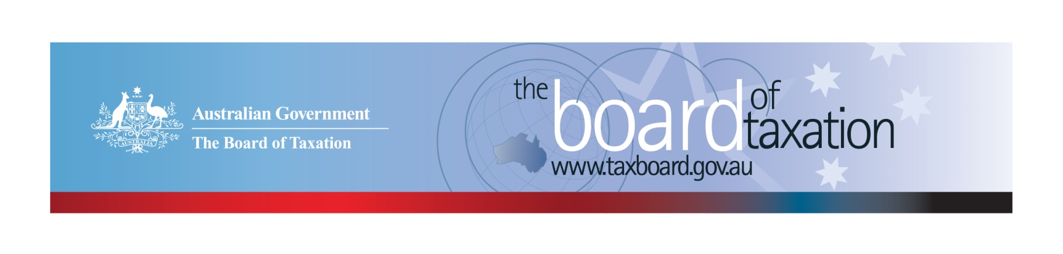
CEO Update – October 2022
Dear Stakeholders,
Since my last update, the Board of Taxation (the Board) has held three face to face meetings - Melbourne on 5 August, Sydney on 9 September and Perth on 21 October.
Stakeholder lunches were held after the three Board meetings. During these lunches the Chair of the Board, Rosheen Garnon, took the opportunity to give a presentation on the role and work of the Board followed by a Q and A session. At the August lunch, stakeholders also heard from Marty Robinson, First Assistant Secretary of the Corporate Tax and International Division, about the Consultation Paper on Multinational Tax Integrity and Tax Transparency released by Treasury that day.
It was fantastic to connect with our stakeholders followingour Melbourne, Sydney and Perth Board meetings and hear about tax issues important to them.
The Board would like to thank PwC Melbourne, EY Sydney and KPMG Perth for their generous hospitality in hosting these recent Board meetings and stakeholder lunches.
As always, I would love to hear from you so please feel free to reach out to me if you have any input, feedback or comments in relation to the Board’s work.

Update on current work program
Review of CGT Roll-overs
The Board has finalised its review of CGT Roll-overs and will be submitting the Final Report to the Government for their consideration shortly. The public release of the Final Report is a matter for the Government.
Review of the Tax Treatment of Digital Assets and Transactions
The Board received confirmation from the Government to continue with the Review of the Taxation of Digital Assets and Transactions (the Review), including progressing public consultations.
The purpose of this Review is to consider the policy framework for taxation of digital assets and if any changes are required to taxation laws and / or their administration. The review will analyse the characteristics of digital assets and transactions in the market, Australia’s taxation treatment of them, investor awareness of that treatment and look at the international experience in the taxation of these assets.
On 18 August 2022, the Board published a Consultation Guide (Guide) for this Review on the Board’s website. The Guide provides an overview of crypto assets and the tax policy framework to be considered under the Review, along with a summary of the current tax treatment, domestic and international government reports and announcements. The Guide also sets out a series of consultation questions to assist stakeholders with formulating input into the Review.
The Board held a series of consultation meetings in September and October 2022 with a number of stakeholders. These meetings targeted different stakeholder groups (tax advisers, crypto exchanges and platforms, software developers, investors and industry organisations) to ensure that the Board obtained access to a wide range of expertise and views covering all relevant issues. The Board has received over 40 written submissions to the Review.
Meetings with international revenue authorities, Treasury agencies, and international tax advisers, where appropriate, are being organised for November 2022.
The Board appreciates the level of engagement that has been received by the tax community to date and looks forward to engaging with interested parties throughout the remainder of the Review.
If you would like further information in relation to the review, please contact the Board of Taxation Secretariat at TaxDigitalAssets@taxboard.gov.au.

2022 and 2023 Board Meeting Dates
The final Board meeting for 2022 will be held in Melbourne on 20 December.
The Board has agreed on the following dates for Board meetings to be held in the 2023 calendar year:
- 10 February 2023 Sydney
- 31st March 2023 Brisbane
- 19th May 2023 Canberra
- 21 July 2023 Adelaide
- 8th September 2023 Melbourne
- 27th October 2023 Perth
- 8th December 2023 Melbourne

Sounding Board+
Do you have an idea to improve the tax system? The Board would love to hear them. The Board’s streamlined Sounding Board+ makes it easier than ever to contribute, without needing to go through a registration and log-on process.
At each of its Board Meetings, the Board considers all new additions to Sounding Board+. Although it is not always possible to respond on Sounding Board+ with the steps the Board is taking in relation to every suggestion, all ideas are actively considered in relation to the Board’s current and future work.
To contribute your own suggestions and to view previously submitted ideas please visit: https://taxboard.gov.au/sounding-board-plus
We encourage you to join the conversation and would really value your input.

Tax Transparency Code
The Tax Transparency Code plays an important role to help educate the public in relation to business compliance with Australia’s tax laws. The Tax Transparency Code provides a framework for large and medium businesses to follow when developing their disclosures. The flexible nature of the code allows organisations to highlight contributions, by way of taxes, to the Australian community.
As of 31 October 2022, there were approximately 206 signatories to the Transparency Code and of these, around 200 have published at least one report. A full list of signatories and more information about the Tax Transparency Code can be found on the Board’s website. Links to published reports can be found here.
For organisations wishing to sign up to the Tax Transparency Code, you can email taxboard@treasury.gov.au stating the name of your organisation and the financial year you intend to first publish a tax transparency report. Your organisation will be recorded on our register of signatories as having committed to applying the principles and details of the Code.
The ATO is responsible for the centralised hosting of published reports for businesses who have adopted the Tax Transparency Code. If you have published a report (or changed where you house your historic reports on your company’s website) – please remember to notify the ATO by emailing ttc@ato.gov.au.

Keep up to date with the latest news
You can keep up to date with the latest from the Board via our website or follow us on LinkedIn| Twitter.
Also, if you wish to receive email notifications about Board updates, you can subscribe here.

Contact us
If you have any questions relating to the Board’s work, please feel free to contact the Board of Taxation Secretariat on taxboard@treasury.gov.au or call 02 6263 4366.
You are also more than welcome to contact me directly on the details below. As always, we value your feedback, so please stay in touch.
Kind regards
Christina Sahyoun
 | Christina Sahyoun  Chief Executive Officer  Board of Taxation | phone: +61 2 6263 3988  email: christina.sahyoun@treasury.gov.au
Treasury Building, Langton Crescent, PARKES ACT 2600 • Telephone: 02 6263 4366 • Email: taxboard@treasury.gov.au
Website: taxboard.gov.au • Sounding Board: taxboard.gov.au/sounding-board-plus

