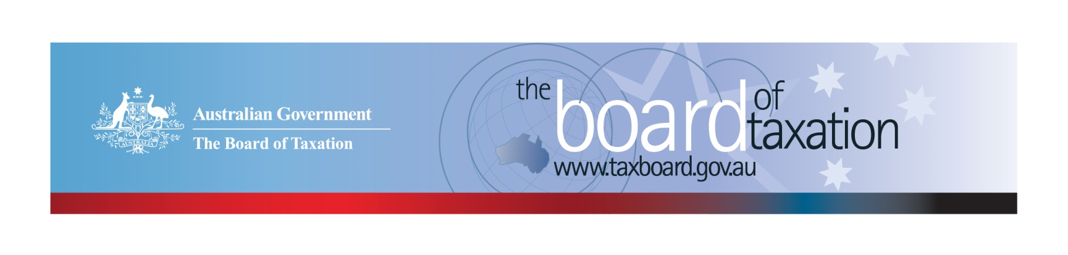
CEO Update – August 2022
Dear Stakeholders,
Since our last update, the Federal Election has come and gone, and we now have a new Government that we are working with. The Board is looking forward to engaging with the Government to discuss our current and potential future work program and how the Board can continue to contribute to Australia’s tax system.
The Board has continued working behind the scenes in preparation for progressing public consultations on the taxation of digital assets and transactions and delivering a final report on the review of capital gains tax (CGT) roll-overs to Government.
The Board held three Board meetings since our last update, including two in person - one in Brisbane in April and the other in Adelaide in July.
We have been very fortunate to have resumed our stakeholder events. It was great to reconnect with our stakeholders at our stakeholder lunches following both our Brisbane and Adelaide Board meetings.
The Board would like to thank BDO Brisbane and Deloitte Adelaide for hosting our recent Board meetings and stakeholder lunches. These lunches provided a great opportunity for the Board to hear from both the Brisbane and Adelaide business and tax communities on tax issues important to them and to provide an update on our work.
We are looking forward to meeting with many more of our stakeholders following our Board meetings in Melbourne, Sydney, and Perth over the remainder of the year.
We would also like to extend our best wishes to Maryanne Mrakovcic on her retirement in July and thank her for her significant contribution to the Board’s work over the past six years through her role as Deputy Secretary of Revenue Group at the Treasury.
As always, I would love to hear from you so please feel free to reach out to me if you have any input, feedback or comments in relation to the Board’s work.

Update on current work program
Review of CGT Roll-overs
The Board is now finalising its report on CGT roll-overs, planned for delivery to the Government in August 2022.
The review was commissioned by the former Government with the purpose of identifying and evaluating opportunities to rationalise the existing CGT roll-overs and associated provisions into a simplified set with the same practical effect.
If you have any queries about the review, please contact the Board of Taxation Secretariat on: CGTRollovers@taxboard.gov.au.
Review of Digital Assets and Transactions
On 21 March 2022, the former Government released the Terms of Reference for the review of the taxation of digital assets and transactions in Australia. The purpose of this review is to consider the policy framework for taxation of digital assets and if any changes are required to taxation laws and / or their administration. The review will analyse the characteristics of digital assets and transactions in the market, Australia’s taxation treatment of them, investor awareness of that treatment and look at the international experience in the taxation of these assets.
The Board will commence public consultations following confirmation of the Terms of Reference from the new Government.
In the meantime, if you would like to provide any early feedback on key issues or have any queries on the review, please contact the Board of Taxation Secretariat on: TaxDigitalAssets@taxboard.gov.au

2022 Board Meeting Dates
The Board is pleased to continue in-person meetings and stakeholder lunches throughout 2022.
The dates and locations for the remaining meetings for 2022 are as follows:
- 5 August – Melbourne  - 9 September - Sydney | - 21 October - Perth  - 9 December - Melbourne

Sounding Board+
Do you have an idea to improve the tax system? The Board would love to hear them. The Board’s streamlined Sounding Board+ makes it easier than ever to contribute, without needing to go through a registration and log-on process.
At each of its Board Meetings, the Board considers all new additions to Sounding Board+. Although it is not always possible to respond on Sounding Board+ with the steps the Board is taking in relation to every suggestion, all ideas are actively considered in relation to the Board’s current and future work.
To contribute your own suggestions and to view previously submitted ideas please visit: https://taxboard.gov.au/sounding-board-plus
We encourage you to join the conversation and would really value your input.

Tax Transparency Code
The Tax Transparency Code plays an important role to help educate the public in relation to business compliance with Australia’s tax laws. The Tax Transparency Code provides a framework for large and medium businesses to follow when developing their disclosures. The flexible nature of the code allows organisations to highlight contributions, by way of taxes, to the Australian community.
As of 31 July 2022, there were 203 signatories, with 198 of those organisations having published at least one report. A full list of signatories and more information about the Tax Transparency Code can be found on the Board’s website. Links to published reports can be found here.

For organisations wishing to sign up to the Tax Transparency Code, you can email taxboard@treasury.gov.au stating the name of your organisation and the financial year you intend to first publish a tax transparency report. Your organisation will be recorded on our register of signatories as having committed to applying the principles and details of the Code.
The ATO is responsible for the centralised hosting of published reports for businesses who have adopted the Tax Transparency Code. If you have published a report (or changed where you house your historic reports on your company’s website) – please remember to notify the ATO by emailing ttc@ato.gov.au.

Keep up to date with the latest news
You can keep up to date with the latest from the Board via our website or follow us on LinkedIn| Twitter.
Also, if you wish to receive email notifications about Board updates, you can subscribe here.

Contact us
If you have any questions relating to the Board’s work, please feel free to contact the Board of Taxation Secretariat on taxboard@treasury.gov.au or call 02 6263 4366.
You are also more than welcome to contact me directly on the details below. As always, we value your feedback, so please stay in touch.
Kind regards
Christina Sahyoun
 | Christina Sahyoun  Chief Executive Officer  Board of Taxation | phone: +61 2 6263 3988  email: christina.sahyoun@treasury.gov.au
Treasury Building, Langton Crescent, PARKES ACT 2600 • Telephone: 02 6263 4366 • Email: taxboard@treasury.gov.au
Website: taxboard.gov.au • Sounding Board: taxboard.gov.au/sounding-board-plus

