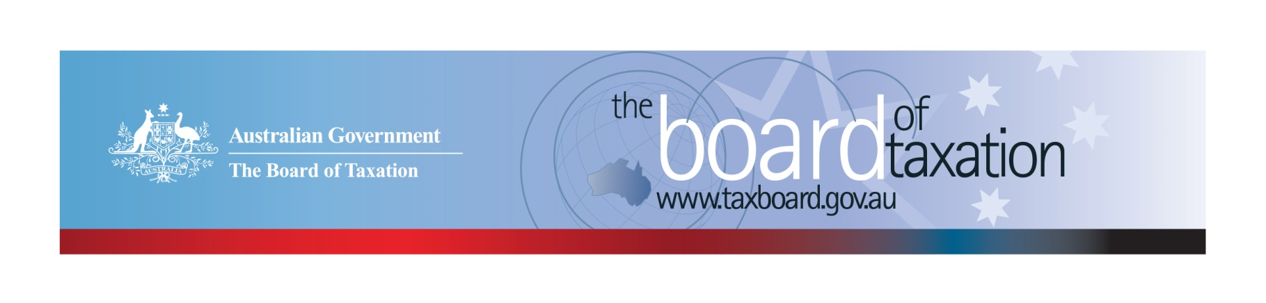
CEO Update – February 2022
Dear Stakeholders,
As we commence another year, the Board of Taxation (the Board) is looking forward to carrying out the 2022 work program and commencing face-to-face engagements with our stakeholders.
On 18 February 2022, the Board met virtually for the first Board Meeting of the year. During the meeting the Board discussed our 2022 work program, including the newly announced review into digital assets and transactions (refer below), and feedback from recent completed reviews in relation to the dual-agency administration model of Research and Development Tax Incentive and Goods and Services Tax on Low Value Imported Goods.
As COVID-19 travel restrictions have eased, we are resuming our stakeholder events where the Board is able to meet many of you in person. The first of these stakeholder events will be held in Brisbane following our Board Meeting in April. We are looking forward to reconnecting with all our stakeholders. In the meantime, I would love to hear from you so please feel free to reach out to me if you have any input, feedback or comments in relation to the Board’s work.

Update on current work program
Review of CGT Roll-overs
The Board is now focussing on delivering its final report on CGT roll-overs to Government on 22 April 2022.
The purpose of the review is to identify and evaluate opportunities to rationalise the existing CGT roll-overs and associated provisions into a simplified set with the same practical effect.
If you would like to discuss the review or provide any further input prior to the Board finalising the report, please contact the Board of Taxation Secretariat on: CGTRollovers@taxboard.gov.au.
Review of Digital Assets and Transactions
On 8 December 2021, the Treasurer announced that the Government will undertake a review of the regulation of digital assets and transactions in Australia. As part of the part of the regulatory review, the Treasurer announced that the Board will undertake a review into the appropriate policy framework for the taxation of digital assets and transactions in Australia.
The Terms of Reference for the review are currently being finalised.

2022 Board Meeting Dates
The Board is excited to announce that we are resuming in-person meetings and stakeholder lunches in April 2022.
The dates and locations for the meetings in 2022 are as follows:
- 8 April - Brisbane  - 27 May - Canberra  - 1 July - Adelaide  - 5 August - Melbourne | - 9 September - Sydney  - 21 October - Perth  - 9 December - Melbourne

Sounding Board+
Do you have an idea to improve the tax system? The Board would love to hear them. The Board’s streamlined Sounding Board+ makes it easier than ever to contribute, without needing to go through a registration and log-on process.
At each of its Board Meetings, the Board considers all new additions to Sounding Board+. Although it is not always possible to respond on Sounding Board+ with the steps the Board is taking in relation to every suggestion, all ideas are actively considered in relation to the Board’s current and future work.
To contribute your own suggestions and to view previously submitted ideas please visit: https://taxboard.gov.au/sounding-board-plus
We encourage you to join the conversation and would really value your input.

Tax Transparency Code
The Tax Transparency Code plays an important role to help educate the public in relation to business compliance with Australia’s tax laws. The Tax Transparency Code provides a framework for large and medium businesses to follow when developing their disclosures. The flexible nature of the code allows organisations to highlight contributions, by way of taxes, to the Australian community.
As of 22 February 2022, there were 197 signatories, with 192 of those organisations having published at least one report. A full list of signatories and more information about the Tax Transparency Code can be found on the Board’s website. Links to published reports can be found here.
For organisations wishing to sign up to the Tax Transparency Code, you can email taxboard@treasury.gov.au stating the name of your organisation and the financial year you intend to first publish a tax transparency report. Your organisation will be recorded on our register of signatories as having committed to applying the principles and details of the Code.
The ATO is responsible for the centralised hosting of published reports for businesses who have adopted the Tax Transparency Code. If you have published a report (or changed where you house your historic reports on your company’s website) – please remember to notify the ATO by emailing ttc@ato.gov.au.

Keep up to date with the latest news
You can keep up to date with the latest from the Board via our website or follow us on LinkedIn| Twitter.
Also, if you wish to receive email notifications about Board updates, you can subscribe here.
Contact us
If you have any questions relating to the Board’s work, please feel free to contact the Board of Taxation Secretariat on taxboard@treasury.gov.au or call 02 6263 4366.
You are also more than welcome to contact me directly on the details below. As always, we value your feedback, so please stay in touch.
Kind regards
Christina Sahyoun
 | Christina Sahyoun  Chief Executive Officer  Board of Taxation | phone: +61 2 6263 3988  email: christina.sahyoun@treasury.gov.au
Treasury Building, Langton Crescent, PARKES ACT 2600 • Telephone: 02 6263 4366 • Email: taxboard@treasury.gov.au
Website: taxboard.gov.au • Sounding Board: taxboard.gov.au/sounding-board-plus

