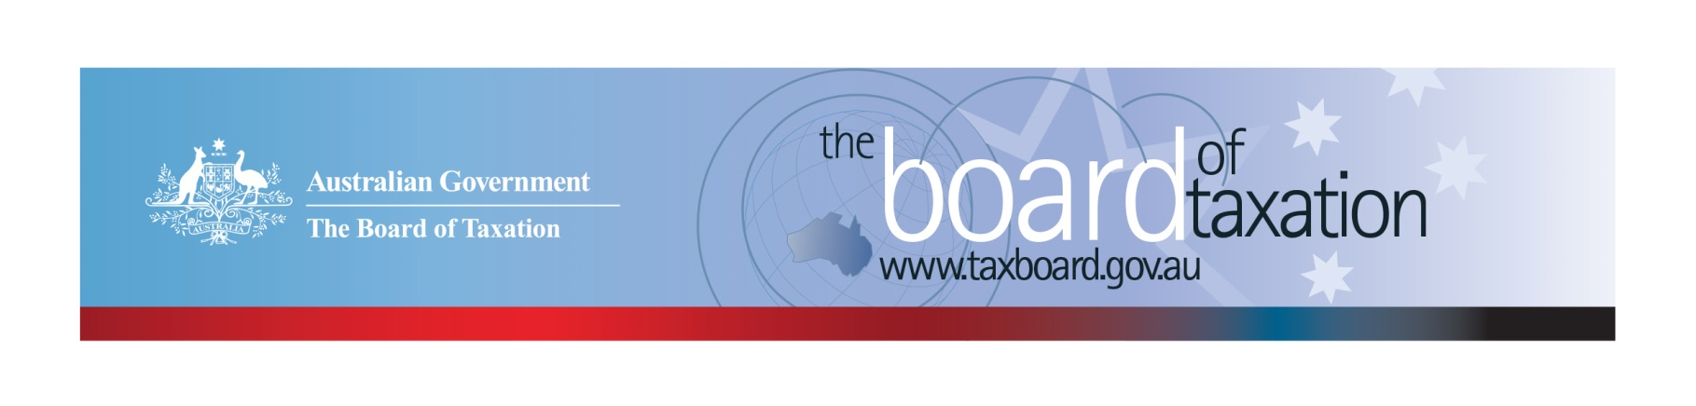
CEO Update – December 2021
Dear Stakeholders,
As I reflect on the 2021 year in my final CEO update for the year, it has been yet another challenging year dealing with COVID-19 and changes to the Board, however I’m pleased to share that we had a successful year in terms of our work program and are set for another busy start to the new year.
It was a big year as we bid farewell to four well respected Board members, Craig Yaxley, Mark Pizzacalla,
Ann-Maree Wolff, and Neville Mitchell and two of our highly regarded CEOs, Lynn Kelly and Kathryn Davy. Fortunately, we were also able to welcome Ian Kellock, Tanya Titman, Andrea Laing and Anthony Klein to the Board who bring with them a wealth of experience and a fresh perspective.
Notwithstanding these changes to the Board and the continued challenges and uncertainty arising as a result of the COVID-19 pandemic, the Board progressed three tax reviews this year and continued to provide real-time tax advice to the Government, The Treasury and ATO.
The Board had its final meeting for the year in December. The focus of the meeting was to finalise our report on the post implementation review of Goods & Services Tax (GST) on the low value imported goods (LVIG) which we delivered to the Assistant Treasurer on 17 December 2021. Our review of the dual-agency administration model of Research and Development Tax Incentive (R&DTI) was delivered to the Assistant Treasurer on 30 November 2021. Work continues on the CGT roll-over review and an update on the review is provided below.
I would like to take this opportunity to thank all our stakeholders for your continued support and contributions towards our reviews. We wish you all a Happy Holiday Season and good wishes for the New Year. We look forward to working with you again in 2022.

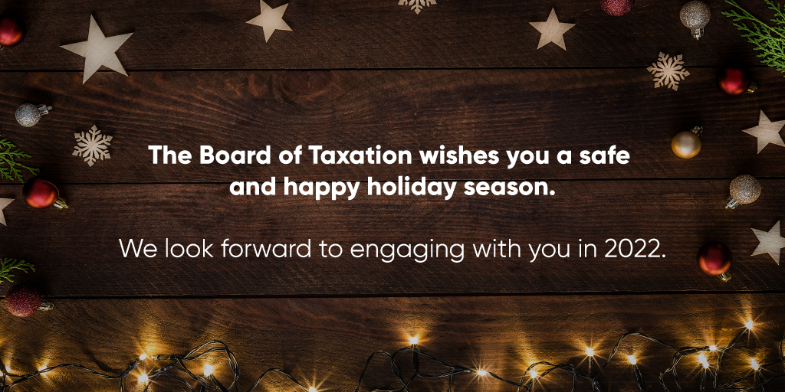

Review of CGT Roll-overs
With our reports on the review of the dual agency administration of the R&DTI program and the post implementation review of GST on LVIG completed, the Board will now focus on delivering its final report on CGT roll-overs in April 2022. The purpose of this review is to identify and evaluate opportunities to rationalise the existing CGT roll-overs and associated provisions into a simplified set with the same practical effect.
Since the departure of former board members, Craig Yaxley, Ann-Maree Wolff and Mark Pizzacalla, the Review has been led by Ian Kellock and Anthony Klein.
The Board has continued to conduct targeted consultations this month to gather further information on several issues raised in earlier submissions. If you would like to discuss the review or provide any input, please contact the Secretariat on: CGTRollovers@taxboard.gov.au

2022 Meeting Dates
The Board is excited to announce that we are expecting to resume in-person meetings and stakeholder lunches in 2022. The dates and planned locations for the meetings in 2022 are as follows:
- 18 February – Sydney  - 8 April – Brisbane  - 27 May – Canberra  - 1 July 2022 – Adelaide | - 5 August – Melbourne  - 9 September – Sydney  - 21 October – Perth  - 9 December – Melbourne
We are really looking forward to reconnecting with our stakeholders in person in the new year.

Sounding Board+
Do you have an idea to improve the tax system? The Board would love to hear them. The Board’s streamlined Sounding Board+ makes it easier than ever to contribute, without needing to go through a registration and log-on process.
At each of its Board Meetings, the Board considers all new additions to Sounding Board+. Although it is not always possible to respond on Sounding Board+ with the steps the Board is taking in relation to every suggestion, all ideas are actively considered in relation to the Board’s current and future work.
To contribute your own suggestions and to view previously submitted ideas please visit: https://taxboard.gov.au/sounding-board-plus
We encourage you to join the conversation and would really value your input.

Tax Transparency Code
The Tax Transparency Code plays an important role to help educate the public in relation to business compliance with Australia’s tax laws. The Tax Transparency Code provides a framework for large and medium businesses to follow when developing their disclosures. The flexible nature of the code allows organisations to highlight contributions, by way of taxes, to the Australian community.
As of 17 December 2021, there were 197 signatories, with 190 of those organisations having published at least one report. A full list of signatories and more information about the Tax Transparency Code can be found on the Board’s website. Links to published reports can be found here.
For organisations wishing to sign up to the Tax Transparency Code, you can email taxboard@treasury.gov.au stating the name of your organisation and the financial year you intend to first publish a tax transparency report. Your organisation will be recorded on our register of signatories as having committed to applying the principles and details of the Code.
The ATO is responsible for the centralised hosting of published reports for businesses who have adopted the Tax Transparency Code. If you have published a report (or changed where you house your historic reports on your company’s website) – please remember to notify the ATO by emailing ttc@ato.gov.au.
Keep up to date with the latest news
You can keep up to date with the latest from the Board via our website or follow us on Twitter |LinkedIn.
Also, if you wish to receive email notifications about Board updates, you can subscribe here.
Thank you and Happy Holidays!
The Board would like to once again thank all our stakeholders for supporting us over the past year. Your continued support and feedback are important to us.
If you have any questions relating to the Board’s work, please feel free to contact the Board of Taxation Secretariat on taxboard@treasury.gov.au or call 02 6263 4366.
You are also more than welcome to contact me directly on the details below. As always, we value your feedback, so please stay in touch.
We wish you all a safe and relaxing holiday and look forward to working with you again in 2022.
Kind regards
Christina Sahyoun
 | Christina Sahyoun  Chief Executive Officer  Board of Taxation | phone: +61 2 6263 3988  email: christina.sahyoun@treasury.gov.au
Treasury Building, Langton Crescent, PARKES ACT 2600 • Telephone: 02 6263 4366 • Email: taxboard@treasury.gov.au
Website: taxboard.gov.au • Sounding Board: taxboard.gov.au/sounding-board-plus

