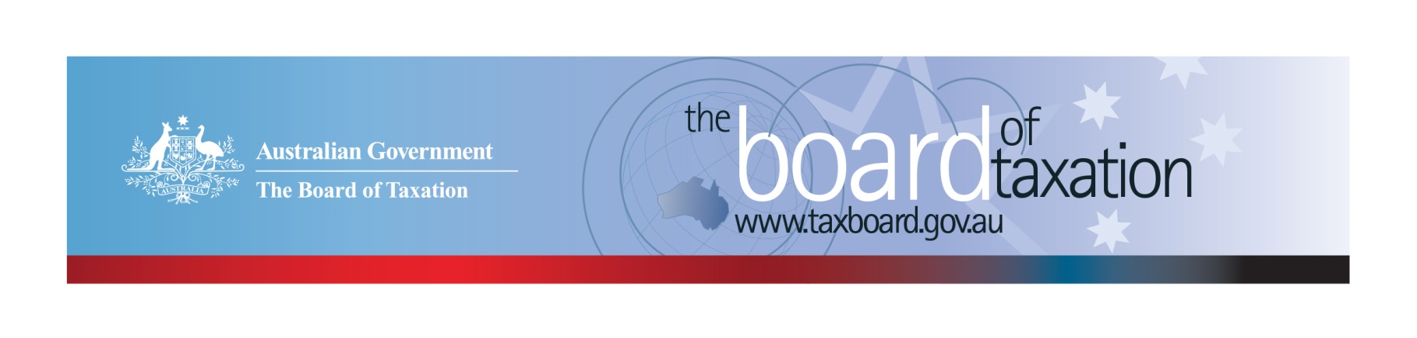
CEO Update – October 2021
Dear Stakeholders,
The Board is currently working through a busy period as we finalise two reviews on the current work program. The Board looks forward to delivering to the Assistant Treasurer our review of the dual administration model of Research and Development Tax Incentive (R&DTI) in late November shortly followed by our review of GST on low value imported goods in late December.
This month the Board welcomed Andrea Laing and Anthony Klein as part-time members of the Board for a three-year period from 20 October 2021. Andrea brings a wealth of knowledge after more than two decades working with Shell on tax issues, particularly indirect and employment taxes, where she was formerly the Global Project Manager and prior to that Country Tax Lead of Shell. Anthony has experience in corporate and international tax and has more than two decades of experience working in the tax advisory space most of which was spent at PwC. We are looking forward to working with Andrea and Anthony.
Our Chair, Rosheen Garnon, recently met with the Assistant Treasurer to provide an update on the Board’s work program and discuss how the Board can support the Government as the economy emerges from the COVID-19 pandemic. The Board will continue to provide the Government with real-time advice that reflects the business and tax community perspective to improve the design and operation of taxation laws.
We are now turning our minds to considering our future work program and would love to hear from you as to where you feel the Board is best placed to continue our contribution to the Australian tax system. We encourage you to have your say via our Sounding Board or please feel free to reach out to me directly.
Due to travel restrictions, the October Board meeting was again held virtually. During the meeting we discussed the progress of our current reviews and discussed proposed recommendations for our reviews.

Update on current work program

Research & Development Tax Incentive - Review of the dual-administration model
The Board is collating and analysing key themes and issues that were raised in the consultation sessions, during discussions with international regulators and through the written submissions and are now in the process of drafting the report with our findings and recommendations.
The Board also has sent a short questionnaire to selected companies so that the Board is able to get a high-level understanding of the nature and level of compliance costs involved in making a claim under the R&DTI program.
The Board is requested to deliver its final advice to Government by 30 November 2021.
If you would like to discuss the review, please get in touch with the Secretariat on: RandD@taxboard.gov.au.

Review of GST on Low Value Imported Goods
The Board’s post-implementation review of GST on low value imported goods has progressed well since our last update. We have now completed our public consultation sessions and have received written submissions from a number of stakeholders. The Board sincerely thanks all stakeholders who took the time to participate in the consultation sessions and/or make a written submission.
The Board is also in the process of meeting with representatives from New Zealand, the UK and the EU to gain a better insight as to how other countries have implemented their GST/VAT on low value imported goods.
The Board is requested to deliver its final advice to Government on 17 December 2021.
If you would like to discuss the review, please get in touch with the Secretariat on: LVIG@taxboard.gov.au. More information can be found on our website here.
Review of CGT Roll-overs
The Board is continuing its work in relation to the review of CGT roll-overs. The purpose of the review is to identify and evaluate opportunities to rationalise the existing CGT roll-overs and associated provisions into a simplified set with the same practical effect.
Following an extensive consultation process and receipt of over 30 written submissions, the Board provided interim advice to the Government and is now in the process of drafting the final report with key findings and recommendations.
The written submissions received which, with the exception of confidential submissions, have been published on the Board’s website.
If you would like to discuss the review or provide any input, please contact the Secretariat on: CGTRollovers@taxboard.gov.au

Sounding Board+
Do you have an idea to improve the tax system? The Board would love to hear them. The Board’s streamlined Sounding Board+ makes it easier than ever to contribute, without needing to go through a registration and log-on process.
At each of its Board Meetings, the Board considers all new additions to Sounding Board+. Although it is not always possible to respond on Sounding Board+ with the steps the Board is taking in relation to every suggestion, all ideas are actively considered in relation to the Board’s current and future work.
To contribute your own suggestions and to view previously submitted ideas please visit: https://taxboard.gov.au/sounding-board-plus
We encourage you to join the conversation and would really value your input.

Tax Transparency Code
The Tax Transparency Code plays an important role to help educate the public in relation to business compliance with Australia’s tax laws. The Tax Transparency Code provides a framework for large and medium businesses to follow when developing their disclosures. The flexible nature of the code allows organisations to highlight contributions, by way of taxes, to the Australian community.
As of 14 October 2021, there were 195 signatories, with 189 of those organisations having published at least one report. A full list of signatories and more information about the Tax Transparency Code can be found on the Board’s website. Links to published reports can be found here.
For organisations wishing to sign up to the Tax Transparency Code, you can email taxboard@treasury.gov.au stating the name of your organisation and the financial year you intend to first publish a tax transparency report. Your organisation will be recorded on our register of signatories as having committed to applying the principles and details of the Code.
The ATO is responsible for the centralised hosting of published reports for businesses who have adopted the Tax Transparency Code. If you have published a report (or changed where you house your historic reports on your company’s website) – please remember to notify the ATO by emailing ttc@ato.gov.au.

2021 Meeting Dates
The Board’s meetings will be held virtually for the remainder of the calendar year. The dates for the meetings are as follows:
- 8 November; and
- 10 December
We are hopeful of resuming our schedule of Board Meetings in person in 2022.
Keep up to date with the latest news
You can keep up to date with the latest from the Board via our website or follow us on Twitter |LinkedIn.
Also, if you wish to receive email notifications about Board updates, you can subscribe here.
Contact us
If you have any questions relating to the Board’s work, please feel free to contact the Board of Taxation Secretariat on taxboard@treasury.gov.au or call 02 6263 4366.
You are also more than welcome to contact me directly on the details below. As always, we value your feedback, so please stay in touch.
Kind regards
Christina Sahyoun
 | Christina Sahyoun  Chief Executive Officer  Board of Taxation | phone: +61 2 6263 3988  email: christina.sahyoun@treasury.gov.au
Treasury Building, Langton Crescent, PARKES ACT 2600 • Telephone: 02 6263 4366 • Email: taxboard@treasury.gov.au
Website: taxboard.gov.au • Sounding Board: taxboard.gov.au/sounding-board-plus

