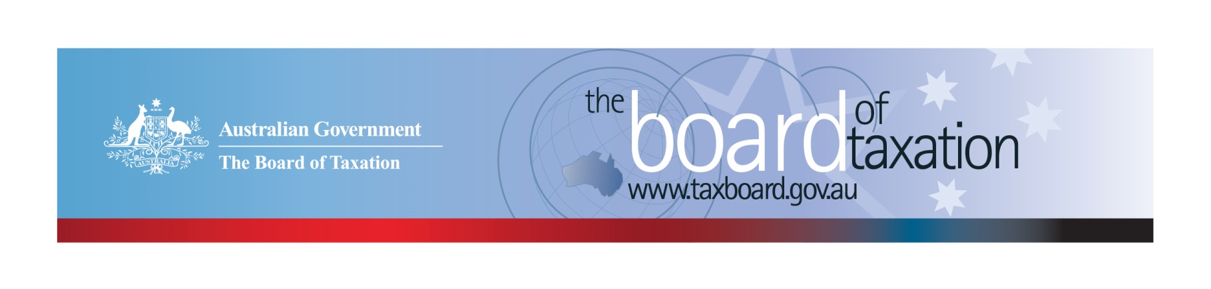
CEO Update – September 2021
Dear Stakeholders,
In September, the Board of Taxation (the Board) farewelled Kathryn Davy, who was acting as interim CEO of the Board from February 2021. Kathryn was a valued member of the Board and has now moved back to the Department of Treasury to resume her role as the Assistant Secretary in the International Tax Branch of the Revenue Group. With Kathryn moving back to Treasury, I recently joined the Board as the Board’s new CEO.
By way of introduction my name is Christina Sahyoun and I am on secondment to the Board from PwC where I am a Partner in the corporate and global tax team. My experience includes advising both the private and public sectors in relation to general tax advisory and tax compliance matters, mergers & acquisitions, structuring and financing transactions with a focus on the infrastructure and real assets industry.
I am really looking forward to working with the Board and the Board’s stakeholders in this role. I am very excited to be able contribute to Australia’s tax system and help deliver on the Board’s mission to contribute a business and community perspective to improving the design and operation of taxation laws.
I hope that as COVID-19 restrictions ease over time, we will be able to resume our stakeholder events where the Board is able to meet many more of you in person. In the meantime, I would love to hear from you so please feel free to reach out to me if you have any input, feedback or comments in relation to the Board’s work.
The Board’s August meeting was again held virtually. At the meeting, the Board discussed the progress and direction of our current review projects. The Board has also continued to engage with business and the broader community through our busy work program and continued to progress the reviews requested by the Treasurer, including the post-implementation review of the Low Value Imported Goods (LVIG) regime and the dual administration of the Research & Development Tax Incentive. Further details in relation to the status of these projects are set out below.

Update on current work program

Research and Development Tax Incentive - Review of the dual-administration model
The Board has now completed all five of its consultation sessions that were set out in the consultation guide. Consultations were held virtually with stakeholders in Adelaide, Sydney, Brisbane, Melbourne and Perth. Over 40 participants joined the consultation sessions.
The Board received over 15 written submissions to the review, from the tax profession (Large and Medium/Small), Industry Associations and Government. The Board sincerely thanks all stakeholders who took the time to participate in the consultation sessions and/or write a submission to the review.
The Board continues its discussions on firsthand experiences of international arrangements in like jurisdictions, including New Zealand, UK and Canada.
The Board is expected to report to Government by 30 November 2021.
If you would like to discuss the review, please get in touch with the Secretariat on: RandD@taxboard.gov.au.

Review of GST on Low Value Imported Goods
The Board’s post-implementation review of the GST regime for low value imported goods in now well underway. The review team is led by Board members Dr Julianne Jaques QC and Ms Tanya Titman and assisted by a working group comprising representatives from the tax profession, ATO, Australian Border Force (ABF) and Treasury. The key objective of the review is to assess the effectiveness of the low value imported goods regime with reference to the policy intent of the law and provide advice regarding its ongoing operation.
Over the course of August and September, the Board held six consultation meetings, providing an opportunity to hear diverse perspectives not only from the tax profession, but from academia, the local retail sector, and stakeholders from the world of freight, logistics, customs processes and e-commerce. Further, a number of written submissions have been received by the Board for consideration.
The upcoming October Board meeting will be an opportunity for the Board to reflect on the lessons from initial consultation process and plan for the next phase. We expect the coming weeks to be a busy period involving working with ABF and the ATO to consider the issues raised, conducting targeted follow-up consultations, and reaching out to overseas revenue authorities to ‘compare notes’ on different approaches for taxing low value imported goods.
If you would like to discuss the review, please get in touch with the Secretariat on: LVIG@taxboard.gov.au. More information can be found on our website. Refer link: Review of GST on low value imported goods | Board of Taxation
The Board is requested to deliver its final advice to Government on 17 December 2021.

Sounding Board+
Do you have an idea to improve the tax system? The Board would love to hear them. The Board’s streamlined Sounding Board+ makes it easier than ever to contribute, without needing to go through a registration and log-on process.
At each of its regular meetings, the Board considers all new additions to Sounding Board+. Although it is not always possible to respond on Sounding Board+ with the steps the Board is taking in relation to every suggestion, all ideas are actively considered in relation to the Board’s current and future work.
To contribute your own suggestions and to view previously submitted ideas please visit: https://taxboard.gov.au/sounding-board-plus
You can also navigate to Sounding Board+ by following the link from the Board’s home page: www.taxboard.gov.au
We encourage you to join the conversation.

Tax Transparency Code
As at 22 September 2021, there were 194 signatories, with 188 of those organisations having published at least one report. A full list of signatories and more information about the Tax Transparency Code can be found on the Board’s website. Links to published reports can be found here.
The ATO is responsible for the centralised hosting of published reports for businesses who have adopted the Tax Transparency Code. If you have published a report (or changed where you house your historic reports on your company’s website) – please remember to notify the ATO by emailing ttc@ato.gov.au.
For organisations wishing to sign up to the Tax Transparency Code, you can email taxboard@treasury.gov.au stating the name of your organisation and the financial year you intend to first publish a tax transparency report. Your organisation will be recorded on our register of signatories as having committed to applying the principles and details of the Code.

2021 Meeting Dates
The Board’s meetings dates for the remainder of the 2021 calendar year are as follows:
- 8 October – via VC
- 8 November – via VC
- 10 December – via VC
We are hopeful of resuming our schedule of Board Meetings in person in 2022.
Contact us
You can keep up to date with the latest from the Board via our website taxboard.gov.au or follow us on Twitter |LinkedIn
If you have any questions relating to the Board’s work, please feel free to contact the Board of Taxation Secretariat on taxboard@treasury.gov.au or call 02 6263 4366. You are also more than welcome to contact me directly on the details below. As always, we value your feedback, so please stay in touch.
Kind regards
Christina Sahyoun
 | Christina Sahyoun  Chief Executive Officer  Board of Taxation | phone: +61 2 6263 3988  email: christina.sahyoun@treasury.gov.au
Treasury Building, Langton Crescent, PARKES ACT 2600 • Telephone: 02 6263 4366 • Email: taxboard@treasury.gov.au
Website: taxboard.gov.au • Sounding Board: taxboard.gov.au/sounding-board-plus

