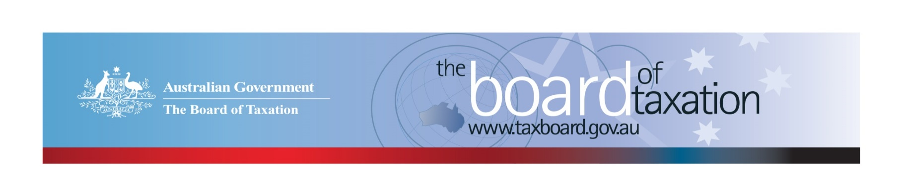
CEO Update – August 2021
Dear Stakeholders,
The work programme of the Board continues to increase, with the Treasurer asking the Board to commence a review into the Low Value Imported Goods (LVIG) measure which facilitates the collection of GST on LVIG, using a vendor registration model.
Our July Board meeting was again held virtually, and we continue to engage virtually with business and the broader community through our busy work program.

Update on current work program

Research and Development Tax Incentive (R&DTI) - Review of the dual-administration model
The Board has now held four of five consultation sessions that were set out in the consultation guide. Consultations have occurred virtually with stakeholders in Adelaide, Sydney, Brisbane and Melbourne. The final consultation session is scheduled to occur with Perth stakeholders on 1 September 2021.
The Board has identified some common issues related to the dual-administration model through the consultation sessions so far. These include, but are not limited to, timeframes for compliance activities to be completed; and clarity needed around guidance products (including the crossover of new guidance and when guidance can be relied upon).
Also, the Board is reaching out to a limited number of international jurisdictions (New Zealand, Canada and the United Kingdom), seeking first-hand experience of their administration arrangements. These jurisdictions have been highlighted as countries with similar and/or innovative administration practices in their research and development programs.
A huge thank you to all our stakeholders that participated in these consultations in recent months.
Written submissions can be made until 15 September 2021. More information can be found on our website: https://taxboard.gov.au/review/dual_agency_administration_model_review

Review of GST on Low Value Imported Goods
The review into GST on LVIG was announced by the Assistant Treasurer on Monday, 5 July 2021. It follows a Government announcement, made in the 2016-17 Budget, that the LVIG arrangements would be reviewed after two years to ensure they were operating as intended and to take into account any international developments.

The Terms of Reference ask the Board to, amongst other things:
- assess the effectiveness of the LVIG regime to efficiently collect GST with reference to the policy intent of the law that low value goods imported by consumers face the same tax regime as goods that are sourced domestically; and
- report on and assess any relevant international developments and experiences regarding the collection of GST and other consumption taxes on LVIG.

The Board is to report back to the Government by 17 December 2021.

Sounding Board+
Do you have an idea to improve the tax system? The Board’s streamlined Sounding Board+ makes it easier than ever to contribute, without needing to go through a registration and log-on process.
At each of its regular meetings, the Board considers all new additions to Sounding Board+. Although it is not always possible to respond on Sounding Board+ with the steps the Board is taking in relation to every suggestion, all ideas are actively considered in relation to the Board’s current and future work.
To contribute your own suggestions and to view previously submitted ideas (migrated from the original Sounding Board) please visit: https://taxboard.gov.au/sounding-board-plus
You can also navigate to Sounding Board+ by following the link from the Board’s home page: taxboard.gov.au
We encourage you to join the conversation.

Tax Transparency Code
The ATO is responsible for the centralised hosting of published reports for businesses who have adopted the Tax Transparency Code. If you have published a report (or changed where you house your historic reports on your company’s website) – please remember to notify the ATO by emailing: ttc@ato.gov.au.
For organisations wishing to sign up to the Tax Transparency Code you can email taxboard@treasury.gov.au stating the name of your organisation and the financial year you intend to first publish a tax transparency report. Your organisation will be recorded on our register of signatories as having committed to applying the principles and details of the Code.

2021 Meeting Dates
The Board’s meetings dates for the remainder of the 2021 calendar year are as follows*:
20 August – Virtual meeting
8 October – Perth
8 November – Canberra
10 December – Sydney
* Locations are indicative at this stage depending on travel restrictions and COVID impacts.
We value your feedback, so please stay in touch. You can keep up to date via the Board’s website, taxboard.gov.au; or follow us on: Twitter |LinkedIn

If you have any questions relating to the Board’s work on any of these projects, please contact the Board of Taxation Secretariat on: taxboard@treasury.gov.au or call 02 6263 4366.
Kind regards
Kathryn Davy
 | Kathryn Davy  Chief Executive Officer  Board of Taxation | phone: +61 2 6263 4266  mobile: 0447 122 425  email: kathryn.davy@treasury.gov.au
Treasury Building, Langton Crescent, PARKES ACT 2600 • Telephone: 02 6263 4366 • Email: taxboard@treasury.gov.au
Website: taxboard.gov.au • Sounding Board: taxboard.gov.au/sounding-board-plus

