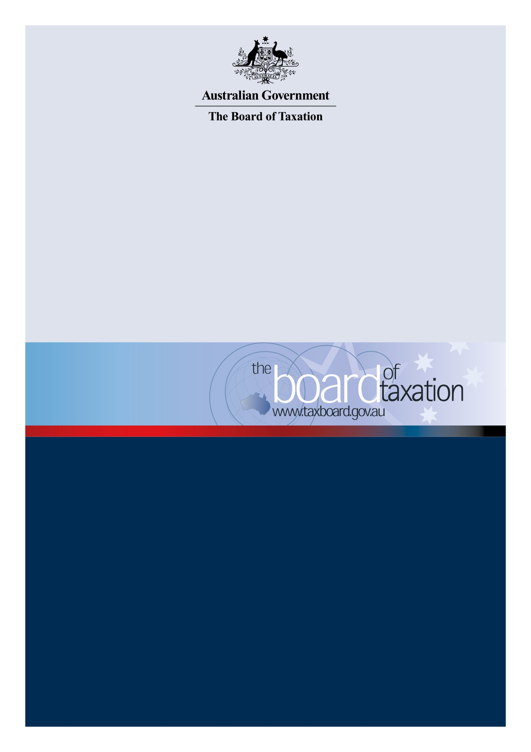

Review of GST ON
LOW VALUE IMPORTED GOODS
  - Consultation Guide

August 2021

Contents
Contents 2
The Board’s review 3
Consultation process 4
The Review Team 5
An overview of the LVIG regime 5
Consultation questions 7
How to participate 8

The Board’s review
On 5 July 2021, the Government announced that the Board of Taxation (Board) would undertake a review of the collection of goods and services tax (GST) on low value imported goods to ensure the system is operating as intended. The terms of reference set out the objectives in undertaking this review, the scope of work, and the timing of the review.
The GST on Low Value Imported Goods (LVIG) was introduced on 1 July 2018 to ensure that low value goods imported by consumers will face the same tax regime as goods that are sourced domestically.
Before this date, goods imported directly by consumers costing $1,000 or less did not attract GST. Only high value goods with a customs value over $1,000 attracted GST, which was assessed and charged at the border.
Australia was one of the first countries in the world to implement a vendor model, requiring suppliers, online platforms and re-deliverers with an Australian annual GST turnover of $75,000 or more to register, collect and pay GST to the ATO.
When announcing the measure in the 2016-17 Budget, the Government committed to reviewing the measure after it was operational, to ensure it was consistent with international best practice. The Board is to conduct this review.
In conducting the review, the Board is asked to:
- Assess the effectiveness of the LVIG regime to efficiently collect GST with reference to the policy intent of the law that low value goods imported by consumers face the same tax regime as goods that are sourced domestically. In doing so, the review will:
1.1 assess the effectiveness of the administration of the measure;
1.2 assess industry compliance with the LVIG rules;
1.3 undertake a targeted external consultation process, working closely and collaboratively with the Treasury, Australian Taxation Office, and Australian Border Force;
1.4 examine the issues identified in the consultation process; and
1.5 provide any observations, findings, and appropriate recommendations for improvements and certainty to the ongoing operation of the LVIG regime.
- Report on and assess any relevant international developments and experiences regarding the collection of GST and other consumption taxes on LVIG.

Timing
The Board is asked to report back to the Government by 17 December 2021.

Consultation process
The Board will undertake a targeted external consultation process, working closely and collaboratively with the Treasury, Australian Taxation Office, and Australian Border Force.
Interested parties may contribute to the review by participating in one of the consultation activities conducted by the Board or through online submissions. Set out below is an indicative timeframe for consultation. Further information will be made available at: www.taxboard.gov.au.

Timetable
August 2021 | Consultation guide – released
 | This consultation guide will be released in August 2021.
August – September 2021 | Consultation roundtables and submissions
The Board will hold a series of roundtable meetings to consult with stakeholders to understand the effectiveness of the regime to collect GST on LVIG (including relevant international developments and experiences), assess industry compliance with the regime and consider opportunities for improvements to the ongoing operation of the LVIG regime. Consultation roundtables will be held virtually throughout the months of August and September 2021.

More detailed information on session times and how to register is included in ‘How to participate’ on page 8 of this consultation guide.
Any written submissions will be accepted until 22 September 2021.
All submissions will be published on the Board’s website except where the submission is made on a confidential basis.

December | Final report
 | The Board is required to report to the Government by 17 December 2021.

The Review Team
The Board has appointed Board members Dr Julianne Jaques QC and Ms Tanya Titman to oversee the review. They will be assisted by a working group comprising industry experts, members of the tax profession, and representatives of Australian Border Force, the Treasury, and the ATO.

An overview of the LVIG regime
The LVIG regime aims to level the playing field for Australian businesses and international competitors and, in so doing, strengthen the integrity and fairness of the Australian tax system.
From its commencement on 1 July 2000, GST provided separate regimes for the treatment of domestic supplies of goods and imported goods. While domestic supplies were taxable to the supplier, imported goods were subject to taxable importation rules involving collection of GST from the importer at the border. However, the taxable importation rules only applied to consignments with a customs value of more than $1000. The effect was that low value imported goods were exempt from GST.
The years following the introduction of GST saw an exponential growth in internet commerce, with a significant proportion of Australian online purchases being made from overseas suppliers. There was a growing appreciation of the need to address the competitive neutrality issues created by the GST exemption for LVIGs – essentially by ‘levelling the playing field’ between domestic and foreign suppliers. However, designing an efficient, alternative collection mechanism was challenging and the revenue authority was encouraged to investigate innovative ways to efficiently collect GST from LVIG.
The LVIG regime came into effect on 1 July 2018, effectively removing the low value exemption for consumers in Australia. The LVIG regime uses a ‘vendor collection’ or ‘vendor registration’ model which imposes the obligation to collect and remit GST on the supplier, rather than importer as is the case for taxable importations. In this sense, the LVIG regime aligns the treatment of LVIG with domestic consumer supplies, while largely preserving the taxable importation rules for imported goods valued at over $1000. A business is required to register if it has GST turnover to Australia of $75,000 (or $150,000 for non-profit bodies).
Non-resident businesses that are required to register for Australian GST for low value imported goods can choose to use the standard registration method used by domestic Australian businesses or a simplified method. The simplified method uses an online system accessible via a portal on the ATO’s website, that allows businesses to register, lodge and pay Australian GST. However, users of the simplified method are not eligible to claim GST credits making it unsuitable for some businesses.
There are three categories of suppliers that may be responsible for the collection of GST on low value imported goods:
- merchants who sell goods directly to consumers in Australia;
- operators of electronic distribution platforms (EDPs), being a service (including a website, internet portal, gateway, store or marketplace) that allows entities to make supplies available to end-users delivered by means of electronic communication; or
- redeliverers, including businesses that assist and charge entities to obtain goods from foreign suppliers by acting as a personal shopper or by providing a mailing address for delivery in the relevant jurisdiction and forwarding the goods to the consumer.
Broadly, the electronic distribution platform rules apply to shift GST liability for supplies made through the platforms from individual merchants to the operators of the platform. The operators of electronic distribution platforms are often better placed to comply with GST obligations because they are generally larger and better resourced entities than individual merchants. Similarly, a redeliverer will bear the GST liability in circumstances where the original merchant or platform has no role in assisting the consumer in getting the goods to Australia.
International developments
The introduction of the LVIG regime in Australia was the beginning of an emerging international trend for the implementation of measures that increased the coverage and efficiency of GST and VAT collection on online sales to consumers. The OECD has advocated an approach that leverages electronic platforms and other intermediaries and uses simplified registration and compliance processes, all of which are features of the Australian LVIG regime.
Since the adoption of the LVIG regime, a number of other countries – including New Zealand, Norway, the United Kingdom, the European Union countries and Singapore – have either implemented a low value imported goods regime or are in the process of doing so. The Board understands that while the regimes differ in terms of the details of their design, they all adopt the core ‘vendor collection’ model.

Consultation questions
The Board encourages you to reflect on the consultation questions below to assist in formulating your input to the review. Not all of these questions may be relevant to you and you should not feel obliged to address all the questions. We encourage you to raise any other issues relevant to the administration of the LVIG program.
Your business
- We are interested in hearing a little about your business (including type of business, platform etc) and your experience with the LVIG regime including the nature of your interactions with the ATO and ABF?
Awareness of the LVIG regime
- Have measures adopted to make foreign suppliers of goods aware of their obligations under the LVIG regime been effective?
Ease of compliance
- Please provide insights on the compliance burden associated with the LVIG regime in relation to the following activities:
  - determining whether an entity is subject to LVIG obligations
  - the registration process
  - managing payments and refunds
  - notification and record-keeping requirements
  - lodgement of returns
  - obtaining assistance to comply with LVIG obligations
Interaction with importation rules
- Do the LVIG rules interact well with the taxable importation rules for higher value goods? What issues arise and how are they managed?
Compliance
- What insights do you have on overall level of compliance with the LVIG regime?
- What do you regard as the main reasons for non-compliance?
- How could compliance levels be improved?
International impacts
- What lessons can Australia draw from the implementation of low value GST or VAT regimes in other countries such as New Zealand, Norway, the United Kingdom, the European Union countries and Singapore?
- How well does the LVIG regime interact with VAT or GST obligations imposed by other jurisdictions? Do issues of double taxation arise and how are they resolved?
Achievement of Purpose
- Overall, how effective is LVIG regime on delivering on its intended purpose? What is working well? Are there aspects of the regime that could be improved?

How to participate
The Board invites comment on the matters set out in this consultation guide and looks forward to engaging further with interested parties throughout the course of this review.
Consultations
The Board will be holding a series of virtual consultations during August and September:
- Tuesday 17 August 2021
- Tuesday 24 August 2021
- Thursday 2 September 2021
- Wednesday 8 September 2021
If you would like to participate in discussions, please express your interest at LVIG@taxboard.gov.au, and let us know where you are located.
Submissions
In addition to participating in consultations, the Board welcomes any written submissions to this review. Submissions can be made to LVIG@taxboard.gov.au.
The Board will accept submissions in response to this Consultation Guide until 22 September 2021.
All submissions will be published on the Board’s website except where the submission is made on a confidential basis.
Contact information
The Board is supported by a secretariat based in the Treasury.
Email: LVIG@taxboard.gov.au
Phone: (02) 6263 4366

Treasurer, Terms of Reference for Productivity Commission Inquiry, Collection Models for GST on Low Value Imported Goods (July 2017).
OECD, The Role of Digital Platforms in the Collection of VAT/GST on Online Sales (March, 2019).

