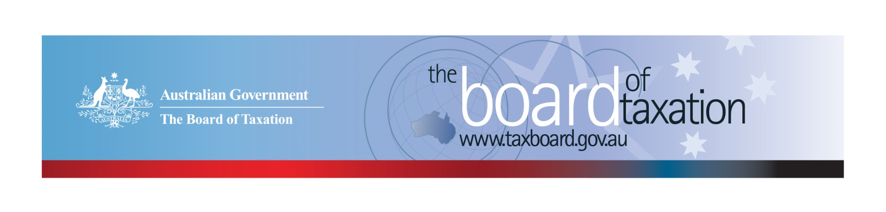
CEO Update – June 2021
Dear Stakeholders,
This time of year is a busy period for a lot of us, the Board of Taxation being no exception. While the COVID pandemic has thrown us all some challenges, it has also taught us how to work more flexibly and be innovative in our channels of communication.
Our May Board meeting was again held virtually, and we continue to engage with business and the broader community virtually through our busy work program. Right now, we are gearing up for online consultation sessions for the Research and Development Tax Incentive (R&DTI) - Review of the dual-administration model, which commence in early July. More information on how to register your interest to participate in upcoming consultations is provided below.

Research and Development Tax Incentive (R&DTI) – Review of the dual administration model
I am very pleased to announce the Board’s consultation Guide for the Research and Development Tax Incentive (R&DTI) - Review of the dual-administration model has been released on our website. The Guide seeks stakeholder input to understand experiences of the R&DTI registration and claiming process as well as considering opportunities to streamline existing administrative functions or process. The Guide also poses a number of questions for interested parties to address when formulating input to the review.
The Board invites your participation in the series of roundtable consultation sessions (to be confirmed as virtual or in-person):
Adelaide – Friday 9 July 2021 – to be held virtually
Sydney – Tuesday 20 July 2021
Brisbane – Wednesday 4 August 2021
Melbourne – Wednesday 11 August 2021
Perth – Wednesday 1 September 2021
If you would like to participate in discussions, please express your interest at RandD@taxboard.gov.au, and let us know where you are located. Written submissions can be made until 15 September 2021. More information can be found on our website: https://taxboard.gov.au/review/dual_agency_administration_model_review
We look forward to engaging with you on this important topic.

May Board meeting
We welcomed our newest Board members Ms Tania Titman and Mr Ian Kellock to their first meeting on 28 May. The Board is also pleased to announce the extended membership of Mrs Ann-Maree Wolff and Mr Neville Mitchell for a further three months. Although the Board was unable to meet in person, we engaged in an active discussion surrounding the recent Budget 2021-22 measures relating to the Board’s work, including:
- modernising individual residency rules: individual tax residency rules will be replaced with a new, modernised framework drawing on the Board’s recommendations;
- finalisation of the corporate collective investment (CCIV) component of the new suite of collective investment vehicles announced in 2016-17 Budget;
- the review into the administrative framework of the R&DTI before the end of 2021; and
- the announcement of the Patent Box concession for Australian medical and biotechnology innovations.
The Board also heard from Ms Karen Payne, Inspector General of Taxation regarding their investigations into undisputed tax debts and death and taxes.

Sounding Board+
Do you have an idea to improve the tax system? The Board’s streamlined Sounding Board+ makes it easier than ever to contribute, without needing to go through a registration and log-on process.
At each of its regular meetings, the Board considers all new additions to Sounding Board+. Although it is not always possible to respond on Sounding Board+ with the steps the Board is taking in relation to every suggestion, all ideas are actively considered in relation to the Board’s current and future work.
To contribute your own suggestions and to view previously submitted ideas (migrated from the original Sounding Board) please visit: https://taxboard.gov.au/sounding-board-plus
You can also navigate to Sounding Board+ by following the link from the Board’s home page: taxboard.gov.au
We encourage you to join the conversation.

Tax Transparency Code
The ATO is responsible for the centralised hosting of published reports for businesses who have adopted the Tax Transparency Code. If you have published a report (or changed where you house your historic reports on your company’s website) – please remember to notify the ATO by emailing: ttc@ato.gov.au.
For organisations wishing to sign up to the Tax Transparency Code you can email taxboard@treasury.gov.au stating the name of your organisation and the financial year you intend to first publish a tax transparency report. Your organisation will be recorded on our register of signatories as having committed to applying the principles and details of the Code.

If you have any questions relating to the Board’s work on any of these projects, please contact the Board of Taxation Secretariat on: taxboard@treasury.gov.au or call 02 6263 4366.

Kind regards
Kathryn Davy
 | Kathryn Davy  Chief Executive Officer  Board of Taxation | phone: +61 2 6263 4266  mobile: 0447 122 425  email: kathryn.davy@treasury.gov.au
Treasury Building, Langton Crescent, PARKES ACT 2600 • Telephone: 02 6263 4366 • Email: taxboard@treasury.gov.au
Website: taxboard.gov.au • Sounding Board: taxboard.gov.au/sounding-board-plus

