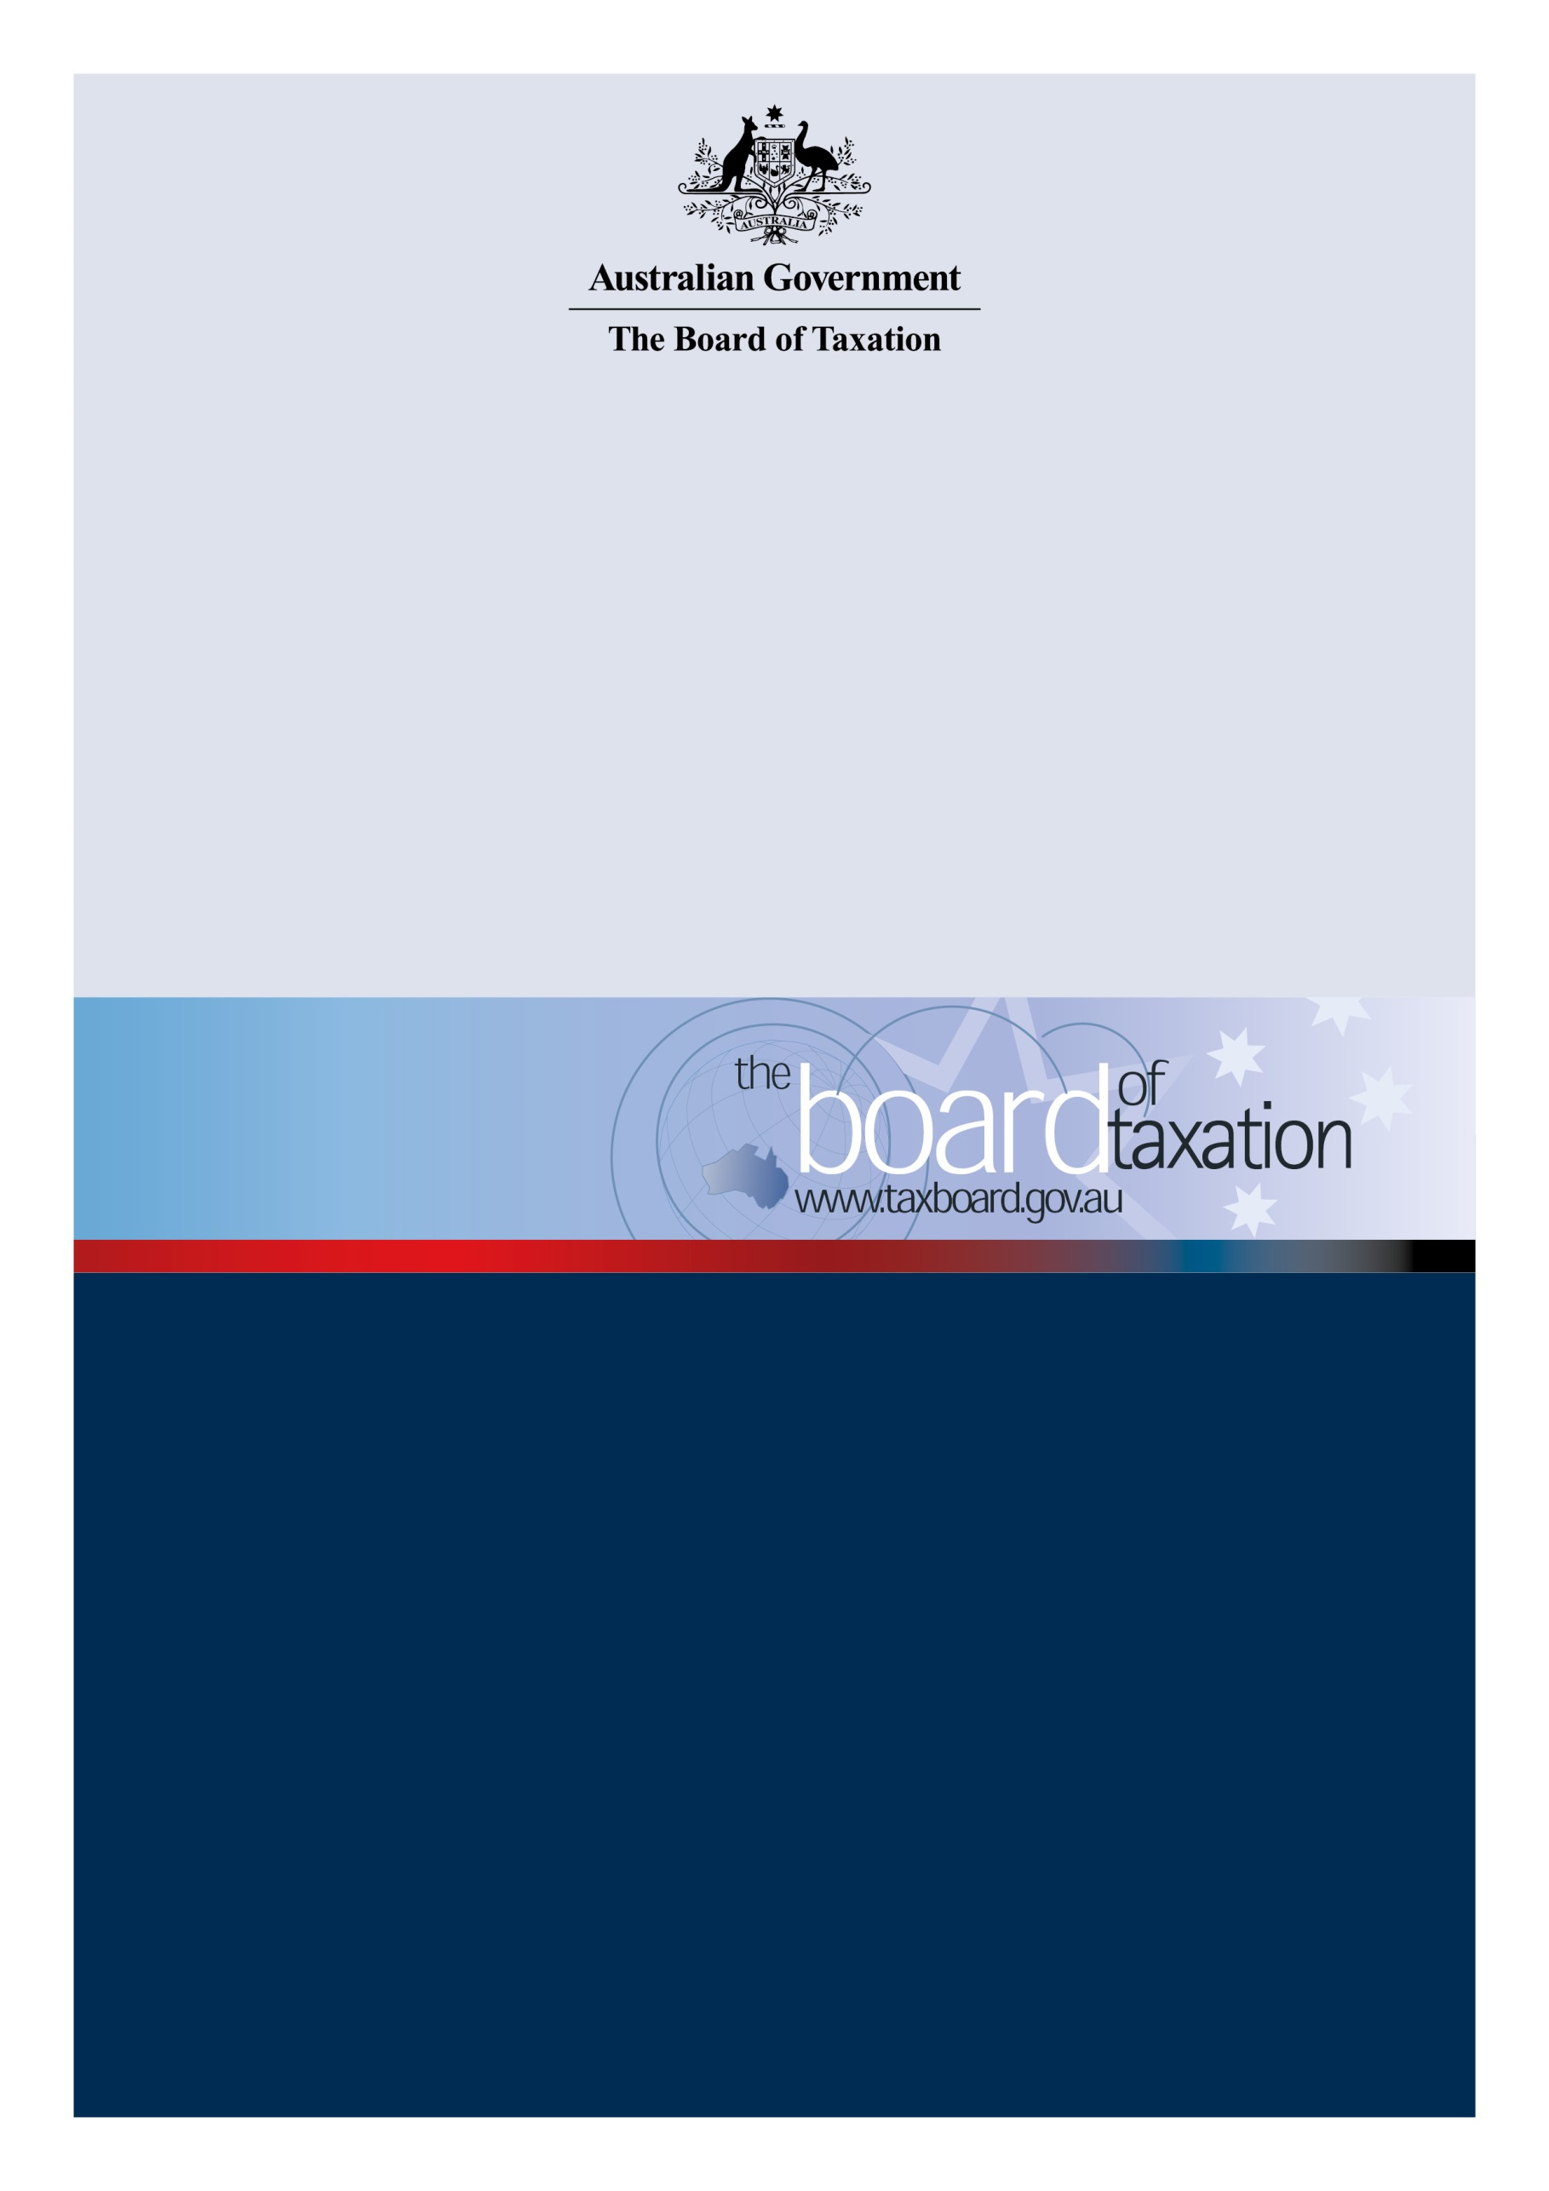

Review of R&D Tax Incentive dual-agency administration model
  - Consultation Guide

June 2021

Contents
Contents 2
The Board’s review 3
Consultation process 4
Membership 5
Previous and current reviews of R&DTI program 6
Consultation questions 7
How to participate 8

The Board’s review
On 11 May 2021, the Government announced that the Board would undertake a review to evaluate the dual-agency administration model for the Research and Development Tax Incentive (R&DTI). The terms of reference set out the objectives in undertaking this review, the scope of work, and the timing of the review.
The R&DTI program is a self-assessment program that provides tax offsets for eligible company R&D expenditure. The stated objective of the program is to encourage industry to conduct R&D activities that may otherwise not be conducted, particularly where the new knowledge gained is likely to benefit the wider Australian economy.
The R&DTI is jointly administered by the Australian Taxation Office (ATO) and Industry Innovation and Science Australia (IISA) and the Department of Industry, Science, Energy and Resources (DISER), with the ATO being responsible for determining whether an amount of expenditure is validly incurred for eligible R&D activities and IISA responsible both for registering companies' ‘self-assessed’ R&D activities and in examining and making findings about those activities. AusIndustry sits within DISER and delivers the program on behalf of IISA.
The Board of Taxation (Board) is requested to evaluate the R&DTI dual-agency administration model, with a view to identifying opportunities to reduce duplication between the two administrators, simplify administrative processes, or otherwise reduce the compliance costs for applicants. The Board may make recommendations to modify the R&DTI’s administrative model or to streamline existing administrative functions or processes. If the Board finds that taxpayers experience difficulty in understanding the different roles and responsibilities of the two administrators, the Board should consider whether education programs or communications would assist.
In conducting the review, the Board should:
- analyse R&D administration models in other comparative jurisdictions and consider how the international experience may inform improvements to Australia’s R&DTI dual agency delivery model;
- consult with taxpayers to obtain an insight into their experience during the registration and claiming process, including their understanding of the different roles and responsibilities of the ATO and IISA in administering the program;
- consider any new and streamlined processes undertaken by the two agencies in response to previous reviews of the scheme’s administration, such as the 2016 Review of the R&DTI and the recent Australian Small Business and Family Enterprise Ombudsman review; and
- identify the advantages and disadvantages of its recommendations, any potential financial impacts, and any trade-offs between simplification and/or reductions in compliance costs and the scheme’s integrity.
Changes to the R&DTI’s broader policy settings, such as eligibility requirements or rates of support, are outside of the scope of this review.
Timing
The Board has been asked to report back to the Government by 30 November 2021.

Consultation process
The Board looks forward to working with the community in developing the Board’s advice to Government.
Interested parties may contribute to the review by participating in one of the consultation activities conducted by the Board or through online submissions. Set out below is an indicative timeframe for consultation. Further information will be made available at: www.taxboard.gov.au.

Timetable
June 2021 | Consultation guide – released
 | This consultation guide will be released in June 2021.
July – September 2021 | Consultation roundtables and submissions
The Board will hold a series of roundtable meetings to consult with stakeholders to understand their experience during the registration and claiming process and consider opportunities to streamline existing administrative functions or process. Consultation roundtables will be held in the following locations:
- Adelaide
- Sydney
- Brisbane
- Melbourne
- Perth

More detailed information on session times and how to register is included in ‘How to participate’ on page eight of this consultation guide.
Any written submissions to this guide will be accepted until 15 September 2021. All submissions will be published on the Board’s website except where the submission is made on a confidential basis.

November 2021 | Final report
 | The Board is required to report to the Government by 30 November 2021.

The Review Team
The Board has appointed Board members Neville Mitchell and Chris Vanderkley to lead the review. They will be assisted by a working group comprising industry experts, members of the tax profession, and representatives of AusIndustry, the Treasury, and the ATO. There will be extensive consultation with a wide range of stakeholders in the business community throughout the review process.

Neville Mitchell | Chris Vanderkley
Neville has been a Board member since 2015. He is the former Chief Financial Officer of Cochlear and currently holds directorships of four ASX-listed medical and healthcare companies and also sits on the South East Sydney Local Health Board. | Chris has been a Board member since March 2020 and is currently Special Counsel at PwC Australia leading their tax transparency and tax governance practice.

Previous and current reviews of R&DTI program
As part of the review, the Board will consider previous and current reviews conducted by the Government to the extent they relate to the administration of the R&DTI program.
The R&DTI program was reviewed in 2016 as part of the Government’s National Innovation and Science Agenda. The focus of this review was to identify reforms for encouraging R&D spending, however, a recommendation was also made for the Government to investigate options for improving the administration of the program including reviewing the two-agency delivery model and streamlining compliance review and findings processes.
In June 2016, the ATO and AusIndustry updated their joint strategy establishing a new suite of joint administration and management groups to ensure that there is appropriate coordination and prioritisation of activities across both agencies. The strategy covers aspects such as joint integrity and communication activities. AusIndustry launched a customer portal in May 2021 to make it easier for companies to manage their applications for the R&DTI. Applications can be submitted via the portal from 5 July 2021, but the system is available for customers to log in now to become familiar with the new portal and start drafting an application.
In August 2019, the Australian Small Business and Family Enterprise Ombudsman commenced a review of the R&DTI that covered both the ATO and AusIndustry into the experiences of small and family businesses that have claimed the R&DTI. As part of the review, recommendations were made to improve guidance and compliance by both administrators. The report was released on 12 December 2019. In response to the Ombudsman’s report, the ATO and DISER noted that a number of recommendations had been implemented and others would be considered.
The Australian National Audit Office (ANAO) is currently a conducting performance audit on the administration of the R&DTI. The ANAO proposes to examine:
- Did DISER and the ATO have effective registration, eligibility review and compliance arrangements?
- Did DISER and the ATO have effective performance measurement and monitoring arrangements?
The ANAO’s report is due to be tabled in October 2021.

Consultation questions
The Board encourages you to reflect on the consultation questions below to assist in formulating your input to the review. You should not feel obliged to address all of these questions and we encourage you to raise any other issues relevant to the administration of the R&DTI program.
Current administration model
- Do you consider that the roles and responsibilities of the two administrators (ATO and IISA/DISER) are distinct and clearly understood? If not, how might they be enhanced?
Dealings with the current administration model
- From your experiences, are there any aspects of the current registration, eligibility review and compliance arrangements which impede or hinder your dealings with the current administration system? What works well?
- Have you experienced any difference in the way the program has been administered in response to previous reviews? We would like to hear what has been improved and/or any additional challenges that have been experienced.
- What is the cost to businesses in claiming the R&DTI? Where have businesses encountered complexity in the process?
- Would you provide any real-life examples of businesses that have recently navigated the R&DTI application process? Were there issues, challenges or frustrations encountered in the process?
- Does the current administrative process impact the decision to apply for the R&DTI? How has it affected the decision to apply?
- How easy or otherwise have applicants found the Advanced Findings process and the Overseas Findings process with DISER?
Improvements and efficiencies
- What changes could be made to simplify the administrative and compliance obligations for taxpayers, whilst maintaining the integrity of the program?
- What opportunities can you identify to reduce duplication between the two administrators?
- Reflecting on recent updates to guidance provided by the administrators, we would like to hear about its effectiveness/usefulness. What improvements could be made (if any)?
International models and experience
- Our review includes an examination of the international R&D administration models. From your international experiences with similar programs abroad, is there any jurisdiction in particular that you consider to be appropriate for us to focus on for further analysis?

How to participate
The Board invites comment on the consultation questions set out in this consultation guide and looks forward to engaging further with interested parties throughout the course of this review.
Consultations
The Board proposes to hold the following series of ‘in-person’ and virtual consultations:
- Adelaide – Friday 9 July 2021
- Sydney – Tuesday 20 July 2021
- Brisbane – Wednesday 4 August 2021
- Melbourne – Wednesday 11 August 2021
- Perth – Wednesday 1 September 2021
If you would like to participate in discussions, please express your interest at RandD@taxboard.gov.au, and let us know where you are located. Private discussions with Board members leading the review, treated in strictest confidence, may also be arranged in certain circumstances upon request.
Submissions
In addition to participating in consultations, the Board welcomes any written submissions to this review. Submissions can be made to RandD@taxboard.gov.au or addressed to the Treasury’s Canberra office below.
The Board will accept submissions in response to this Consultation Guide until 15 September 2021. All submissions will be published on the Board’s website except where the submission is made on a confidential basis.
Contact information
The Board is supported by a secretariat based in the Treasury.

Board of Taxation Secretariat
The Treasury
Langton Crescent
Parkes ACT 2600
RandD@taxboard.gov.au
Phone: (02) 6263 4366

