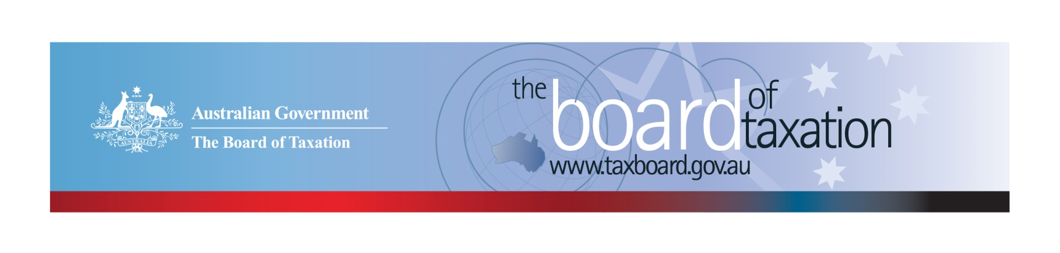
CEO Update – Budget Edition
Dear Stakeholders
I have some very important developments to report in this month’s update including reflections on what the Budget means for the Board, the outcomes of our April meeting, a farewell to departing Board members, and an announcement of new appointments.

2020-21 Budget
Individual tax residency rules
While the Budget contained much that was of interest, the Board was particularly delighted by the announcement of reforms to the individual tax residency rules to make them more certain and easier to understand and apply in practice. As our Chair recently noted, modernising residency rules has been a significant part of the Board’s work program since 2016. My thanks to the Working Group, Secretariat members past and present, and to our many stakeholders who contributed to this important outcome.
Research and Development Tax Incentive (R&DTI) – Review of the dual administration model
You may have noticed that, as part of a broader strategy for encouraging innovation, the Government has asked the Board to review the administrative framework of the R&DTI. Details of the review, including Terms of Reference, are now available at the Board’s website. It aims to identifying opportunities to reduce duplication between the two administrators, simplify administrative processes, or otherwise reduce the compliance costs for applicants.
We will keep our website updated to let you know of further developments and how you can participate. If you wish to provide early feedback on issues relating to R&DTI, or would like to register your interest to participate in future consultation, please drop us a line at RandD@taxboard.gov.au or +61 2 6263 4366.

April Board meeting
The Board’s April meeting – our second face-to-face meeting since the COVID shutdowns – was held in Brisbane at the offices of EY.
Much of the meeting was devoted to mapping out our work program for the coming financial year, including the R&D review. I look forward in coming months to sharing further details of our future work program and how you can contribute.
The Board also engaged in a lively discussion on recent developments on the OECD’s Blueprints for Pillar one and Pillar two.
The Board is maintaining a watching brief over developments in global taxation and its potential impacts on Australian multinational businesses. If you have views or insights to share, the Board would be most interested in hearing them.
Following the meeting, Board members had an opportunity to meet with stakeholders over lunch to continue the discussion of global taxation and a range of other topics. The insights we gain from these discussions are invaluable and we would like to extend our thanks to EY for being such a generous host.

Farewell to Mark and Craig
I couldn’t let this update pass without noting that the Board has bid a fond farewell to Dr Mark Pizzacalla and Mr Craig Yaxley, two valued members of the Board for the past six years.
Through their work with the Board, Mark and Craig contributed at the highest level in advising the Government of the business and broader community perspective.
Mark’s key contribution was on all things small business-related, bringing a wealth of expertise and experience to reviews of bare trusts, deferred consideration, CGT roll-overs and other Board work. It culminated in the important Review into Small Business Concessions which Mark chaired.
Craig’s corporate tax and accounting insights lead to the Board’s 2018 Reports on the alignment of tax and accounting concepts. He also provided the Board with a crucial link to Western Australia, where he is well-known and respected within the tax and business communities. Most recently, he chaired the Board’s ongoing review in CGT roll-overs where his experience in corporate restructures proved to be invaluable in the development of the Board’s recent advice to Government.
I should also note that both Mark and Craig were members of the Board’s Working Group for the individual residency report and will be encouraged by the recent Budget announcement.
I’m sure you will join me in congratulating Mark and Craig on their work with the Board and wishing them well in their future endeavours.

Appointments to the Board
Finally, I am happy to report that the Government has announced the appointment of Mrs Tanya Titman and Mr Ian Kellock as part-time members of the Board for a three-year period from 12 May 2021.
Tanya is a Partner at BDO and the Head of Strategic Innovation. She has 25 years’ experience in working with SMEs in areas such as strategic planning and management accounting. Mrs Titman founded her own small business and is the creator of BDO’s Startups Program and Business Growth Program for SMEs. Mrs Titman is a fellow of CPA Australia.
Ian is a Tax Partner at Ashurst, specialising in corporate and international tax and focused on taxation of mergers and acquisitions, corporate restructures, financing and other major transactions. Mr Kellock has over 20 years’ experience in taxation and is a Chartered Accountant.
The Board is looking forward to welcoming Tanya and Ian to their first Board meeting in May.
If you have any questions relating to the Board’s work on any of these projects, please contact the Board of Taxation Secretariat on: taxboard@treasury.gov.au or call 02 6263 4366.
Kind regards
Kathryn Davy
 | Kathryn Davy  Chief Executive Officer  Board of Taxation | phone: +61 2 6263 4266  email: Kathryn.Davy@treasury.gov.au
Treasury Building, Langton Crescent, PARKES ACT 2600 • Telephone: 02 6263 4366 • Email: taxboard@treasury.gov.au
Website: taxboard.gov.au • Sounding Board: taxboard.gov.au/sounding-board-plus

