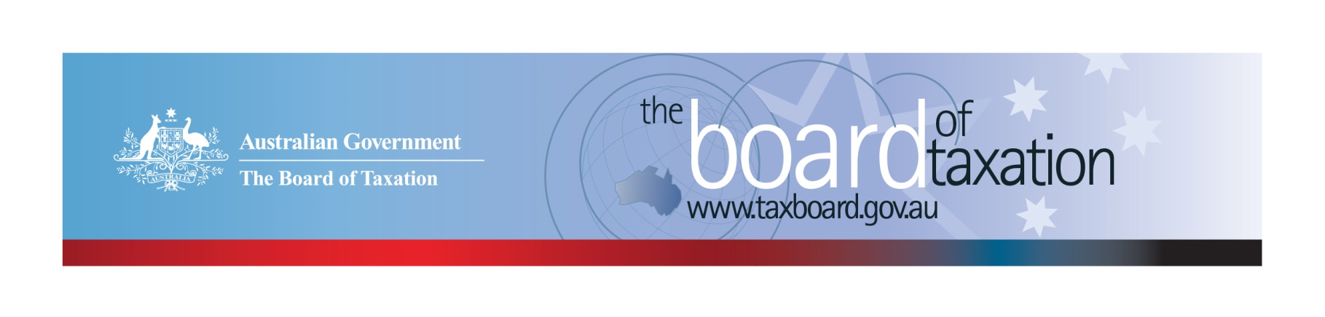
CEO Update – April 2021
Dear Stakeholders,
In February, the Board farewelled Lynn Kelly, who has been the Board’s interim CEO and an enormous asset to the Board since 2019. The Board congratulates Lynn on her new role as a First Assistant Secretary of Markets Group in the Department of the Treasury.
With Lynn’s departure, the Board has asked me to fill in as interim CEO. My name is Kathryn Davy. I have been a part of the tax profession for over 35 years. During this time, I have experienced the tax system and tax policy from the perspective of many of the Board’s stakeholders. Prior to starting my career in tax policy, I was the Head of Tax for a large media conglomerate and before this, a tax partner at EY. I look forward to working with the Board and with you, our stakeholders.
The Board met in Sydney for its February board meeting. It was a pleasure for the Board to reconnect in person after exactly one year of virtual board meetings. The Board was also delighted to again engage with our stakeholders face-to-face at the stakeholder lunch that followed. We were pleased and very encouraged to see stakeholders continue to express enthusiasm and interest in Board projects. The focus of the Board meeting and many of the questions raised by stakeholders at the lunch was on the review of CGT roll-overs. You can read about the review’s latest developments below.
I am also excited to announce the launch of a new Sounding Board platform, called, Sounding Board+. Stakeholders will now be able to submit ideas for tax system improvements to the Board using a more streamlined platform that is easier to use. You will find a link to Sounding Board+ below.
We would like to thank PwC for generously hosting the February Board meeting and stakeholder lunch. Much care and thought had gone into the planning of these events to ensure that participants would be COVID-safe. I would also like to thank our stakeholders who attended the lunch. It is important to the Board to hear your feedback.
We hope that as the year progresses, we will have many more successful stakeholder events where the Board is able to meet many more of you in person. In the meantime, you can keep up to date with the latest from the Board via our website or follow us on LinkedIn. You are also welcome to contact me directly (my details can be found at the end of this newsletter). I would love to hear from you.

Review CGT roll-overs
Submissions in response to the Board’s Second Consultation Paper for the CGT roll-over project has now closed. The consultation paper sought submissions on:
- a framework of principles for CGT roll-overs identified by the Board to help develop a shared understanding of the purpose of roll-overs, and
- a preliminary model for a general restructure roll-over proposed as a proof of concept.
The Board was pleased to receive 23 written submissions over a short consultation period. This response highlights to the Board the importance our stakeholders place on this review and reforms in the CGT roll-over space. We thank everyone who has contributed a written submission as well as area experts who have donated their time to discuss with us specific aspects of the Board’s paper. The practical insights provided by our stakeholders have been extremely valuable.

The release of the second consultation paper was accompanied by a Q&A session and the release of an information video discussing key components of the general roll-over for business restructuring. The Board has received tremendously positive feedback in respect of these initiatives which were designed to supplement the consultation paper. The information video which can still be viewed from the Board’s website received close to 150 views.
The Board has heard that these initiatives have helped stakeholders to quickly digest the complex ideas in the consultation paper and have made the Board’s ideas accessible to an audience that may not have engaged with a long consultation paper.
The Board is taking all this feedback on board and will consider similar initiatives in comparable future consultations. If you have any other feedback you would like to share with the Board, please feel free to reach out to me.

Sounding Board+
The Board is excited to launch its new Sounding Board platform, Sounding Board+!
We have redesigned the Sounding Board to focus on its core purpose - provide a public platform where users can submit ideas for tax law simplification and regulatory reform. Submitting your ideas is now easier and faster without the need to go through a registration and log-in process.
Like the original Sounding Board, all ideas submitted on Sounding Board+ are reviewed as a standing item on the agenda at each Board meeting. The ideas and the Board’s response to these ideas (including any progress made) will be published on the Sounding Board+ platform.
To contribute your own suggestions and to view previously submitted ideas (migrated from the original Sounding Board) please visit: https://taxboard.gov.au/sounding-board-plus
You can also navigate to Sounding Board+ by following the link from the Board’s home page: taxboard.gov.au
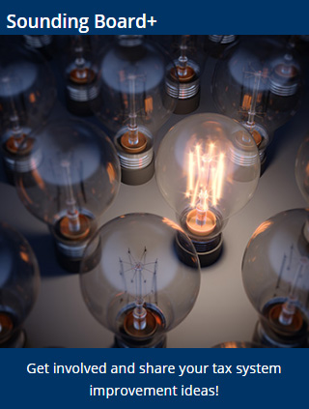
We hope you will like the new look of Sounding Board+.

Tax Transparency Code
The ATO is responsible for the centralised hosting of published reports for businesses who have adopted the Tax Transparency Code. If you have published a report (or changed where you house your historic reports on your company’s website) – please remember to notify the ATO by emailing: ttc@ato.gov.au.
For organisations wishing to sign up to the Tax Transparency Code you can email taxboard@treasury.gov.au stating the name of your organisation and the financial year you intend to first publish a tax transparency report. Your organisation will be recorded on our register of signatories as having committed to applying the principles and details of the Code.

2021 Meeting Dates
The Board’s meetings dates for the year are as follows*:

- 16 April – Brisbane
- 28 May – Melbourne
- 9 July – Adelaide
- 20 August – Melbourne
- 24 September – Canberra
- 29 October – Perth
- 10 December – Sydney

* Locations are indicative at this stage depending on travel restrictions.

Kind regards
Kathryn Davy
 | Kathryn Davy  Interim Chief Executive Officer  Board of Taxation | phone: +61 2 6263 4266  email: Kathryn.Davy@treasury.gov.au
Treasury Building, Langton Crescent, PARKES ACT 2600 • Telephone: 02 6263 4366 • Email: taxboard@treasury.gov.au
Website: taxboard.gov.au • Sounding Board: taxboard.gov.au/sounding-board-plus

