Skill Connector/Collaborator – Job Keeper/Job Seeker/Job Maker
Current Situation:
As a country we are entering a Recession, and there are fears that this recession could turn into a long-term depression.
If this happens, the Australian Government won’t be able to continue to provide financial support to every Australian, whether through Job Seeker, Job Keeper or Job Maker, without it impacting future Generations prosperity.
There are currently 3.5million Australians receiving the Job Keeper subsidy , and 1.3 Million receiving Job Seeker. Within those 4.8 Million Australians currently displaced, we have a lot of individuals who are highly skilled and educated outside of their occuptation.
For example, the below indicates different occupations that if given the Platform, could connect with each other. And either use their primary skills, or secondary skills to generate some kind of economic benefit. Create some kind of product, or service, or collaborative opportunity.
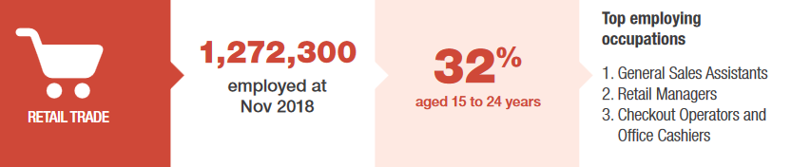
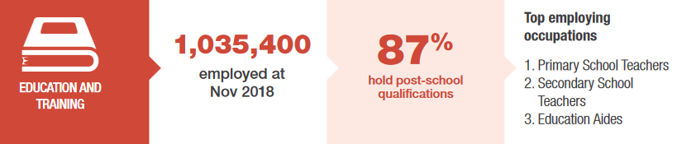
This idea is also more like a Pilot concept, as the real benefits could be realised depending on the state of the economy by the end of the year. But matching people based on Skills is something new that would need to be fleshed out.
If we as a Country are faced with Unemployment of 20% or more, Government stimulus for All Australian’s impacted will be untenable.
Other alternatives to help Australians help themselves will be needed.
This is one option.

Proposed Solution/ Steps involved:
- Develop a simple Platform that allows individuals to create a user profile and give them the ability to nominate skills they have, skills they’re interested in learning, and skills in others that could be useful.
- Identify which skills work well together currently, reflecting on current Business Teams. E.g. What types of people would you need for a Change Management Project in an organisation?
  - Change Manager
  - Content Creator
  - Project Manager
  - Analysts
  - Developers
What type of people would you need to Fix a Road?
What type of people would you need to Build a Website?
What type of people would you need to build Playground equipment?
What type of people would you need, to help with child raising activities?
What type of people would you need to build a Farm?
- Reflecting that – Just because someone has “Call Handling Skills” from working in a Call Centre, doesn’t mean that Don’t have
- Using free software like Zoom, Facebook Messenger, Whatsapp, Skype, allow individuals to move from a text based connector, to a video based connector.
- This could also be something that Google or Facebook, working in conjunction with the Australian Government could provide.
Benefits:
Develop a deeper understanding of a Population, their skills, aspirations and individuals they’re likely to connect with.
Provides a safe space for Australian’s to:
- Connect with each other
- Engage with each others Ideas
- Review or improve on previous projects.
The biggest benefit will be realised if we see more than 5% of the Job Insecure population trying to connect with others.
Potential Obstacles:
- Initial Buy-in from the average individual. Most people would want to see evidence this initiative works before engaging with it.
- Might require a small Pilot, potentially 100-1000 people, to see whether people find it beneficial.
- Job Keeper is a short-term interim initiative due to the COVID-19 pandemic, therefore this idea may not be deemed viable based on long-term prospects.
  - The assumption that Australia will bounce back from the Covid-19 economic impact is naïve, this concept has the potential to provide to generate economic activity through new Productive Digital Connections.
Current Outcome
OUTCOME 17/06/2020: I've let Scott know that I’ve received feedback from stakeholders in relation to the development of a capability (platform, systems, processes etc) that supports job seekers and job keepers to engage, skill match and participate in meaningful and productive work and/or project activities. While Superannuation and Employer Obligations (SEO) is the lead business line (BSL) for the design and delivery of the government’s current JobKeeper stimulus measure, we believe his aspirational idea is pointing to something different; it’s sort of a ‘next generation’ extension initiative for government/treasury to consider for job seeker and job keeper. This idea goes beyond our agency and also Centrelink (job seeker). A way forward may be to consider submitting this idea via the Sounding Board. While this space is related to ‘ideas for better tax regulation’, it might be a way to get some ‘Board’ eyes on the idea and see what happens from there. It could be added under the ‘Can government fix it?’ active campaign (the best available option). Investment funding will always be an issue but we believe this idea has merit and might grab some interest especially in the current context of a recessional environment, journey out of COVID and the government’s recently announced jobmaker plan that includes major infrastructure projects. Perhaps Scott might like to re-word his idea to include some linkage between jobseeker, jobkeeper and jobmaker? The 'public section innovation' had a space to submit ideas but this seems to have disappeared (or I've suggested to Scott to send them an email psi@industry.gov.au); July is Innovation month and this would fit in nicely we would think. Based on the above we have now finalised this idea in the Innovation system.

