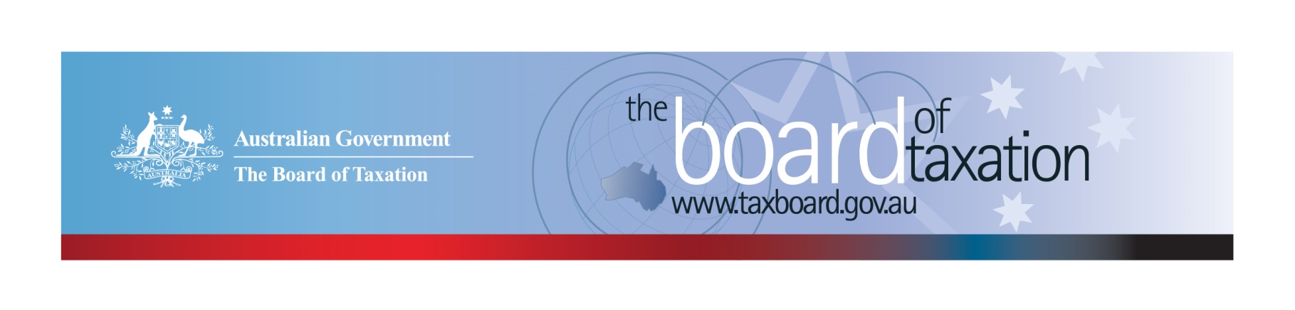
CEO Update – January 2021
Dear Stakeholders,
Happy New Year from the Board of Tax.
The past year was something of a landmark in the Board’s history. We welcomed our new Chair, Rosheen Garnon and a new member, Chris Vanderkley. Importantly, the Board was involved in developing a number of important Budget announcements, an example of which was our new report on corporate residency.
Similar to the business and tax communities, one of the major challenges for the Board in 2020 was adapting to the challenges of the COVID-19 global pandemic. This brought about major changes, not only to way we carry out activities but also our work program. The Board was repositioned to focus on supporting the Government in responding to the immediate economic impacts of the pandemic and developing a roadmap to economic recovery and returned prosperity. Fortunately, throughout this period, we were able to maintain a busy program of virtual engagement with the business and broader community.
A huge thank you to all our stakeholders for your support during this most challenging time.

December Board meeting
The Board held its final meeting for 2020 on Friday, 11 December.
The focus of the Board’s meeting was to discuss important developments in the review of CGT roll-overs, to reflect on the key lessons learned from a recent workshop with representatives of the small business sector, and to consider the Board’s work program for the coming year.
We also thanked Peter Quiggin PSM, QC who announced that he will be retiring from the Office of Parliamentary Counsel in early February. Peter has served as First Parliamentary Counsel and a Board member since 2004 and his impact on the Board has been profound, including through his long-standing work on the design of tax laws that are clear and simple to implement and administer. Peter’s wise counsel, exceeding generosity and good humour will be greatly missed. I’m sure you will join me in wishing Peter a happy and fulfilling retirement.

Review CGT roll-overs
The Board also released its Second Consultation Paper for the CGT roll-over project in December 2020. The paper has been prepared with two key objectives in mind:
- to present a framework of principles for CGT roll-overs to help develop a shared understanding of the purpose of roll-overs and the role they play in the CGT framework and the tax system more broadly.
- The development of the first application of the framework: a general roll-over for business restructuring.
The Board believes that a general business restructure roll-over could significantly reduce red tape, increase certainty and better align the tax rules with commercial restructuring practice. However, designing the roll-over is an ambitious exercise and your input will be crucial to its success.
The Board has requested written submissions by Friday, 5 February. In coming weeks, the Board will be reaching out to stakeholders to discuss specific aspects of the proposal. The Secretariat will also be releasing an information video on its website to cover the key aspects of the paper and will host a Q&A session at 4pm AEST on Thursday, 28 January 2021 to help stakeholders understand the key components of the proposed general roll-over for business restructuring. Please do not hesitate to get in touch with the Secretariat if you would like to register for the Q&A session or there are issues you would like to discuss.

Small business workshop
Early in December, the Board held a workshop with its Small Business Tax Concessions working Group. The aim was for participants to share their perspectives on how small businesses are faring in the current environment, and to discuss tax reform priorities. This in turn will inform the Board’s regular advice to Government on matters of small business taxation.
The workshop produced very useful intelligence on how small businesses are currently operating. A key observation was that the effects of the crisis are having very different impacts in different sectors with hospitality and tourism singled out as the most exposed. That said, there was some optimism that the ‘bounce back’ is coming quicker than expected. The Board also gathered very useful feedback on the various government programs and generated new ideas for possible future reforms.
Our sincere gratitude to those who participated in the workshop.

Tax Transparency Code
The ATO is responsible for the centralised hosting of published reports for businesses who have adopted the Tax Transparency Code. If you have published a report (or changed where you house your historic reports on your company’s website) – please remember to notify the ATO by emailing: ttc@ato.gov.au.
For organisations wishing to sign up to the Tax Transparency Code you can email taxboard@treasury.gov.au stating the name of your organisation and the financial year you intend to first publish a tax transparency report. Your organisation will be recorded on our register of signatories as having committed to applying the principles and details of the Code.

2021 Meeting Dates
The Board’s meetings dates for next year are as follows*:

- 26 February – Sydney
- 16 April – Brisbane
- 28 May – Melbourne
- 9 July – Adelaide
- 20 August – Melbourne
- 24 September – Canberra
- 29 October – Perth
- 10 December – Sydney

* Locations are indicative at this stage depending on travel restrictions.

Kind regards
Lynn Kelly
 | Lynn Kelly  Interim Chief Executive Officer  Board of Taxation | phone: +61 2 6263 3279  email: lynn.kelly@treasury.gov.au
Treasury Building, Langton Crescent, PARKES ACT 2600 • Telephone: 02 6263 4366 • Email: taxboard@treasury.gov.au
Website: taxboard.gov.au • Sounding Board: taxboard.ideascale.com

