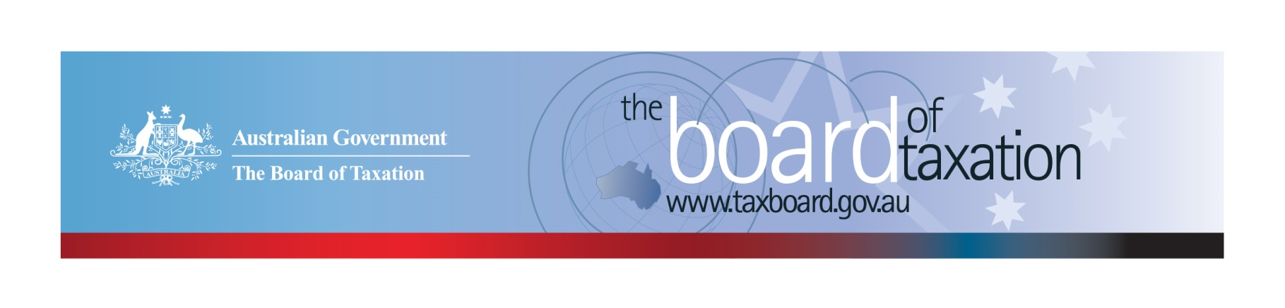
CEO Update – November 2020
Dear Stakeholders,
The Board met via video conference on 6 November to discuss, amongst other things, the review of CGT rollovers and the outcomes from the 2020-21 Budget. We were particularly encouraged to see that the Budget included a number of significant announcements drawing on the Board’s recent work in the Review of Corporate Tax Residency and Review of Granny Flat Arrangements. The Board also welcomes the Government’s announcement to allow employers to rely on corporate records for the purposes of fringe benefits tax (FBT). This measure is consistent with the Board’s findings on compliance pain points through our Fringe Benefits Tax Compliance Cost Review.
Further information about these recommendations have been included below, with the reports from the Review of Corporate Tax Residency and Review of Granny Flat Arrangements available on the Board’s website.
These high quality Board reports and well-considered recommendations would not be possible without the active support and contributions from our stakeholders. Your engagement really does make a difference!
The Board is currently working towards releasing a discussion paper before the end of the year as part of its Review of CGT Rollovers. We would like to encourage our stakeholders to get in touch and participate in our future consultations. Further details are enclosed below.

Corporate Tax Residency Review
As part of the Budget, the Government announced that it would amend and clarify corporate residency laws consistent with the Board’s key recommendation from the Review of Corporate Tax Residency. A company incorporated overseas will be an Australian tax resident if both the company’s core commercial activities are undertaken in Australia and its central management and control is in Australia.
The Board understands the business community’s desire to see further implementation detail, including how the concept of ‘core commercial activities undertaken in Australia’ is to be expressed in the law. In this regard, the Board’s report, which can be found here, outlines a list of factors that the Board considered relevant in determining whether “core commercial activities” are undertaken in Australia (see section 5.32). In addition, a number of examples that illustrate how the factors listed may be applied in practice is outlined in Appendix C to the report.
The Board expects that this work will play a key role in informing the legislative design. However, most importantly, Treasury is likely to undertake a public consultation on the draft legislation and explanatory memorandum in due course, so watch this space.

Review of Granny Flat Arrangements
The Board’s Review of Granny Flat Arrangements Report involved assessing the tax circumstances surrounding the making of formal, written and legally enforceable family arrangements where, at its simplest, older Australians transfer their home, or proceeds from the sale of their home to their adult children, or other trusted persons, in return for the promise of ongoing housing and care.
On 5 October 2020, the Government announced a capital gains tax exemption for the creation of a granny flat arrangement, as well as other CGT events that happen over the life of the arrangement. It will apply from 1 July 2021 subject to legislation passing. It also appears that the exemption will be available for arrangements involving people with disabilities in addition to older Australians.
The Government’s announcement draws on the Board of Taxation’s recommendations. The Board’s report can be found here.

Fringe Benefits Tax Compliance Cost Review
In February 2018, the Government asked the Board to conduct a comprehensive review of the compliance costs associated with obligations under the FBT legislation. As part of the review, the Board undertook a number of research initiatives, including employer surveys, to estimate and identify reasons for compliance costs.
Through this process businesses discussed evolutions in technology and corporate governance which had the effect of making available information through normal corporate records that previously had to be prescribed in the FBT law, albeit in a different format. This now unnecessary compliance burden was a source of much angst (and cost) amongst employers. As a consequence the Board welcomes the Government’s announcement. This measure will make a real difference, reducing compliance cost for employers of all sizes in Australia.

Review of CGT Roll-overs
Despite the difficulties and disruptions created by the pandemic, the Board is very grateful for the strong engagement from the tax community on this Review.
The Board has sought to ensure that we are prioritising the diverse issues raised with us to align with the Government’s current economic strategy, including supporting a private sector-led economic recovery that drives employment and productivity. Key to this is red tape reduction and making it easier for businesses to invest/adapt.
Consistent with the Terms of Reference for the review, the Board has focussed on:
- identifying and developing foundation principles for CGT roll-overs, and
- exploring the opportunity to rationalise the most commonly used business restructure roll-overs into a new generic roll-over that is more flexible (because it removes the disparate constraints of the current transaction-based rules), more aligned with commercial practice, and more certain in its application.
At this stage, the Board considers that generic business restructuring relief has the potential to significantly reduce the cost of compliance associated with the current roll-over system.
However, rationalisation is an incredibly complex undertaking and we would appreciate your assistance in co-designing the generic roll-over relief. The Board is looking to release a consultation paper next month and we invite your collaborative input.

Sounding Board
We recently received an idea on the Sounding Board relating to the indirect value shifting provisions. You can read the idea here and if you have insight relating to this issue, please leave a comment.
The Sounding Board is a public forum run by the Board where stakeholders can submit ideas for tax law simplification and improvement. If you would like to contribute your own suggestions or to view ideas currently listed on Sounding Board visit: https://taxboard.ideascale.com/.

Tax Transparency Code
The ATO is responsible for the centralised hosting of published reports for businesses who have adopted the Tax Transparency Code. If you have published a report (or changed where you house your historic reports on your company’s website) – please remember to notify the ATO by emailing: ttc@ato.gov.au.
For organisations wishing to sign up to the Tax Transparency Code you can email taxboard@treasury.gov.au stating the name of your organisation and the financial year you intend to first publish a tax transparency report. Your organisation will be recorded on our register of signatories as having committed to applying the principles and details of the Code.

Board meeting dates
The Board will meet once more this year on 11 December 2020, and has agreed on the following dates for 2021.

- 26 February
- 16 April
- 28 May
- 9 July
- 20 August
- 24 September
- 29 October
- 10 December

Contact options
Our team continues to work remotely so encourages stakeholders to stay in contact with us through the following ways.

Thank you and we look forward to meeting you in person again in the near future.
Please stay safe and keep in touch.
If you have any questions relating to the Board’s work on any of these projects, please contact the Board of Taxation Secretariat on: taxboard@treasury.gov.au or call 02 6263 4366.

Kind regards
Lynn Kelly
 | Lynn Kelly  Chief Executive Officer  Board of Taxation | phone: +61 2 6263 3279  email: Lynn.kelly@treasury.gov.au
Treasury Building, Langton Crescent, PARKES ACT 2600 • Telephone: 02 6263 4366 • Email: taxboard@treasury.gov.au
Website: taxboard.gov.au • Sounding Board: taxboard.ideascale.com

