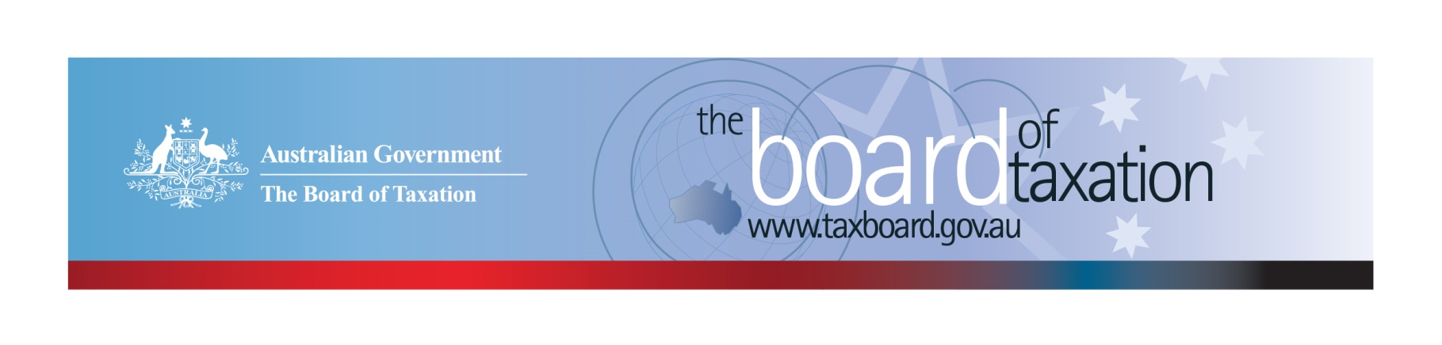
CEO Update – August 2020
Dear Stakeholders,
The Board of Taxation (the Board) has continued to meet over the winter months via video conference. Key items discussed at these meetings included approving the Board’s final report on corporate tax residency rules and progressing the Board’s review of CGT rollovers, please see below for more detail on these two projects.

We were also joined at our last meeting by the Inspector-General of Taxation and Taxation Ombudsman (IGTO), Karen Payne and from Duy Dam to hear about their Review into Death and Taxes and their current work assessing the effectiveness of ATO communications. As part of this investigation, the IGTO has developed a ten question survey to help understand what information is currently provided to taxpayers and their representatives about their rights to complain, review and appeal.
Our Chair, Rosheen Garnon, recently met with the Assistant Treasurer to provide an update on the Board’s work and discuss how the Board can support the Government as the economy emerges from the COVID-19 pandemic. In these challenging times, the Board will continue to provide the Government with real-time advice that reflects the business and tax community perspective to improve the design and operation of taxation laws.

Review of corporate tax residency rules
The Board has now finalised and submitted its report on the corporate residency rules to the Government for consideration. During the course of the Board’s review, it became clear that the rules determining the tax residency of a foreign incorporated company are in need of urgent reform. The Board has undertaken extensive consultation in developing its recommendations and also worked closely with stakeholders to ensure that the recommended reform would operate appropriately in light of modern board practices and Australian international tax integrity rules.
We are very grateful to the significant stakeholder engagement that has assisted to finalise this work.

Review of CGT rollovers
To date, the Board had successfully conducted two physical and six video general consultation sessions and received fourteen written submissions from stakeholders, which are currently under review by the Working Group.
As the next step of the review process, we have set up a number of Working Group workshops to discuss the information collected from the initial consultation phase and to develop a range of reform options. Three of these workshops have been conducted since my last update, covering issues relevant to superannuation funds, corporate restructures and small business rollovers.
As an output from these workshops, the Board is looking to release a reform options paper later this year. In the meantime, if you are interested in providing the Board feedback on how to make rollovers simpler and easier to use, please email CGTrollovers@taxboard.gov.au.

Voluntary Tax Transparency Code
The voluntary tax transparency code plays an important role to help educate the public in relation to businesses’ compliance with Australia’s tax laws. The voluntary code provides a framework for large and medium businesses to follow when developing their disclosures. The flexible nature of the code allows organisations to highlight contributions, by way of taxes, to the Australian community.
The Board is aware that many companies have been busy dealing with the impacts of COVID-19 but continues to encourage businesses to sign up to the voluntary code and continue to publish their reports as they transition to normality.
Signing up to the voluntary code is easy. Simply email taxboard@treasury.gov.au stating the name of your organisation and the financial year you intend to first publish a tax transparency report. Your organisation will be listed on our Register of Signatories as having committed to applying the principles and details of the voluntary code. Don’t forget to update the ATO with the link to your new report each year!

Sounding Board
Improving the tax system through simplification and regulatory reform is a key mandate of the Board of Taxation. One way the community can influence what the Board looks at in the future is via the Board’s online collaborative platform - Sounding Board. Sounding Board is a public forum run by the Board where stakeholders can submit ideas for tax law simplification and improvement.
If you would like to contribute your own suggestions or to view ideas currently listed on Sounding Board visit: https://taxboard.ideascale.com/.

2020 Meeting Dates
The Board’s meeting dates for the remainder of 2020 are as follows*:

- 18 September – Melbourne
- 5 November – Perth
- 11 December – Sydney

*The Board is currently meeting virtually and will continue to assess how we meet to ensure compliance with social distancing and travel requirements.

Contact options
Our team continues to work remotely so encourages stakeholders to stay in contact with us through the following ways.

Thank you
We look forward to meeting you in person again in the near future.
Please stay safe and keep in touch.

Kind regards
Lynn Kelly

 | Lynn Kelly  Interim Chief Executive Officer  Board of Taxation | phone: +61 2 6263 3279  email: lynn.kelly@treasury.gov.au
Treasury Building, Langton Crescent, PARKES ACT 2600 • Telephone: 02 6263 4366 • Email: taxboard@treasury.gov.au
Website: taxboard.gov.au • Sounding Board: taxboard.ideascale.com

