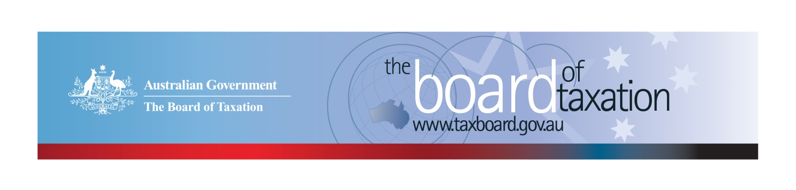
CEO Update – June 2020
Dear Stakeholders,
The Board of Taxation (the Board) held its June meeting recently via video conference. As part of the meeting our Chair Rosheen Garnon congratulated Dr Julianne Jaques on her reappointment to the Board for a second three-year term. I am personally looking forward to continuing to work with Julianne given the keen intellect and legal acumen she contributes to our work.
Key items discussed at the meeting included finalising elements of the Board’s review of corporate tax residency rules and progressing the Board’s review of CGT rollovers. I have outlined further details on these two pieces of work below.
Importantly, members turned their attention to how best the Board can support economic recovery in a post-COVID-19 world. We considered what the tax system might look like, the role the Board can play and discussed some potential measures that might drive growth, productivity and reduce the regulatory burden on businesses.

Review of corporate tax residency rules
The Board is close to finalising our review of the corporate residency rules and is working closely with Treasury and the ATO in formulating our recommendations. As part of this, the Working Group conducted a targeted consultation with a number of small and medium (SME) enterprise tax specialists in order to ensure that the Board’s recommendations will effectively work across different segments of the market.
The Board appreciates the continued support and assistance from our stakeholders in this project.

Review of CGT rollovers
The Board has resumed consultations on our review of CGT rollovers, replacing previously scheduled face-to-face round-table consultations with video conferences. We conducted seven consultations between 21 May and 5 June 2020, including two specialist consultations - one focused on SME issues and another on marriage breakdown rollovers. We have received eleven written submissions so far.
Through our recent consultations, the Board received valuable insights from over thirty stakeholders around how the current suite of CGT rollovers could be improved. We thank all of our stakeholders who have contributed to this initial consultation process for their flexibility, professionalism and generosity with sharing their knowledge.
While this general round of video consultation has finished, we are still interested to hear from stakeholders with expertise in relationship breakdown rollover relief or the effect of death on CGT (Division 128 of the ITAA 1997). If you have knowledge in either of these areas and are interested in assisting the Board to make rollovers simpler and easier to use, please email CGTrollovers@taxboard.gov.au.

Voluntary Tax Transparency Code
The voluntary tax transparency code plays an important role to help educate the public in relation to business compliance with Australia’s tax laws. The voluntary code provides a framework for large and medium businesses to follow when developing their disclosures. The flexible nature of the code allows organisations to highlight contributions, by way of taxes, to the Australian community.
The Board is aware that many companies have been busy dealing with the impacts of COVID-19 but continues to encourage businesses to sign up to the voluntary code and continue to publish their reports as they transition to normality.
Signing up to the voluntary code is easy. Simply email taxboard@treasury.gov.au stating the name of your organisation and the financial year you intend to first publish a tax transparency report. Your organisation will be listed on our Register of Signatories as having committed to applying the principles and details of the voluntary code.

Sounding Board
Improving the tax system through simplification and regulatory reform is a key mandate of the Board of Taxation. One way the community can influence what the Board looks at in the future is via the Board’s online collaborative platform - Sounding Board. Sounding Board is a public forum run by the Board where stakeholders can submit ideas for tax law simplification and improvement.
If you would like to contribute your own suggestions or to view ideas currently listed on Sounding Board visit: https://taxboard.ideascale.com/.

Vale Paul Drum
Paul was a great friend and supporter of the Board of Taxation. Paul gave his time freely to assist with the Board’s work and always made himself available notwithstanding other commitments he may have had. On the personal side, Paul was able to break the ice and have a laugh to make things seem lighter whenever things got heavy. The Board would like to extend its condolences to family and friends – Paul will be sorely missed. A true gentleman of the profession.

2020 Meeting Dates
The Board’s meeting dates for the remainder of 2020 are as follows*:

- 10 July – Sydney
- 14 August – Adelaide
- 18 September – Melbourne
- 5 November – Perth
- 11 December – Sydney

*The Board is currently meeting virtually and will continue to assess how we meet to ensure compliance with social distancing and travel requirements.

Contact options
Our team continues to work remotely so encourages stakeholders to stay in contact with us through the following ways.

Thank you
We look forward to meeting you in person again in the near future.
Please stay safe and keep in touch.

Kind regards
Lynn Kelly

 | Lynn Kelly  Interim Chief Executive Officer  Board of Taxation | phone: +61 2 6263 3279  email: lynn.kelly@treasury.gov.au
Treasury Building, Langton Crescent, PARKES ACT 2600 • Telephone: 02 6263 4366 • Email: taxboard@treasury.gov.au
Website: taxboard.gov.au • Sounding Board: taxboard.ideascale.com

