 | 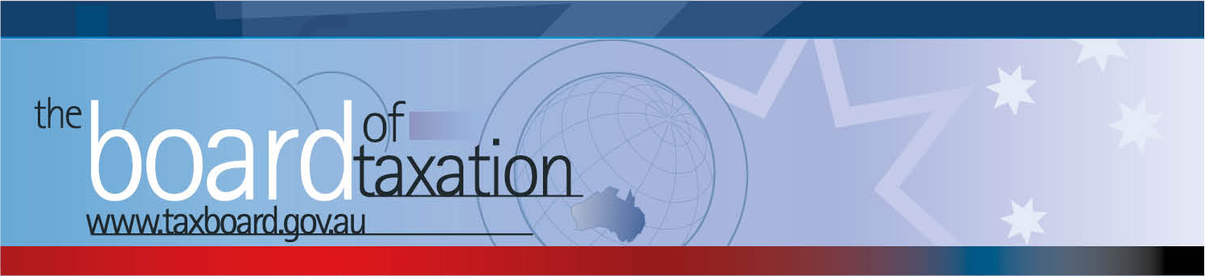
 |  |  | CEO Update – June 2017
Dear Stakeholders,
On 26 May 2017, the Board of Taxation (the Board) held its fourth meeting for 2017 in Canberra. The meeting was hosted by the Department of the Treasury and the recent Budget was a central theme of the Board’s agenda.
In addition to our discussion of the tax measures from the Government’s 2017/18 budget, the Board discussed the progress and direction of our current projects (a number of which are concluding in June), new instructions and referrals, a stocktake of our reports and recommendations to date and our possible pipeline for future projects (to be confirmed with the Minister). The Board also discussed a range of ideas from the Sounding Board that could be included in a Regulatory Reform Bill. The Board noted the publication by the Australian Accounting and Standards Board (AASB) of guidance for corporate taxpayers on complying with the Tax Transparency Code (the Code). Some additional detail on these matters is set out below.
 |  |  | 2017/2018 Budget
 |  |  | The Board received an update from Treasury on the 2017/2018 Budget and the budgetary process. There was a general discussion on the budgetary process and measures during which the Board members had an opportunity to share some observations and provide comments and feedback based on their discussions with community stakeholders.
 |  |  | LinkedIn – Board of Taxation is live!
The Board is now on LinkedIn! For those of you who are on LinkedIn, you can follow the Board’s page here.
As you can see, this CEO Update has been published on our LinkedIn, and we will be publishing future correspondence on our page. The Board expects that this platform will enhance its engagement with stakeholders in the tax community (as we know so many of you are already very active on LinkedIn). We hope you enjoy and share our posts!
 |  |  | Our Pipeline for 2017 – contingent consideration
The Board discussed several ideas (many of which have been contributed by stakeholders) to add to its pipeline of work.
The Board agreed to undertake a review of the current taxation treatment of contingent consideration arrangements - to be led by Board member Ann-Maree Wolff and the working group to include Craig Yaxley and Mark Pizzacalla. Please contact us on the details below if you would like to be consulted.
 |  |  | Our current projects and new referrals
The Board continues to be involved with the Government’s Black Economy Taskforce. The Board is also progressing (some towards completion) the Board’s other projects. This includes the following projects:
- targeted trust simplification – bare trusts (to conclude in June);
- definitions under State and Federal Laws (to conclude in June);
- high wealth individuals and residency (ongoing);
- tax and the sharing economy (ongoing); and
- alignment of tax and accounting concepts (ongoing).
The Board also discussed its recommendations and advice to Treasury on whistle-blower protections and its ongoing consultation on the OECD proposal for Mandatory Disclosure Rules (for the early disclosure of aggressive tax arrangements). Some further details on some of the projects is provided below.
 |  |  | Black Economy Taskforce
 |  |  | The Board received an update from the Chair on the work to date of the Black Economy Taskforce. This included both the Government’s release of the interim report and the opening of a public discussion into the black economy. The Chair noted that public meetings will be held nationally throughout June. Go to the website for more information https://consult.treasury.gov.au/tax-framework-division/black-economy-taskforce/.
 |  |  | Targeted Trust Simplification – Bare Trusts
 |  |  | The Board discussed a revised draft working paper of the working group led by John Emerson in relation to the income tax treatment of bare trusts. The project is considering how to ‘disregard’ custodial style bare trusts and simplify the ‘absolute entitlement’ interaction issues for CGT and income tax purposes. The Board expects to finalise this report before 30 June 2017.
 |  |  | Mandatory Disclosure Rules
 |  |  | The Board has undertaken consultation with business, professional and community stakeholders to inform its advice and evaluate proposals for implementation of Mandatory Disclosure Rules. The Board continues to consult on these measures and encourages you to contact us on the details below if you would like to be consulted. The Board is due to speak with officers from HMRC to understand the UK experience in implementing similar rules.
 |  |  | Stocktake of our work to date
 |  |  | The Board discussed a revised stocktake of its reports and recommendations. As the Board finalises its stocktake, it will also be seeking stakeholder input on priority issues for the business community and tax profession. Please contact the Board if you are interested in contributing to this work.
 |  |  | Tax Transparency Code
The Board noted that 90 organisations (including private and foreign companies) have now indicated their intention to adopt the Code – the set of principles and minimum standards to guide the disclosure of tax information by businesses. As this update is being sent out, 45 companies have already published their first reports. A register of these organisations can be found at: http://taxboard.gov.au/current-activities/transparency-code-register/.
The Board discussed the draft guidance material published by the AASB that will guide organisations seeking to comply with the obligations under the Code. The AASB seeks public comments on this draft – the Board urges you to review the draft guidance and submit comments to the AASB at: http://www.aasb.gov.au/Work-In-Progress/Open-for-comment.aspx?id=2085.
The Board encourages you to adopt the Code and support and assist your clients to adopt it. For further information on the Code or to register your intention to adopt it, please contact the Board at taxboard@treasury.gov.au.
 |  |  | Regulatory Reform Bill and Sounding Board
The Board discussed a range of ideas – generated from stakeholder consultations and the Sounding Board - that could be included in a regulatory reform Bill. These ideas are (in the Board’s view) ‘uncontentious’ and represent tax system improvement, reduction of red tape or reduced tax compliance. The Board believes these ideas to be non-controversial and supported by the business and tax community, and as such, likely to attract bi-partisan support.
The Board continues to monitor and review activity on Sounding Board, which is a standing item on the Board’s agenda. If you would like to comment, vote or post your own suggestion, you can do so by registering with Sounding Board. Please visit Sounding Board for more information – https://taxboard.ideascale.com/.
 |  |  | Upcoming 2017 Board Meetings
 |  |  | The next Board meeting will be held in Melbourne on 6 July 2017. KPMG have kindly agreed to host the next Board meeting. Please do not hesitate to contact the Board of Taxation on 02 6263 4366 should you wish to discuss any of the above matters further.
Kind regards
Karen Payne
 |  | Karen Payne  Chief Executive Officer  Board of Taxation |  | phone: +61 2 6263 2122  mobile: 0405 843 880  email: karen.payne@treasury.gov.au
 |  | C/- The Treasury  100 Market Street, Sydney NSW 2000 |  | website: www.taxboard.gov.au  The Board of Taxation Secretariat  Langton Crescent, Parkes ACT 2600 Australia

