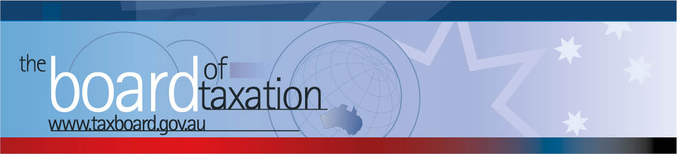

CEO Update – July 2017
Dear Stakeholders,
On 6 July 2017, the Board of Taxation held its fifth meeting for 2017 - in Melbourne.
The Board had the pleasure of welcoming the Minister for Revenue and Financial Services, the Hon Kelly O’Dwyer MP, to the meeting. This provided us with an opportunity to update the Minister on the Board’s current projects and pipeline of ideas. The Minister also welcomed Dr Julianne Jaques to her first Board meeting.
The Minister outlined the Government’s priorities and thanked the Board for its important work. The Minister also discussed the legislative agenda with the Board; including the Government’s provision of additional funding in the 2017-18 Budget for Treasury and the Office of Parliamentary Counsel to ensure dedicated drafting resources are available for progressing the Government’s legislative agenda – a large component of which includes financial services and taxation reform legislation.
The Board’s lunch meeting was hosted by KPMG and included an information session and discussion with stakeholders. Thank you to everyone for attending and contributing your ideas and observations on how we can improve the tax system.
Some additional detail on the progress of the Board’s work is set out below.

Tax Transparency Code
The Board noted that over 100 organisations (including Government Business Enterprises and foreign companies) have now indicated their intention to adopt the Code – the set of principles and minimum standards to guide the disclosure of tax information by businesses.
The Board notes that more than 40 signatories have signed up for the Code this year.
A register of these organisations can be found at: http://taxboard.gov.au/current-activities/transparency-code-register/.
The Board continues to work with the AASB on material to guide organisations seeking to comply with the obligations they have taken on under the Code.
The Board encourages you to adopt the Code and support and assist your clients to adopt it. It is as simple as sending us an email setting out your groups’ intentions! For further information on the Code or to register your intention to adopt it, please contact the Board at taxboard@treasury.gov.au.

Our Current Projects
The Board continues to be involved with the Government’s Black Economy Taskforce and is progressing several other projects towards completion. Work continues to progress on the following projects:
- tax and the sharing economy;
- high wealth individuals and residency;
- alignment of tax and accounting concepts;
- definitions under State and Federal Laws;
- contingent consideration.
The Board provided an outline of its consultations regarding the implementation of the OECD proposal for Mandatory Disclosure Rules.
The Minister encouraged the Board to consider ways to improve the experience of business interacting with Government through the tax system by identifying holistic solutions (not a silo, single issue approach).
Some of our current projects are expanded upon below.

Black Economy Taskforce
The Board received an update from the Chair on the work to date of the Black Economy Taskforce (the Taskforce). The Board discussed the recently concluded national roadshow of the Taskforce, the previously announced interim recommendations and longer term issues still under consideration. A number of the Taskforce themes have overlap with the work of the Board.
Tax and the Sharing Economy
The Board discussed a draft report of the working group led by Neville Mitchell in relation to income tax and the Sharing Economy. The Board provided some observations and is now in a position to finalise this report. The report will be made available to the Taskforce workstream groups that are considering sharing economy issues.
High Wealth Individuals and Residency
The Board discussed a draft working paper of the working group led by Mark Pizzacalla in relation to residency and high wealth individuals. The Board provided observations and comments in relation to some matters still under consideration by the working group including the interactions between other tax and visa policies relating to inbound and outbound individuals. The Board intends to conclude this project at the next Board meeting.

Definitions under State and Federal Laws
The Board received an update on the working group’s review of inconsistencies between core definitions and concepts relating to the state and territory payroll taxes, land tax and duties. This work, based on a report provided to the Board by Deloitte, notes a number of significant differences. The Board would like to include in its report some feedback from stakeholders on the likely impact and consequences of the variations and differences relating to the state and territory payroll taxes, land tax and duties. The report, once completed, will be made available to Federal and State Ministers for their information. Please contact us at taxboard@treasury.gov.au if you have any comments, observations and feedback to share in relation to this issue. Stakeholders that would like to receive a copy of the report, once completed (and have not previously asked for a copy), should contact us.

Stakeholder Information Discussion
During the Board’s information session with stakeholders and the Board’s Advisory Panel, there was an update on a number of projects of interest to participants. A number of ideas were also raised by Stakeholders for future analysis by the Board. Some of these ideas include the following:
- Improved operation of the Employee Share Scheme rules for private companies. Reynah Tang from Johnson, Winter & Slattery provided the Board with a submission prepared by the Law Council of Australia to the ATO April 2017 Consultation Paper on Division 83A. The submission identified ten areas that would deliver tax system improvement, including matters of administration, the exercise of the Commissioner’s remedial power and legislative reform. This includes:
- the interaction with value shifting, fringe benefits tax and Division 7A;
- the application of the share buy back and the franking regime in the context of private company employee share scheme buy-backs;
- the meaning of “ESS interest” and related issues;
- indeterminate rights;
- deferral conditions; and
- cross-border schemes.
The ATO is currently considering stakeholder feedback to design and develop public advice and guidance in this area. Some of the issues raised may extend beyond tax administration.
- Post-implementation reviews in the coming years on the Diverted Profits Tax and the GST on low value goods (these ideas were raised by Tony Stolarek from EY and Paul Drum from CPA Australia respectively).
We welcome your feedback on any of the ideas and other areas that you consider should be considered in our potential pipeline of work.

 |  |  | Thank You
 |  |  | The Board would also like to thank KPMG for hosting the Board in Melbourne – the Board is most grateful. The Board would like to thank all those who participated in the discussions over lunch. We remind you that you can contact us at any time – refer to my contact details below or please email taxboard@treasury.gov.au.
 |  |  | Sounding Board
 |  |  | The Board continues to monitor and review activity on Sounding Board, which is a standing item on the Board’s agenda. If you would like to comment, vote or post your own suggestion, you can do so by registering with Sounding Board. Please visit Sounding Board for more information – https://taxboard.ideascale.com/.
 |  |  | Upcoming 2017 Board Meetings
 |  |  | The next Board meeting will be held in Adelaide on 10 August 2017. Please do not hesitate to contact the Board of Taxation on 02 6263 4366 should you wish to discuss any of the above matters further.
Kind regards
Karen Payne
 |  | Karen Payne  Chief Executive Officer  Board of Taxation |  | phone: +61 2 6263 2122  mobile: 0405 843 880  email: karen.payne@treasury.gov.au
 |  | C/- The Treasury  100 Market Street, Sydney NSW 2000 |  | website: www.taxboard.gov.au  The Board of Taxation Secretariat  Langton Crescent, Parkes ACT 2600 Australia

