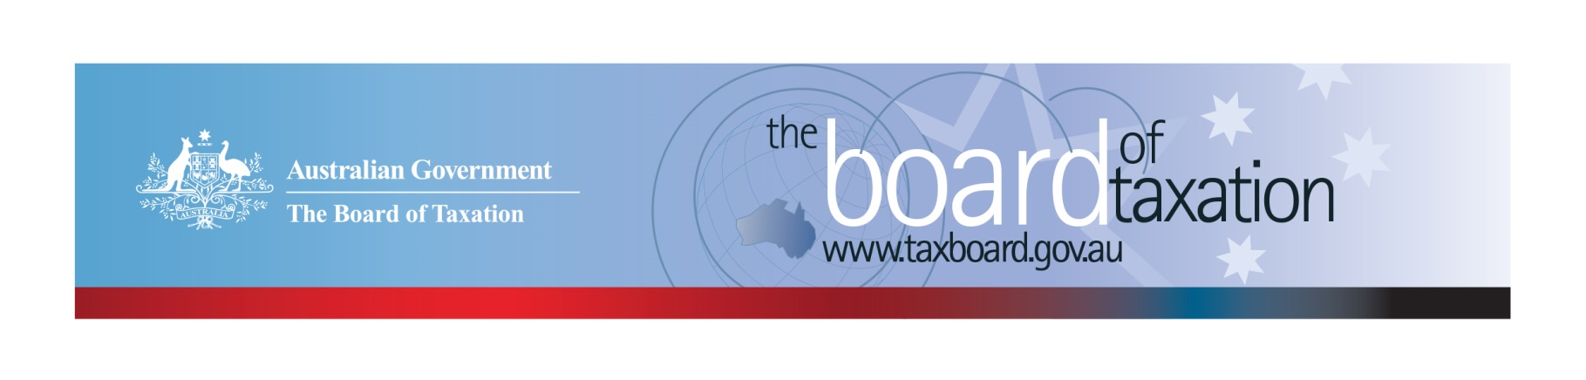
CEO Update – October 2018
Dear Stakeholders,
The Board of Taxation (the Board) held its October Board meeting recently in Perth. The Board would like to thank KPMG for hosting our meeting and discussion over lunch with our advisory panel and stakeholders.
At the Board’s meeting, we discussed the progress and direction of our current projects and future work programs. We also took the opportunity in Perth to consult with a number of stakeholders on some of these projects. We discussed a number of recently released Treasury consultations including The Digital Economy and Australia’s Corporate Tax System. The Board also received an update from the Chair on his ongoing involvement in the implementation of measures relating to the black economy. Peter Quiggin and myself met with the Tax Institute in Perth to provide an update and overview on the work of the Board. Some further details are set out below for your information.
Many thanks to the corporate and tax community in Perth for your engagement with the Board.

Overview of current agenda
The following is an overview of our current work program, which includes:
- Review of small business tax concessions;
- Further work on tax residency for individuals;
- Review of the Voluntary Tax Transparency Code (the Code);
- Consideration of certain aspects of not-for-profit tax concessions;
- Fringe Benefits Tax (FBT) compliance cost and international practice review;
- Sounding Board.
Further information on the status of some of our projects is set out below.

FBT compliance cost and international practice review
Taxpayers selected to participate in the Board’s FBT Compliance Cost Survey were sent an invitation by the ATO, on behalf of the Board, on 2 October 2018. Participation rates for the taxpayer survey have been better than expected and the Board will have sufficient responses to conduct sound statistical analysis on FBT compliance costs when the surveys close at mid-night on Tuesday, 6 November 2018.
Taxpayers and tax advisers who would like to volunteer to participate in the Board’s Public Survey on FBT compliance costs can go to the Public Survey using on the link below:

Start Public Survey

The Board encourages tax agents to share their experience and insights into FBT compliance costs via the Public Survey. All responses are private and confidential - the Board will receive aggregated data only. Greater participation from tax agents in the Public Survey will help us complete the picture!
Please note, you do not need to be a registered tax agent (personally) to complete the survey. The survey can be can be completed on the basis of your ‘collective’ experience in advising clients on FBT and need not be on behalf of any specific client. That is, we are interested to understand your experience as an advisor.
The information gathered from both surveys will assist the Board in identifying areas where FBT legislation could be improved to reduce compliance costs.
Information is also being collected as part of this review through case study interviews with employers from a wide spread of industries and market segments.

Tax residency for individuals
The Board’s consultation on reforming the individual tax residency rules continued throughout October. The Board has undertaken roundtable consultation with stakeholders in Perth, Sydney and Melbourne, and received written submissions. Consistent with the Board’s prior consultations on this topic, there was overwhelming consensus from stakeholders on the importance of reforming the rules and reducing the burden on taxpayers and the ATO. Discussions focused on ways to make it easier for taxpayers to understand the rules and thus comply, as well as how to strike the right balance of simplicity, certainty and integrity.
The period for receiving written submissions closed on 26 October. The Board extends its sincere thanks to all who have participated in the consultation process to date.
The Board will now consider the results of its consultation with a view to providing advice to Government by the end of the year.

Tax transparency
The Board is pleased to report that take-up of the Code continues to increase. As at 29 October 2018, there were 152 signatories of the Code, with 125 of those having published at least one report. The full register of signatories can be found on the Board’s website.
The ATO maintains a list of published reports, with links to those reports, on data.gov.au. A reminder to all signatories of the Code – please notify the ATO when you publish your tax transparency reports so the ATO can update its dataset. You should also notify the ATO if the link to your report changes. Details on how to notify the ATO are available on the ATO website.
The Board encourages you to adopt the Code and support and assist your clients to adopt it. It is as simple as sending us an email setting out your groups’ intentions! For further information on the Code or to register your intention to adopt it, please contact us at taxboard@treasury.gov.au.
The Board has recently met with stakeholders in Sydney, Melbourne and Perth as part of its review of the Code. Thank you to all who have participated in the consultations to date. Some key themes include:
- Current signatories of the Code were supportive of the current voluntary regime, and in particular, the flexibility to ‘tell their own story’.
- There is broad support for a mechanism to link the disclosures under the Code to the data published annually by the ATO under the mandatory corporate tax transparency regime.
- Most stakeholders agreed that the Code could benefit from additional oversight – for example, an agency or body that verifies that the minimum standards have been met in published reports.

The Board is now considering the feedback gathered at these sessions, along with global developments in tax transparency, with a view to recommending changes to the Code to improve its content, usability and take-up. If you have feedback or insights you would like to share with the Board, please feel free to contact us directly at taxboard@treasury.gov.au.

Sounding Board Refresh

The Sounding Board is an on-line platform, hosted by the Board to provide the community a place where it can contribute, vote and comment on ideas for tax system improvement. The Sounding Board was recently redesigned to allow ideas to be better organised and managed under five new campaign headings, as follows:
- Sweating the small stuff: typos and slip ups - for care and maintenance suggestions [1 Idea]
- What were they thinking: clarifying the policy - for ideas that require clarification of the policy intent or that identifies uncertainty in the application of the law? [2 Ideas]
- Too taxing: reducing red tape - for ideas that result in compliance cost savings [12 Ideas]
- Can government fix it: policy improvements. Whilst the Sounding Board is not a forum for substantive tax policy proposals, this campaign documents suggestions submitted that require a change to government policy [44 Ideas]
- Tell it to the Tax Office: Administrative fixes - for suggestions of ATO administrative changes [9 Ideas]
You can now also monitor the progress of ideas submitted via the Sounding Board. Ideas will be marked as being open for discussion; under consideration, completed, referred or archived.
Please submit your own suggestion for tax law improvement at https://taxboard.ideascale.com/.

Thank You
The Board would like to thank all the stakeholders who attended the lunch discussions. Your continued feedback and support is important to us.
The next Board meeting will be held in Melbourne on 15 November 2018, hosted by MinterEllison.
We value your feedback, so please stay in touch. You can keep up to date via the Board’s website, or follow us on LinkedIn.

2019 Meeting Dates
The Board will meet in 2019 as follows:
13 February – hosted by EY Melbourne | 8 August – hosted by Deloitte Adelaide
14 March – hosted by CAANZ Sydney | 12 September – hosted by Deloitte Sydney
11 April – hosted by EY Brisbane | 17 October - - hosted by KPMG Perth
30 May – hosted by Treasury Canberra | 21 November – hosted by Baker McKenzie Sydney
4 July – hosted by PwC Melbourne | 19 December – hosted by BDO Melbourne
Kind regards
Karen Payne
 | Karen Payne  Chief Executive Officer  Board of Taxation | phone: +61 2 6263 2122  mobile: 0405 843 880  email: karen.payne@treasury.gov.au
Treasury Building, Langton Crescent, PARKES ACT 2600 • Telephone: 02 6263 4366 • Email: taxboard@treasury.gov.au
Website: taxboard.gov.au • Sounding Board: taxboard.ideascale.com

