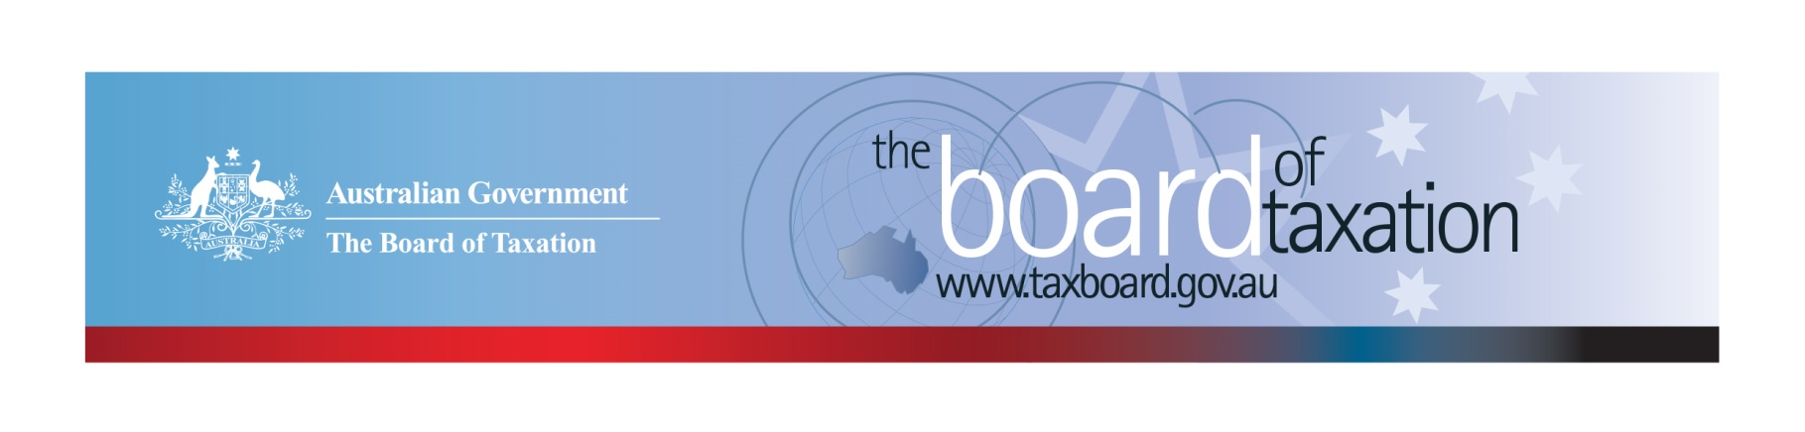
CEO Update – July 2018
Dear Stakeholders,
Since my last update, the Board of Taxation (the Board) has held two meetings as follows:
Place: | Date: | Hosted by:
Canberra | 25 May 2018 | the Office of Parliamentary Counsel
Melbourne | 5 July 2018 | Deloitte
We would like to thank both the Office of Parliamentary Counsel and Deloitte for hosting the Board.
At these meetings, the Board discussed the progress and direction of our current projects. Some further information on the status and scope of these projects is set out below. This includes the release of the Board’s consultation paper on small business tax concessions, the release of the Board’s report following our review of residency rules for individuals (and further consultations to follow) and details of an upcoming survey to collect data for the Board’s review of FBT compliance costs.
The Board met with stakeholders over lunch in Melbourne following the Board meeting on 5 July 2018 to share an update on our current projects and to hear about taxation issues affecting the business community and tax profession. We value your feedback and insights on where improvements to the tax system can be made. Please don’t hesitate to contact us.

Overview of our current agenda of work
The Board discussed the scope and direction of a number of current projects, including:
- Post implementation review of contingent consideration rules (earn out arrangements);
- A review of small business tax concessions;
- Reviewing fringe benefits tax (FBT) compliance costs, including international comparisons;
- Consultation on aspects of the residency rules for individuals;
- A review of potential areas for greater alignment between tax and accounting treatments; and
- Reviewing aspects of the taxation of the not-for-profit sector.
Please contact the Board if you would like to share your views or be involved in any of these projects. We have already received some expressions of interest from stakeholders and we keep a register of your interest so that we can contact you at the appropriate time.

Update on Review of FBT Compliance Costs
The Board has commenced a review of the compliance costs associated with obligations under the FBT legislation. This will include a survey of a random sample of taxpayers as well as a public survey for stakeholders to complete on a voluntary basis. This will ensure that we (can) receive feedback from tax professionals, business and industry bodies as well as employers. The surveys are expected to be released late August or early September – we are currently in a design phase.
Through one of these surveys, employers and tax professionals can anonymously inform the Board about their experiences with FBT compliance costs. A link to the public survey will be shared via the CEO update once it has gone live and will be available through our website. You can subscribe to receive email updates via our website – http://taxboard.gov.au/contact/.
The Board would like to encourage all of our stakeholders to participate in this survey. Your participation will help the Board formulate its recommendations by identifying areas where we can reduce the time and compliance cost associated with complying with their FBT obligations.

Review of Residency Rules for Individuals
The Board has published its self-initiated report ‘Review of the Income Tax Residency Rules for Individuals’. The report is available on the Board’s website (under 2017 Reports). The Board would like to thank all the stakeholders who participated and contributed to this review.
The Minister for Revenue and Financial Services, the Hon Kelly O’Dwyer MP, has asked the Board to consult further on key recommendations, including how Australia could draw on residency tests used in other countries. The Board will be undertaking this consultation in the coming months including developing options for:
- a two-step model for individual tax residency; and
- addressing the integrity risk posed by ‘residents of nowhere’ and related schemes to circumvent the tax residency rules.
Stay tuned for further details on the next round of consultation. If you would like to be involved, please let us know via email to taxboard@treasury.gov.au.

Update on Review of Small Business Tax Concessions
The Board will be conducting public consultation sessions in Sydney, Melbourne, Adelaide and Canberra in coming weeks to discuss issues relevant to its Small Business Tax Concessions Review.
The Board’s review is being undertaken in response to feedback from the business community that there is scope for significantly improving the way that tax concessions can help small businesses and positively contribute to the broader economy. Whilst some concessions are highly valued by small business, others are thought to be outdated, poorly targeted or too difficult to understand and/or access.
You can share your views by attending one of the public consultation sessions outlined below. To register your interest, please email taxboard@treasury.gov.au.
Wednesday 18 July 2018 | Sydney | The Treasury  Level 5, 100 Market Street | 3:30pm – 4:30pm
Thursday 19 July 2018 | Melbourne | The Treasury  Level 6, 120 Collins Street | 9:00am – 10:00am
Wednesday 8 August 2018 | Adelaide | BDO Office  Level 7, 420 King William Street | 4:00pm – 5:00pm
Thursday 16 August 2018 | Canberra | The Treasury  Langton Crescent | 1:00pm – 2:00pm
If you are unable to attend one of these sessions and would like to provide feedback, the Board is accepting written submissions until 20 July 2018. Alternatively, please contact the Board via email to taxboard@treasury.gov.au to discuss other ways you can share your views.

Sounding Board
The Board discussed a number of ideas from Sounding Board that are currently under consideration and a number of possible improvements to the Sounding Board site, so watch this space for further details.
Regulations were made on 21 June 2018 to update the list of approved stock exchanges for tax purposes. The list has been updated to remove references to stock exchanges that no longer exist, added stock exchanges that have been produced from mergers and the renaming of stock exchanges that were previously listed. This list was updated in response to a Sounding Board suggestion that has now been marked as completed.
The Board encourages stakeholders to post new ideas for tax system improvement on the Sounding Board site or make comments on existing ideas.

Tax Transparency Code
The Board discussed the take-up of the Voluntary Tax Transparency Code (the Code). As at 9 July 2018, there were 137 signatories to the Code, of which 116 have published at least one tax transparency report.
The Board continues to monitor developments in the tax transparency landscape both in Australian and overseas, to identify ‘best practice’ disclosures and opportunities to further improve the Code. The Board welcomes views from the business and broader community on the Code.
The Board recently met with the Australian Accounting Standards Board to understand proposed changes to implement the International Accounting Standards Board’s Reporting Conceptual Framework in Australia, which is likely to include the phasing out of Special Purpose Financial Reports. The Board will continue to keep abreast of developments in financial reporting which may impact on tax transparency.
The Board encourages you to adopt the Code and support and assist your clients to adopt it. It is as simple as sending us an email setting out your groups’ intentions! For further information on the Code or to register your intention to adopt it, please contact us at taxboard@treasury.gov.au.

Thank You!
Thank you to all our stakeholders and advisory panel members who continue to support the Board’s work. Thank you also to the Office of Parliamentary Counsel and Deloitte for hosting our recent Board meetings.
Our next Board meeting will be held in Adelaide on 9 August 2018.
Stay in touch. You can keep up to date with the latest news from the Board on our website and via LinkedIn. For those who are on LinkedIn, follow the Board of Taxation here.
Kind Regards
Karen Payne
 | Karen Payne  Chief Executive Officer  Board of Taxation | phone: +61 2 6263 2122  mobile: 0405 843 880  email: karen.payne@treasury.gov.au
Treasury Building, Langton Crescent, PARKES ACT 2600 • Telephone: 02 6263 4366 • Email: taxboard@treasury.gov.au
Website: taxboard.gov.au • Sounding Board: taxboard.ideascale.com

