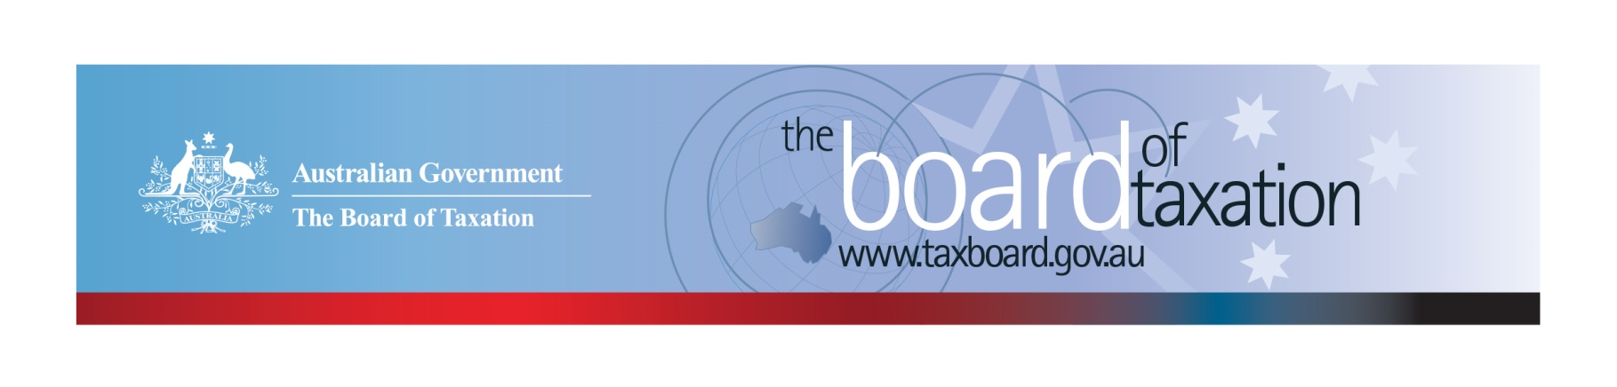
CEO Update – December 2018
Dear Stakeholders,
The Board of Taxation (the Board) held a Board meeting in Melbourne on Thursday 15 November 2018. Thank you to MinterEllison for hosting the Board for our meeting and discussion over lunch with stakeholders.
The focus of the Board’s meeting was to review the progress on a number of current projects, many of which are nearing completion. The Board also continued to discuss new referrals from the Minister and our pipeline of possible future projects, which is yet to be finalised.
The Board held discussions over lunch with stakeholders, members of our Advisory Panel and partners and staff from MinterEllison. Thank you to everyone for attending and contributing your ideas and observations on how we can improve the tax system.
This edition of the CEO update will be the final for 2018. Further details of our meetings for 2019 are set out below.
On behalf of the Board, I would like to thank you for your support this year, especially those who have contributed to the Board’s project work. Thank you also to the ATO, KPMG, Rio Tinto, the Office of Parliamentary Counsel, Deloitte, Grant Thornton, PwC and (again) MinterEllison for hosting the Board this year.

Update on current work program
The Board has recently completed consultations on a number of projects, including:
- Fringe Benefits Tax (FBT) compliance cost review;
- Review of small business tax concessions;
- Further work on tax residency for individuals; and
- Review of the Voluntary Tax Transparency Code (the Code).
A huge thank you to all our stakeholders that participated in these consultations in recent months.
In particular, the Board would like to thank all taxpayers and tax agents who took part in our FBT compliance costs survey. We were overwhelmed by the response rate, which far exceeded our expectations! The strong response rate will enable us to undertake additional analysis to gain insights on compliance savings.
Thank you also to those who participated in roundtable consultations and provided written submissions to our project on tax residency for individuals.
The Board is not expecting to conduct any further consultations this year. However, if you have views to share with us, please feel please feel free to contact us at any time via email to taxboard@treasury.gov.au.
These projects have now moved into the analysis phase, with the Board considering views and data collected from stakeholders during consultations.
The Board also continues to discuss its work program for 2019, much of which is still to be confirmed. We can now share with you that the Assistant Treasurer has asked the Board to undertake a review of the tax treatment of granny flat arrangements and the interaction with social security rules. This review will kick off in early 2019.
Additional details on our current and new projects will be shared in the new year.

Year in Review
It has once again been a big year for the Board, with a number of projects completed and reports released by the Government. The Board completed work in relation to:
- Post-implementation review of contingent consideration rules (earn out arrangements);
- FBT and child care;
- A review of tax and agriculture; and
- A comparison of the taxing rights for real property under Australia’s double tax agreements and domestic laws.
In addition, the Board has worked with the Department of Treasury on the following matters:
- Proposed amendments to Division 7A of Part III of the Income Tax Assessment Act 1936;
- Tax implications of new accounting standard for insurance contracts (AASB17);
- Digitalisation of the economy.
The Board has also assisted on a number of other confidential matters, including ideas to be considered as part of the Federal Budget and Mid-Year Fiscal and Economic Outlook. We have also maintained a “watching brief” on global tax developments relating to the digitalisation of the economy, and implementation of the Government’s response to the black economy through the involvement of the Chair.
Five of the Board’s reports were published on our website this year. These were:
- Review of the Tax Treatment of Bare Trusts and Similar Arrangements;
- Review of the Income Tax Residency Rules for Individuals (which was accompanied by a request from the former Minister of Revenue and Financial Services for the Board to undertake additional work, which is currently underway);
- Tax and the Sharing Economy; and
- Two reports on greater alignment between tax and accounting systems in Australia.
The Board is also pleased to see progress on implementation of a number of measures for which the Board provided input into the policy design process, including the anti-hybrid rules (which are now law).
The Board recently refreshed Sounding Board, its online platform for discussion of ideas to improve the tax system. Ideas are now organised under five new campaign headings to allow ideas to be better organised and managed. We encourage all our stakeholders to visit the Sounding Board website - https://taxboard.ideascale.com/ - share your ideas, and vote or comment on existing ideas.

Tax transparency update
The Board is continuing to monitor take-up of the Code. As at 3 December 2018, there were 154 signatories of the Code, with 128 of those having published at least one report. The full register of signatories can be found on the Board’s website, and links to published reports are available on data.gov.au.
As highlighted last month, as part of a post-implementation review of the Code, the Board has been meeting with stakeholders and collecting feedback on the Code. There remains strong support for a voluntary code in its current form. Stakeholders expressed a preference for having all tax transparency information in one place. The Board is considering ways to better link the ATO mandatory corporate tax transparency disclosures with disclosures made under the Code.
The Board is also monitoring financial reporting developments, including the proposed changes to the reporting entity concept in Australian accounting standards, and phasing out of ‘special purpose financial statements’ in Australia.
We strongly encourage all our stakeholders to consider adopting the Code, and to work with your clients to adopt the Code. There are now a significant number of high quality sample reports available to assist businesses that are considering adopting the Code. For further information on the Code or to register your intention to adopt it, please contact us at taxboard@treasury.gov.au.

2019 Meeting Dates
The Board will meet in 2019 as follows:
- 13 February – hosted by EY Melbourne | - 8 August – hosted by Deloitte Adelaide
- 14 March – hosted by CAANZ Sydney | - 12 September – hosted by Deloitte Sydney
- 11 April – hosted by EY Brisbane | - 17 October – hosted by KPMG Perth
- 30 May – hosted by Treasury Canberra | - 21 November – hosted by Baker McKenzie Sydney
- 4 July – hosted by PwC Melbourne | - 19 December – hosted by BDO Melbourne

Thank You and Happy Holidays!
The Board would once again like to thank all our stakeholders who have supported us over the past year, and all the firms and organisations that have hosted the Board meetings and stakeholder lunches. Your continued support and feedback is important to us.
We value your feedback, so please stay in touch. You can keep up to date via the Board’s website, or follow us on LinkedIn.
We wish you all a safe and relaxing holiday, and look forward to working with you again in 2019.

Kind regards
Karen Payne
 | Karen Payne  Chief Executive Officer  Board of Taxation | phone: +61 2 6263 2122  mobile: 0405 843 880  email: karen.payne@treasury.gov.au
Treasury Building, Langton Crescent, PARKES ACT 2600 • Telephone: 02 6263 4366 • Email: taxboard@treasury.gov.au
Website: taxboard.gov.au • Sounding Board: taxboard.ideascale.com

