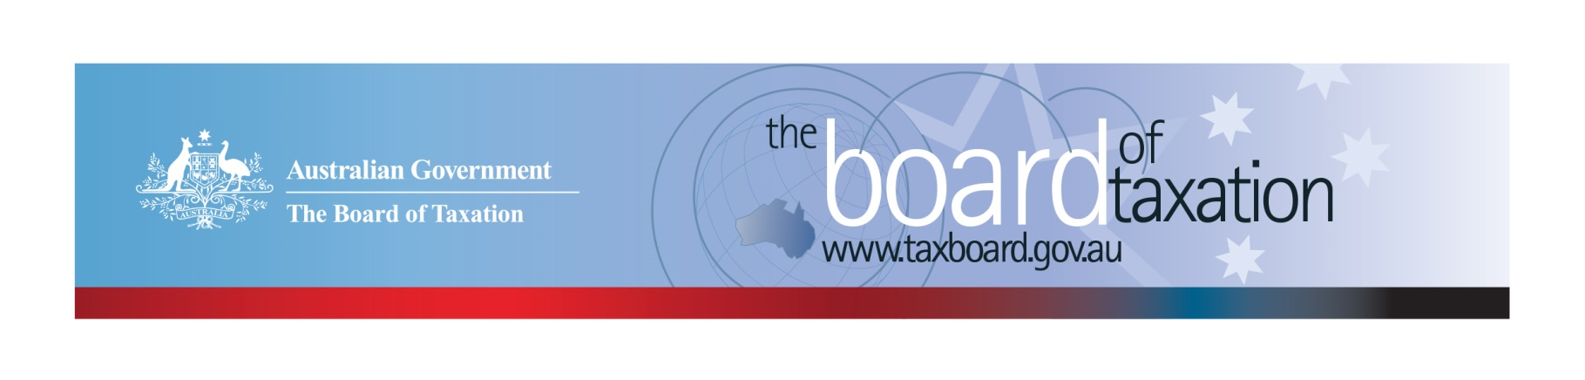
CEO Update – August 2019
Dear Stakeholders,
Since my last update in June, the Board of Taxation (the Board) was deeply saddened by the passing of our Chair, Michael Andrew AO. Michael was a highly respected member of the business and tax community and we acknowledge the integrity, leadership and keen intellect that Michael brought to making the tax system simpler and fairer for all Australians. The Board and Secretariat will miss his friendship, guidance and support.
As a consequence of Michael’s unexpected passing, the Treasurer appointed Dr Julianne Jaques as acting Chair of the Board. For those that don’t know Julianne, she has been a Board member since July 2017 and is a commercial barrister specialising in tax. Julianne has been a part of the tax community for over 25 years and I look forward to working with Julianne in her capacity as acting Chair. I am sure you will all join me in welcoming her to the role.
On 8 August 2019 the Board met in Adelaide. The Board would like to thank Deloitte for their kind hospitality in hosting us and thank all who attended lunch for a really interesting discussion. I was particularly interested in the discussion on the commercial benefits of entering into the Voluntary Tax Transparency Code (the Voluntary Code), attendees noted that signing up to the Voluntary Code is a factor being considered by the investor community and can reduce the pricing of finance obtained under Australia’s emerging sustainability performance linked loan market.
In the Board meeting, we discussed a new review I am pleased to say has been referred to us by the Government:
- A review of the operation of Australia’s corporate tax residency rules.
We also discussed other matters on our current work program including:
- Review of the Voluntary Code;
- Fringe Benefits Tax (FBT) compliance cost and international practice review;
- Review into granny flat arrangements; and
- Sounding Board.
More on these projects is discussed below.

New project - Review of the corporate tax residency rules
The Treasurer wrote to the Board requesting that we conduct a review of the operation of Australia’s corporate tax residency rules. The purpose of the review is to ensure these rules are operating appropriately, in light of modern, international, commercial board practices and international tax integrity rules.
The terms of reference set out by the Treasurer are for the Board to consider whether the existing rules:
- minimise commercial uncertainty and ambiguity;
- are consistent with and aligned with modern day corporate board practices;
- protect the tax system against multinational profit shifting; and
- otherwise support Australia’s tax integrity rules as they apply to multinational corporations.
The Board has been asked to report back to the Government before 31 December 2019. We expect to issue a consultation paper shortly and to conduct round table discussions in Melbourne, Sydney and Perth. To keep updated, please follow the Board on LinkedIn or register your interest to be involved in the round table discussions by emailing us at taxboard@treasury.gov.au.

Review of the Voluntary Code
The Board is putting the finishing touches onto its post-implementation review of the Voluntary Code. The Board expects to submit the report to the Government following our September meeting.
Pleasingly, the number of signatories to the Voluntary Code has increased to 169, with 153 of those organisations having already published at least one report. The full list of signatories can be found on the Board’s website. Links to published reports can be found on data.gov.au.
Indicating your intention to adopt the Voluntary Code is easy. Organisations wishing to sign up can do so by sending an email to taxboard@treasury.gov.au and state the name of your organisation and the financial year you intend to first publish a tax transparency report. We will list your organisation on our Register of Signatories which indicates those organisations who have committed to applying the principles and details of the Voluntary Code.
The ATO is responsible for the centralised hosting of published reports by businesses who have adopted the Voluntary Code. Businesses wishing to advise the ATO of the links to their published reports can do so by emailing ttc@ato.gov.au.
Please don’t forget to email the ATO with the link to your new report each year.

Review of FBT compliance cost and international practice
The Board is similarly putting the finishing touches on its review of Fringe Benefits Tax (FBT) compliance cost and international practices.
Due to the generous contributions of stakeholders, the Board has collected an unprecedented amount of data on FBT compliance costs. We are preparing a two volume report to Government, the first volume outlines the Board’s recommendations for reducing the compliance costs associated with providing fringe benefits and the second volume outlines the Board’s key research findings.
The Board expects to sign off on this report and submit it to the Government in the coming months.

Review into granny flat arrangements
The Board is now well advanced on its review of the taxation of granny flat arrangements and is on track to provide its advice to Government in the coming months. This review has represented something of a departure from the Board’s usual work program and has generated quite a bit of curiosity from our Advisory Panel and the community.
I note that the term “granny flat arrangement” is one used in social security law to describe an arrangement whereby a person acquires a lifetime right of accommodation in a private residence that is to be their home. The accommodation could be in an actual granny flat but likewise may be within a larger house. In practice these arrangements tend to be part of a broader arrangement – known as an ‘asset for care agreement’ or ‘family agreement’ – in which a trusted younger person provides accommodation, care and support to an ageing parent.
Granny flat arrangements can be very beneficial to the families involved and to broader society. However, unfortunately in some cases they have left the older person at risk of financial exploitation and as a consequence have come under the spotlight as part of the Government’s commitment to combat elder abuse. Whilst, this is clearly a larger issue than tax, the Board’s involvement has been focused on removing any tax impediments (real or perceived) to preventing elder abuse through granny flat arrangements.
Over the course of the review, the Board has consulted widely with diverse stakeholders drawn from elder law specialists, the community legal sector and academia. It also benefited from Advisory Panel members such as Reynah Tang, an acknowledged leader in providing access to justice for victims of elder abuse. In tackling the tax issues the Board has collaborated across Government including: the ATO, Treasury, Department of Social Services, Department of Human Services and Centrelink.

Sounding Board
As many of you know, Sounding Board is a standing item on the agenda at each Board meeting. Sounding Board is a public platform where users can submit ideas for tax law simplification and regulatory reform. You can also comment on and vote for ideas posted by other stakeholders. To view ideas currently listed on Sounding Board or to submit your own, please visit: https://taxboard.ideascale.com/.

2019 Meeting Dates
The Board’s meetings for the remainder of 2019 are as follows:
- 12 September – hosted by Deloitte (Sydney)
- 17 October – hosted by KPMG (Perth)
- 21 November – hosted by Baker McKenzie (Sydney)
- 13 December – hosted by BDO (Melbourne)

Thank you!
Once again, the Board would like to thank Deloitte for hosting our August meeting along with all those who attended our stakeholder lunch.
You can keep up to date with the latest from the Board via our website or follow us on LinkedIn. You can also contact me on the details below. As always, we value your feedback, so please stay in touch.

Kind regards
Lynn Kelly
 | Lynn Kelly  Interim Chief Executive Officer  Board of Taxation | phone: +61 2 6263 3279  email: lynn.kelly@treasury.gov.au
Treasury Building, Langton Crescent, PARKES ACT 2600 • Telephone: 02 6263 4366 • Email: taxboard@treasury.gov.au
Website: taxboard.gov.au • Sounding Board: taxboard.ideascale.com

