 |  | 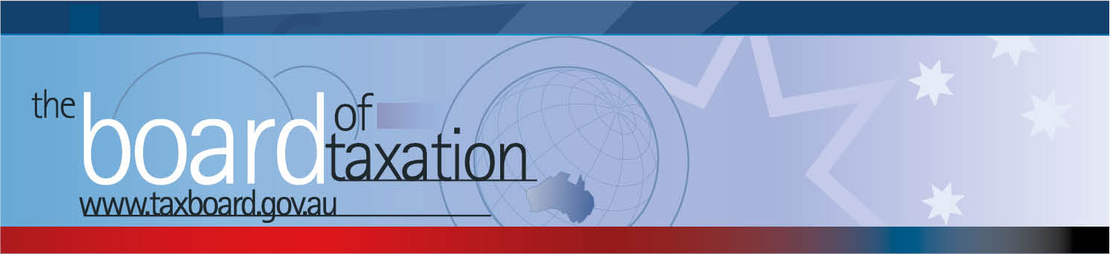
 |  |  |  |  | 0BCEO Update – March 2017
Dear Stakeholders,
On 24 March 2017 the Board of Taxation held its second meeting for 2017. The meeting was hosted by EY in Brisbane and was followed by an informal discussion over lunch with stakeholders and the Board’s Advisory Panel members. Thank you to everyone (EY partners, clients, stakeholders and the Board’s Advisory Panel) for attending and taking the opportunity to engage with the Board.
At the Board’s meeting, we discussed the progress and direction of our current projects and 2017 agenda, the operation of Sounding Board and the adoption of the Tax Transparency Code (the Code) among Australian corporate taxpayers.
Some additional detail on the progress of the Board’s work is set out below.
 |  |  |  |  | Tax Transparency Code
The Board noted that 76 organisations (including private and foreign companies) have now indicated their intention to adopt the Code – the set of principles and minimum standards to guide the disclosure of tax information by businesses. As this update is being sent out, half (38) of these companies have already published their first reports. A register of these organisations can be found at: http://taxboard.gov.au/current-activities/transparency-code-register/. The Board expects more organisations to adopt the Code as 2017 progresses.
The Board received an update on the status of the AASB’s work on material to guide organisations seeking to comply with the obligations they have taken on under the Code.
The Board encourages you to adopt the Code and support and assist your clients to adopt it. For further information on the Code or to register your intention to adopt it, please contact the Board at taxboard@treasury.gov.au.
 |  |  |  |  | Sounding Board
The Board received an update on the recent activity on the Sounding Board and noted some of the most-supported ideas. The Board acknowledged that improvements needed to be made in the timeliness of providing feedback on ideas and communicating on the progress of ideas. We are investigating ways to improve the effectiveness of this transparent forum and the opportunity to share tax ideas with the Board.
The Board continues to monitor and review activity on Sounding Board, which is a standing item on the Board’s agenda. If you would like to comment, vote or post your own suggestion, you can do so by registering with Sounding Board. Please visit Sounding Board for more information – https://taxboard.ideascale.com/.
 |  |  |  |  | Our current projects and pipeline for 2017
The Board continues to be involved with the Government’s Black Economy Taskforce, as well as progressing several projects towards completion. Following the February Board meeting, the Board finalised and delivered to Government its report on asset merger roll-over relief.
Work continues to progress on the following projects:
- high wealth individuals and residency (refer below for further detail);
- Targeted improvements for custodial trusts;
- tax and the sharing economy (consultation ongoing); and
- alignment of tax and accounting concepts (consultation ongoing).
The Board is also considering whistleblower protections and mandatory disclosure of aggressive tax arrangement rules.
The Board expects to review additional projects to add to its 2017 work program at the April Board meeting.

High wealth individuals and residency
The Board discussed a draft working paper of the working group led by Dr Pizzacalla in relation to the tax residency test for individuals and affirmed the key principles of the emerging draft recommendations. The Board also provided observations and comments to the working group in relation to several matters still under consideration by the working group.
 |  |  |  | Thank You
The Board would also like to thank Kevin Griffiths, Michael Hennessy and EY for extending the invitation to host the Board in Brisbane – the Board is very grateful.
The Board would like to thank all those who participated in the discussions over lunch. We remind you that you can contact us at any time – refer to my contact details below or please email taxboard@treasury.gov.au

Upcoming 2017 Board Meetings
The next Board meeting will be held in Melbourne on 28 April 2017. The Secretariat is preparing a draft invitation list for stakeholder meetings that coincide with the upcoming Board meeting dates.
Please do not hesitate to contact the Board of Taxation on 02 6263 4366 should you wish to discuss any of the above matters further.
Kind regards
Karen Payne
 |  |  | Karen Payne  Chief Executive Officer  Board of Taxation |  |  | phone: +61 2 6263 2122  mobile: 0405 843 880  fax: +61 2 6263 2617  email: 31TUkaren.payne@treasury.gov.auU31T
 |  |  | C/- The Treasury  100 Market Street, Sydney NSW 2000 |  |  | website: 31TUwww.taxboard.gov.au  The Board of Taxation Secretariat  Langton Crescent, Parkes ACT 2600 Australia

