 | 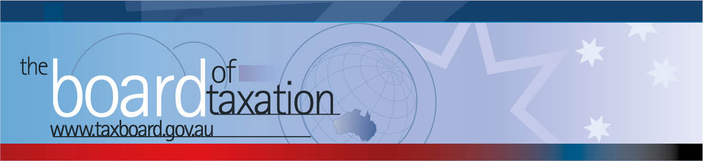
 |  |  | CEO Update – October 2017
Dear Stakeholders,
On 14 September 2017, the Board of Taxation held its seventh meeting for 2017 in Sydney. The focus of this meeting was to discuss the Board’s current projects and Stocktake of Board reports, receive updates on recently allocated Sounding Board suggestions and settle a future pipeline of projects.
The Board’s meeting was hosted by Deloitte in Sydney. The Board held an information session and discussion over lunch with stakeholders and partners from Deloitte. Thank you to everyone for attending and contributing your ideas and observations on how we can improve the tax system.
Some additional detail on the progress of the Board’s work is set out below.
 |  |  | Our current projects
A number of projects have now been finalised and submitted to the Government for consideration, including:
- High wealth individuals and residency;
- Definitions under State and Federal laws.
The Board is also progressing a project on contingent consideration (see below).
 |  |  | Pipeline of possible projects
The Board discussed and prioritised a number of possible projects from its current pipeline and will prepare a scoping document for each project – including for the purpose of assessing the level of stakeholder and Government engagement with the project and topic. These included:
- Certain compliance issues relating to taxation in Agriculture;
- New tax measures to promote innovation;
- A comparison of the taxing rights for real property under Australia’s double tax agreements and domestic laws;
- A review of the Small Business tax concessions;
- A review of competitive neutrality within the tax system; and
- Tax settings and digital disruption.
Board Members and Working Groups are expected to discuss their scoping documents at their October Board meeting where projects and priorities will be discussed further. Please contact the Board if you would like to share your views or be involved in any of these projects if they progress.

 |  |  | Contingent consideration
Work continues of the contingent consideration project. Following consultations in Sydney, Brisbane, Melbourne and Perth, the Working Group is now progressing to drafting of the report.
The review includes a post-implementation review of the earnout provisions introduced in 2016 as well as a review of the transactions that do not fall within these provisions.
 |  |  | Black Economy Taskforce
 |  |  | The Board received an update from the Chair on the ongoing work of the Black Economy Taskforce (the Taskforce). The Taskforce is in the process of preparing the final report. The due date for the report is the end of October 2017.
 |  |  | Sounding Board
The Board received an update on a number of Sounding Board ideas that were allocated to Board Members for further investigation – refer to the previous CEO Update for details. Please see the Sounding Board site for an update on how ideas are progressing - https://taxboard.ideascale.com/.
The Sounding Board continues to be a standing agenda item for every Board meeting.
 |  |  | Stocktake of Reports
The Board discussed a high level stocktake of its reports and recommendations and potential priorities for reform. The Board will be seeking feedback from stakeholders to understand which (if any) of its outstanding reports and recommendations continues to be a priority for reform for the tax and business community.
There was a more detailed review and discussion of the board’s reports on consolidation, namely:
- The 2012 Report - Post implementation review of certain aspects of the Consolidation tax cost setting process
- The 2013 Report - Post-Implementation Review into Certain Aspects of the Consolidation Regime
Stakeholder feedback will be collated for the purpose of the Board’s report back to the Minister for Revenue and Financial Services.
This is an opportunity to identify outstanding priorities for the tax and business community and improve tax certainty surrounding these measures. Please contact the Board if you would like to contribute your views.
 |  |  | Tax Transparency Code
The Board noted that 108 organisations (including Government Business Enterprises and foreign companies) have now indicated their intention to adopt the Code – the set of principles and minimum standards to guide the disclosure of tax information by businesses. The Board notes that 71 organisations have now published their transparency reports under the Code as at the time of the meeting. A register of signatory organisations can be found at: http://taxboard.gov.au/current-activities/transparency-code-register/.
The Board noted the recent Senate inquiry in to corporate tax avoidance had received testimony from a number of US technology companies to the effect that they will not publish or sign up to the code unless it is made mandatory. The Board discussed various alternatives to this ‘compliance’ approach.
The Board encourages you to adopt the Code and support and assist your clients to adopt it. It is as simple as sending us an email setting out your groups’ intentions! For further information on the Code or to register your intention to adopt it, please contact the Board at taxboard@treasury.gov.au.
 |  |  | Thank You
 |  |  | The Board would also like to thank Deloitte for hosting the Board and luncheon in Sydney – the Board is most grateful. The Board would like to thank all those who participated in the discussions over lunch. The next Board meeting will be held in Perth on 19 October 2017.
 |  |  | Don’t forget, the Board is live on LinkedIn! For those of you who are on LinkedIn, you can follow the Board’s page here.
 |  | Karen Payne  Chief Executive Officer  Board of Taxation |  | phone: +61 2 6263 2122  mobile: 0405 843 880  fax: +61 2 6263 2617  email: karen.payne@treasury.gov.au
 |  | C/- The Treasury  100 Market Street, Sydney NSW 2000 |  | website: www.taxboard.gov.au  The Board of Taxation Secretariat  Langton Crescent, Parkes ACT 2600 Australia

