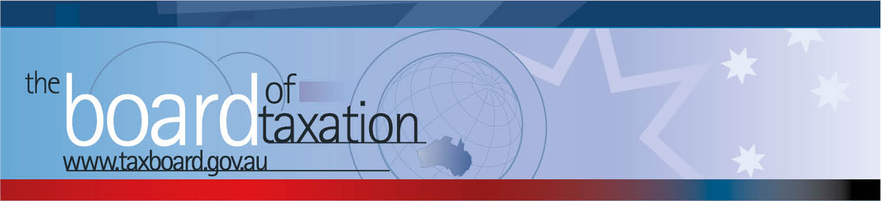

CEO Update – August 2017
Dear Stakeholders,
On 10 August 2017, the Board of Taxation held its sixth meeting for 2017 in Adelaide. The focus of this meeting was to discuss the progress of the Board’s current projects (many of which are concluding), our future pipeline and ideas from Sounding Board.
The Board’s lunch meeting was hosted by University of South Australia (UniSA) and included an information session and discussion with stakeholders. Thank you to everyone for attending and contributing your ideas and observations on how we can improve the tax system.
Some additional detail on the progress of the Board’s work is set out below.
 | Pipeline of Possible Projects
The Board discussed a range of possible projects to progress from its pipeline of projects. These will be prioritised, and resourcing needs assessed, before we finalise which ideas to progress. The Board continuously monitors trends and issues in the tax system through its stakeholder engagement and adds potential topics for further investigation to its pipeline. At the meeting, the Board discussed the following potential areas for investigation:
- certain compliance issues relating to taxation in agriculture;
- new tax measures to promote innovation;
- the simplicity and effectiveness of the small business CGT concessions;
- a comparison of the taxing rights reserved for real property under Australia’s tax treaties and the domestic rules for taxing non-residents on Australian real property.
 | Our Current Projects
The Board continues to be involved with the Government’s Black Economy Taskforce and is progressing several other projects towards completion. Work continues on the following projects:
- alignment of tax and accounting concepts;
- definitions under state and federal laws;
- high wealth individuals and residency;
- contingent consideration and earnouts.
The Board also continues to work with the ATO on the operation of the Commissioner’s Remedial Power (CRP). The Board provided feedback to the ATO during consultation on the recently tabled determination under the CRP relating to the foreign resident CGT withholding tax.
Some of our current projects are expanded upon below.
 | Contingent consideration
As mentioned in previous CEO updates, the Board is undertaking a review of the current taxation treatment of contingent consideration (including a post-implementation review of the CGT earnout rules) led by Board member Ann-Maree Wolff. The Board’s working group includes Board members Craig Yaxley and Mark Pizzacalla, officials from the ATO and Treasury, and external advisers.
The Board is currently undertaking consultation. Please contact us if you would like to be consulted.
 | Black Economy Taskforce
 | The Board received an update from the Chair on the work to date of the Black Economy Taskforce (the Taskforce). The Board discussed the recently released discussion paper, the previously announced interim recommendations and longer term issues still under consideration. A number of the Taskforce themes have overlap with the work of the Board.
 | High Wealth Individuals and Residency
 | The Board discussed a draft report of the working group led by Mark Pizzacalla in relation to high wealth individuals and residency. The Board made comments in relation to some points under consideration and is now in a position to finalise this report.
 | Sounding Board
The Board continues to monitor and review activity on Sounding Board, which is a standing item on the Board’s agenda. The Board is currently investigating the following ideas on the Sounding Board:
- Superannuation: the compliance burden associated with obtaining an actuary's certificate for income to qualify as exempt current pension income;
- GST: the operation of the law to joint ventures and a potential grouping solution;
- PAYG instalment calculations and materiality thresholds: opportunities to simplify;
- updating the Approved Stock Exchange List used throughout the Tax Acts;
- CGT main residence exemption: considering the compliance burden imposed by the special market value rule in the main residence exemption;
- FBT grouping: are any compliance savings possible by allowing grouping;
- FBT year end: would an election to allow taxpayers to align their FBT and income tax year ends provide compliance savings or simplicity (at least for some taxpayers);
- employee share plan interests in foreign vehicles: can or should interests in certain foreign vehicles qualify as ‘shares’;
- public officers: is there a need to allow a company to appoint multiple public officers (or delegations for same);
- GST errors: is the correction mechanism operating appropriately?
If you would like to comment or vote on the above issues, you can do so by registering with Sounding Board. Please visit Sounding Board for more information – https://taxboard.ideascale.com/.
 | Tax Transparency Code
The Board noted that 105 organisations (including Government Business Enterprises and foreign companies) have now indicated their intention to adopt the Code – the set of principles and minimum standards to guide the disclosure of tax information by businesses. The Board notes that more than 40 signatories have signed up for the Code this year.
A register of signatory organisations can be found at: http://taxboard.gov.au/current-activities/transparency-code-register/.
The Board encourages you to adopt the Code and support and assist your clients to adopt it. It is as simple as sending us an email setting out your groups’ intentions! For further information on the Code or to register your intention to adopt it, please contact the Board at taxboard@treasury.gov.au.
 | Thank You
 | The Board would also like to thank UniSA for hosting the Board in Adelaide – the Board is most grateful. The Board would like to thank all those who participated in the discussions over lunch. We remind you that you can contact us at any time – refer to my contact details below or please email taxboard@treasury.gov.au.
 | Upcoming 2017 Board Meetings
The next Board meeting will be held in Sydney on 14 September 2017. Please do not hesitate to contact the Board of Taxation on 02 6263 4366 should you wish to discuss any of the above matters further.
Don’t forget, the Board is live on LinkedIn! For those of you who are on LinkedIn, you can follow the Board’s page here.
Kind regards
Karen Payne
 |  | Karen Payne  Chief Executive Officer  Board of Taxation | phone: +61 2 6263 2122  mobile: 0405 843 880  email: karen.payne@treasury.gov.au
 |  | C/- The Treasury  100 Market Street, Sydney NSW 2000 | website: www.taxboard.gov.au  The Board of Taxation Secretariat  Langton Crescent, Parkes ACT 2600 Australia

