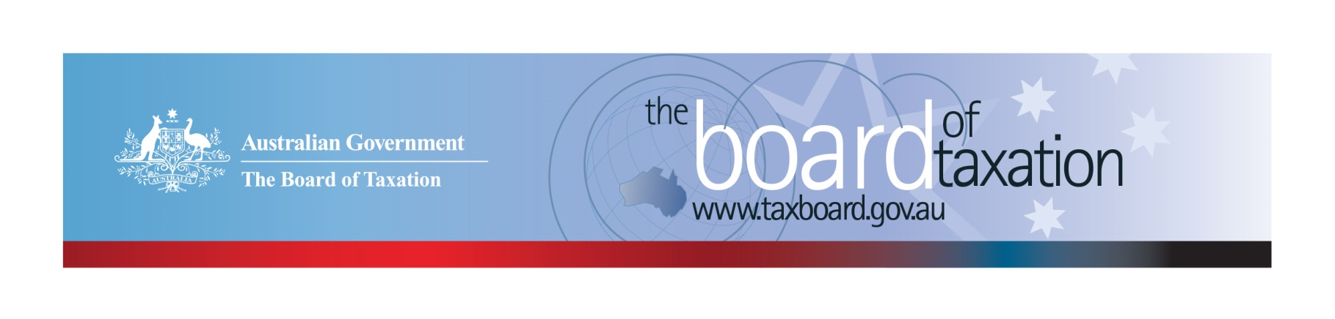
CEO Update – February 2020
Dear Stakeholders,
The Board met recently in Melbourne for its 200th meeting. The Board’s first meeting was in September 2000 and whilst the tax landscape has changed in many ways over the last 20 years, the Board’s mission still remains very relevant: to contribute a business and broader community perspective to improving the design of taxation laws and their operation.
We would like to thank Chartered Accountants Australia and New Zealand (CA ANZ) for generously hosting the meeting and the stakeholder lunch that followed.
The focus of the Board’s meeting was to review our current work program, including the progress of our corporate tax residency rules review and our new referral from the Government – a review of the CGT roll-over rules. More information on our ongoing projects is discussed below.

Review of the corporate tax residency rules
Following the release of the Board’s Reform Options Consultation Paper on 6 December 2019, we have now completed the second stage of our consultation process to review the corporate tax residency rules. We received ten written submissions, which included representatives from a wide range of stakeholders. These submissions have helped the Board better understand the issues from stakeholders’ perspectives and their preferences in relation to the two reform options outlined in the December Consultation Paper.
The Board is now in the process of finalising its review. This includes meeting with the Working Group, Treasury, and the ATO to explore how the potential reform options may impact on the practical interactions between the domestic and international tax systems and to develop appropriate recommendations. In forming recommendations, the Board is conscious of our terms of reference to minimise commercial uncertainty and ambiguity, whilst protecting the tax system against multinational profit shifting.
The Board expects to submit the final report to the Government following our March meeting.

Review of CGT roll-overs
On 7 February 2020, the Board published a consultation guide on its review of capital gains tax (CGT) roll-over rules. The deadline for written submissions will close on 30 April 2020. The purpose of the review is to identify and evaluate opportunities to rationalise the existing CGT rollovers and associated provisions into a simplified set that have a substantially similar practical effect, but are easier to use and interpret. The Board is expected to provide its report to the Government by 30 November 2020.
The Board conducted its first roundtable meeting in Melbourne on Thursday 20 February 2020. A series of public roundtable consultations will also be held on the following dates in 2020:
- Sydney – Thursday 26 March 2020 ▪ Perth – Tuesday 21 April 2020
- Brisbane – Thursday 30 April 2020
If you would like to register your interest in attending one of the roundtables, please email CGTrollovers@taxboard.gov.au or contact the Board’s Secretariat on +61 6263 4366.

Voluntary Code
As at 24 February 2020, there were 179 signatories, with 169 of those organisations having published at least one report. A full list of signatories and more information about the Code can be found on the Board’s website. Links to published reports can be found on data.gov.au.
To sign up to the Voluntary Code simply email taxboard@treasury.gov.au stating the name of your organisation and the financial year you intend to first publish a tax transparency report. Your organisation will be listed on our Register of Signatories as having committed to applying the principles and details of the Voluntary Code.
The ATO is responsible for the centralised hosting of published reports by businesses who have adopted the Voluntary Code. Businesses wishing to advise the ATO of the links to their published reports can do so by emailing ttc@ato.gov.au. Please don’t forget to email the ATO with the link to your new report each year.

Sounding Board
The Sounding Board is a public forum run by the Board where stakeholders can submit ideas for tax law simplification and regulatory reform. It is a useful platform for the Board to hear from the tax and business community on ideas for tax system improvement – the Board discusses new ideas submitted at each Board meeting.
The Government is interested in ideas to reduce red tape within the taxation system. The Board welcomes you to contribute your own suggestions and to view ideas currently listed on Sounding Board. Please visit: https://taxboard.ideascale.com/.

2020 Meeting Dates
The Board’s meetings dates for the remainder of 2020 are as follows:

- 27 March – Sydney
- 30 April – Brisbane
- 5 June – Canberra
- 10 July – Sydney
- 14 August – Adelaide
- 18 September – Melbourne
- 5 November – Perth
- 11 December - Sydney

Thank you
The Board would like to once again thank CA ANZ for hosting our February meeting along with those who attended our stakeholder lunch. You can keep up to date with the latest from the Board via our website or follow us on LinkedIn. You can also contact me on the details below. As always, we value your feedback, so please stay in touch.

Kind regards
Lynn Kelly
 | Lynn Kelly  Interim Chief Executive Officer  Board of Taxation | phone: +61 2 6263 3279  email: lynn.kelly@treasury.gov.au
Treasury Building, Langton Crescent, PARKES ACT 2600 • Telephone: 02 6263 4366 • Email: taxboard@treasury.gov.au
Website: taxboard.gov.au • Sounding Board: taxboard.ideascale.com

