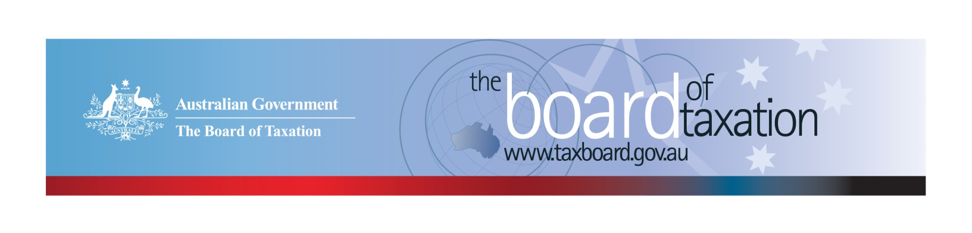
CEO Update – May 2020
Dear Stakeholders,
The Board of Tax (the Board) held its April board meeting recently, it was the first meeting under our new Chair, Rosheen Garnon, and joined by our new Board member, Chris Vanderkley. Like many in the business community the Board continues to meeting virtually and we expect to do so again for our June meeting.
At the meeting, the Board discussed the progress and direction of our current projects. Some further information on the status and scope of these projects is set out below.
In addition to the ongoing projects, the Board also discussed its role in assisting the Government in the next phase of the economic response to the COVID-19 pandemic, focussing on ‘kickstarting the economy’ in the short term and ensuring an efficient and fair business tax system in the longer term. The Board encourages stakeholders to participate in a constructive debate and welcomes ideas and discussion, including through our Sounding Board.

Michael Andrew, 2020 Inductee in the Australian Accounting Hall of Fame
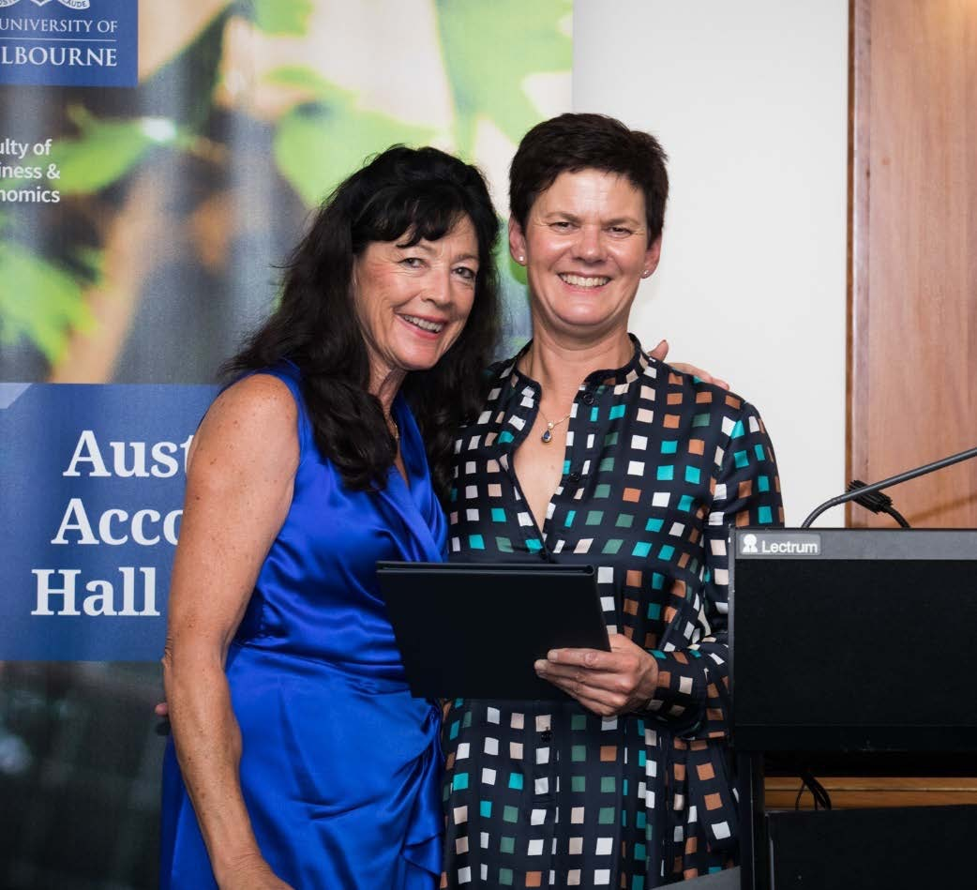
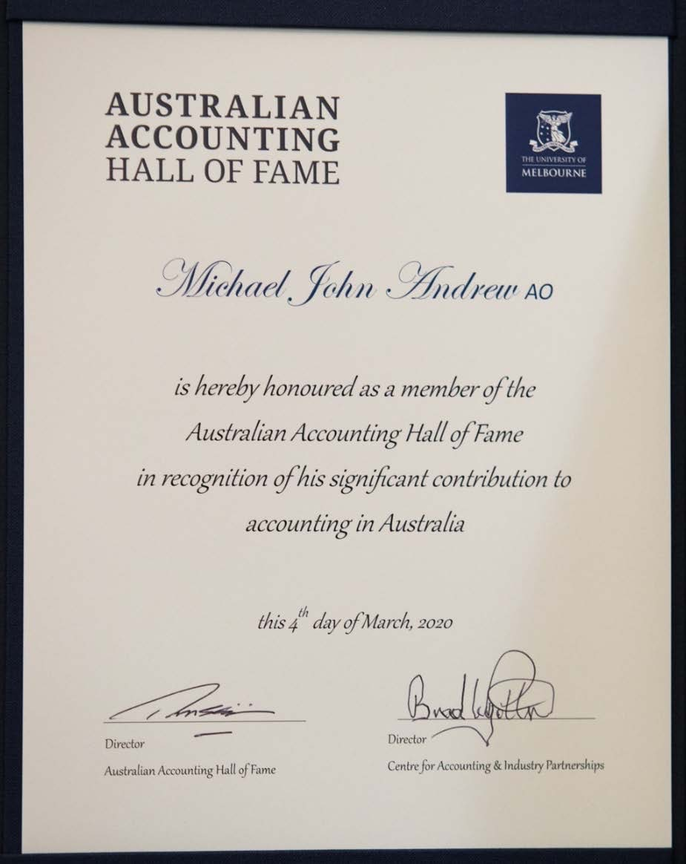
The Board was very pleased to note the recent admission of our former Chair, the late Michael Andrew AO, into the University of Melbourne’s ‘Australian Accounting Hall of Fame’. Michael’s achievements in the field were recognised during an awards dinner held in Melbourne in early March, with his award accepted by his wife Mardi Andrew and his citation read by the National Chair of KPMG, Alison Kitchen. Photos below are courtesy of the University of Melbourne.
Mardi Andrew and Alison Kitchen accepting Michael Andrew’s award.

Review of the corporate tax residency rules
The Board’s review of the corporate tax residency rules is progressing, with the Board exploring the current impact of the COVID-19 pandemic on the way that corporate boards are meeting, as well as the expected impact into the future - including as a consequence of evolving technology and corporate governance policies that may limit international travel for years to come. In this highly dynamic environment, the Board has been considering how best to balance the various elements of our terms of reference, including the need to provide certainty whilst maintaining integrity within the tax system.
The Board also noted that the current demands for government resources to respond to the COVID-19 pandemic and the deferral of the Budget have meant a small delay to the project timeline.

Review of CGT roll-overs
As noted in last month’s CEO Update, we had to postpone our scheduled consultations in Sydney, Brisbane and Perth due to disruptions from the COVID-19 pandemic. We have also extended the closing date for making written submissions to 31 May 2020.
The Board is expecting the formal consultation program to resume in July. In the meantime, our Working Group will seek opportunities in coming weeks to hold “virtual” consultations, either on a one-on-one basis or in small groups to collect the vital stakeholder feedback.
We continue to accept written submissions and encourage those interested in this review to register their details. The Consultation Guide for this project is available from the Board’s website and you can register your interest by emailing CGTrollovers@taxboard.gov.au or calling the Board’s Secretariat on +61 6263 4366.
A further Consultation Paper on the reform options should be released later this year, we will continue to keep you informed of developments with respect to the consultation process via this newsletter and our website.

Sounding Board
The Sounding Board is a public forum run by the Board where stakeholders can submit ideas for tax law simplification and regulatory reform. It is a useful platform for the Board to hear from the tax and business community on ideas for tax system improvement – the Board discusses any new ideas submitted at the next Board meeting.
The Board welcomes you to contribute your own suggestions and to view ideas currently listed on Sounding Board. Please visit: https://taxboard.ideascale.com/.

2020 Meeting Dates
The Board’s meeting dates for the remainder of 2020 are as follows*:

- 5 June – Canberra
- 10 July – Sydney
- 14 August – Adelaide
- 18 September – Melbourne
- 5 November – Perth
- 11 December – Sydney

*The Board will continue to assess how we meet to ensure compliance with social distancing and travel requirements.

Voluntary Code
As at 14 May 2020, there were 179 signatories, with 169 of those organisations having published at least one report. A full list of signatories and more information about the Code can be found on the Board’s website. Links to published reports can be found on data.gov.au.
To sign up to the Voluntary Code simply email taxboard@treasury.gov.au stating the name of your organisation and the financial year you intend to first publish a tax transparency report. Your organisation will be listed on our Register of Signatories as having committed to applying the principles and details of the Voluntary Code.
The ATO is responsible for the centralised hosting of published reports by businesses who have adopted the Voluntary Code. Businesses wishing to advise the ATO of the links to their published reports can do so by emailing ttc@ato.gov.au. Please don’t forget to email the ATO with the link to your new report each year.

Contact options
Our team is mostly working remotely, and we encourage stakeholders to stay in contact with us through the following ways.

Thank you
The Board would like to thank all our stakeholders for their patience and understanding in these challenging times. We will continue to maintain open communication with our stakeholders and explore alternative ways to conduct our reviews. We look forward to meeting you in person again in the near future.
Please stay safe and keep in touch.

Kind regards
Lynn Kelly

 | Lynn Kelly  Interim Chief Executive Officer  Board of Taxation | phone: +61 2 6263 3279  email: lynn.kelly@treasury.gov.au
Treasury Building, Langton Crescent, PARKES ACT 2600 • Telephone: 02 6263 4366 • Email: taxboard@treasury.gov.au
Website: taxboard.gov.au • Sounding Board: taxboard.ideascale.com

