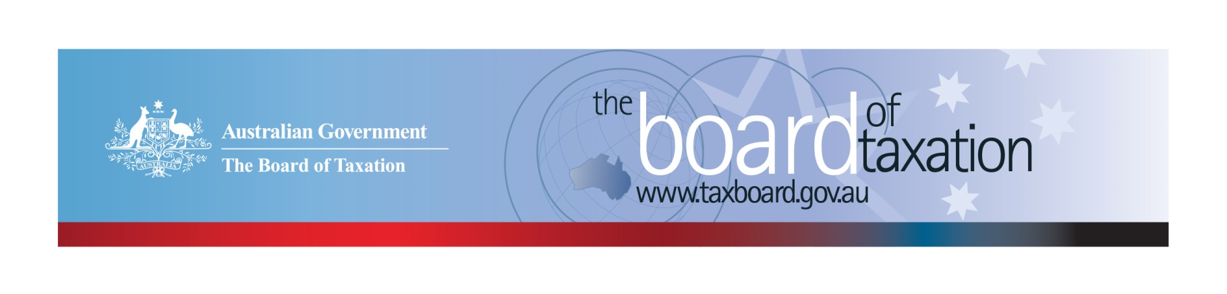
CEO Update – March 2019
Dear Stakeholders,
The Board of Taxation (the Board) held its March Board meeting recently in Sydney - hosted by Chartered Accountants Australia and New Zealand (CAANZ). After the meeting, the Board held discussions over lunch (again hosted by CAANZ) with stakeholders, members of our Advisory Panel, the CAANZ Tax Technical Panel and other stakeholders. Thank you to everyone for attending and contributing your ideas and observations on how we can improve the tax system. We value the opportunity to engage in these discussions and hear your feedback directly.

Overview of current agenda
The following is an overview of our current work program, which includes:
- Review into granny flat arrangements;
- Fringe Benefits Tax (FBT) compliance cost and international practice review;
- Review of the Voluntary Tax Transparency Code (the Code);
- Further work on tax residency for individuals;
- Review of small business tax concessions; and
- Sounding Board.

The reviews of small business tax concessions and tax residency for individuals will be finalised shortly.
At the March Board meeting, the Board also discussed some possible ideas to include in our future pipeline of project work. Some further information, details and updates on some of these projects is set out below.

Review into granny flat arrangements

The Board has commenced consultations for the review of the tax implications of granny flat arrangements. The Board has recently met with key Government stakeholders, including the Department of Social Services, Department of Human Services and the Attorney-General’s Department, as well as practitioners with specialist knowledge of social security laws and elder abuse. The Board will continue consultations throughout April - especially legal aid lawyers and advocates who represent those suffering from elder abuse in legal proceedings. If you would like to be involved in the consultations, please contact the Board via email – taxboard@treasury.gov.au.

Tax Transparency Code consultation & update
As highlighted in last month’s update, the Board has released a Consultation Paper outlining proposed changes to the Code. The Consultation Paper is available on the Board’s website. The consultation period closed on 26 March 2019, with the Board receiving 10 written submissions to date and granted a number of extensions till the week of 1 April 2019 to allow additional participants to submit their responses. We would like to thank all those that contributed to the process both in consultation sessions last year and with written submissions to our Consultation Paper. We are currently reviewing these submissions in detail, and will incorporate this feedback into our final recommendations to Government. Initial indications suggest wide spread support for the proposed changes.
As at 20 March 2019, there were 162 signatories of the Code, with 146 of those having published at least one report. Some of our signatories are now approaching their third year of reporting under the Code, which is a tremendous achievement! The full register of signatories can be found on the Board’s website, and links to published reports are available on data.gov.au.
It is crucial that we keep the conversation going about tax transparency, and its role in encouraging responsible tax practices and building trust in our tax system. To this end, we strongly encourage all our stakeholders to consider adopting the Code, and to work with your clients to adopt the Code. For further information on the Code or to register your intention to adopt it, please contact us at taxboard@treasury.gov.au.

Sounding Board update
Sounding Board has received two new ideas since my last CEO update, both of which relate to the superannuation system. At the March Board meeting, the Board noted that superannuation has been a recurring theme on the platform - there are currently seven (7) ideas noted on the theme of superannuation, including:
- The treatment of excess super contributions;
- The exclusion of unpaid annual leave and long service leave from the superannuation guarantee charge calculations and system;
- Cumbersome and bureaucratic superannuation system for those with portfolio careers - especially non-executive directors;
- Simplification of the superannuation guarantee charge regime for SMEs; and
- Replacing the current requirement for an actuary certificate for exempt current pension income with a statutory formula to reduce compliance costs.
We will be writing to specific industry associations for their thoughts and observations on these ideas, but invite you to comment directly on Sounding Board - either on the themes raised or specific suggestions for improvement.
I would like to remind you that you can share your ideas for tax law simplification and regulatory reform via the Sounding Board website. You can also comment on and vote for ideas posted by other stakeholders. Regulatory reform and red tape reduction is an ongoing focus for the Board, and we are keen for your help in identifying opportunities to reduce red tape in the tax system. To view these ideas and others, and join the discussion, please visit: https://taxboard.ideascale.com/ .

Future Pipeline of Projects
The Board is conscious that a caretaker period and conventions will soon commence and accordingly, we are not expecting to commence any new Projects before the next Federal election. However, this is a great opportunity for the Board to reflect on What’s Next. We would welcome your thoughts and ideas on the tax system priorities for review and improvement.
One suggestion, which was received directly from a stakeholder, is for the Board to consider a simplification or rewrite of Division 230 of the Income Tax Assessment Act 1997 (relating to the taxation of financial arrangements, or TOFA). The Board noted that extensive simplification amendments to the TOFA regime were announced in the 2016-17 Federal Budget (and previously) and so agreed that it would maintain a watching brief on this area and consider this further in the second half of 2019. We would be interested in your feedback on this topic - we will post the idea to Sounding Board.

2019 Meeting Dates
The Board’s meetings for the remainder of 2019 are as follows:
- 11 April – hosted by EY Brisbane | - 12 September – hosted by Deloitte Sydney
- 30 May – hosted by Treasury Canberra | - 17 October – hosted by KPMG Perth
- 4 July – hosted by PwC Melbourne | - 21 November – hosted by Baker McKenzie Sydney
- 8 August – hosted by Deloitte Adelaide | - 13 December – hosted by BDO Melbourne

Thank You!
The Board would once again like to thank CAANZ for hosting the Board meeting and lunch discussions with stakeholders.
We value your feedback, so please stay in touch. You can contact me directly at any time using the details below. You can also keep up to date with the Board’s activities via the Board’s website, or follow us on LinkedIn.

Kind regards
Karen Payne
 | Karen Payne  Chief Executive Officer  Board of Taxation | phone: +61 2 6263 2122  mobile: 0405 843 880  email: karen.payne@treasury.gov.au
Treasury Building, Langton Crescent, PARKES ACT 2600 • Telephone: 02 6263 4366 • Email: taxboard@treasury.gov.au
Website: taxboard.gov.au • Sounding Board: taxboard.ideascale.com

