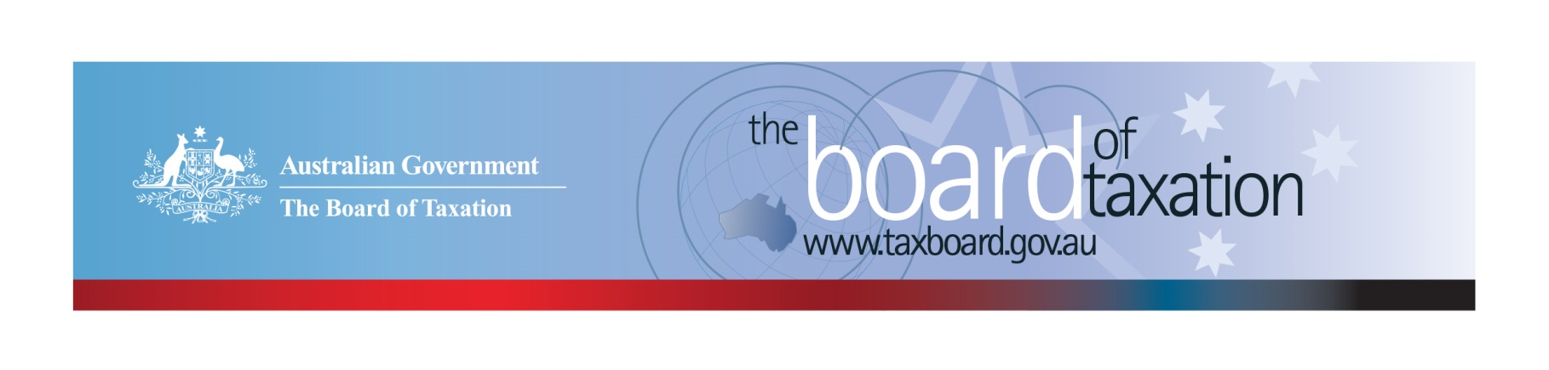
CEO Update – September 2018
Dear Stakeholders,
The Board of Taxation (the Board) held its September Board meeting recently in Sydney. PwC hosted the Board meeting and a discussion over lunch with stakeholders. The Board wishes to thank the partners, staff and guests of PwC – especially Pete Calleja, Australian Tax Leader and his Executive Assistant, Tracey Williams.
At the Board’s meeting, the Board continued to discuss the progress and direction of our current projects, and received an update from the Chair on his ongoing involvement in the implementation of measures relating to the black economy. The Board also met with stakeholders to share an update on our current work program, and sought feedback on issues facing the business community and tax profession. Thank you to all who attended and provided insights over lunch – it was very useful. Some key themes from these discussions are set out below.

Overview of current agenda
The following is an overview of our current work program, which includes:
- Review of small business tax concessions;
- Review Voluntary Tax Transparency Code (the Code) and a broader consideration of tax transparency trends in Australia and globally;
- Consideration of certain aspects of not-for-profit tax concessions;
- Further work on tax residency for individuals;
- Fringe Benefits Tax (FBT) compliance cost and international practice review;
- Review of aspects of the taxation of agriculture;
- Consideration of the interaction of tax and accounting concepts; and
- The Sounding Board.
Further information on the status of some of our projects is set out below.

Review of small business tax concessions
The consultation period for this review has now concluded and Dr Pizzacalla, the Reference Group and the Board have begun developing the final report. The review has attracted a great deal of interest and the submissions have given the Board some great insights into what matters most to small business. Our sincere thanks to those who have participated in the review.

The review is operating to a revised timetable that will see the Board delivering its final report in the New Year. However, the Board is also working closely with Treasury to share some insights gained through consultations to date. This real time input is a useful way to contribute to ideas development.

FBT compliance cost and international practice review
The Board is continuing work on its review of compliance costs associated with FBT obligations for employers. As previously highlighted, the Board will be conducting two surveys to collect evidence and data to inform its recommendations, as follows:
- Taxpayers selected to participate in an FBT Compliance Cost Survey. If you are selected, the ATO will send an invitation to you on behalf of the Board.
- Taxpayers and advisers who volunteer to participant in the Board’s Public Survey on FBT compliance costs.
A link to the Public Survey will soon be available on the Board’s website.
Whilst developing these surveys, the Board is also gathering evidence and data on international experiences with the taxation of non-cash benefits provided to employees. This information will be used for comparison purposes, to assist the Board in identifying areas where compliance costs could be improved or reduced.

Tax residency for individuals
A Consultation Guide on the Board’s ongoing work on tax residency for individuals is now available on the Board’s website. The Consultation Guide invites stakeholders to consider a series of design principles for modernising and simplifying the individual tax residency rules. The design principles include consideration of a ‘two-step’ approach, using a bright-line test based on time spent in Australia followed by a test based on an individual’s personal circumstances, as well as considering integrity issues.
Written submissions can be made to the Board by 26 October 2018. The Board will also be hosting open consultation sessions during October – if you have already registered your interest, we will soon be in touch with dates, times and locations. To keep updated, please follow the Board on LinkedIn or register your interest to be involved by emailing us at taxboard@treasury.gov.au.

Taxation of agriculture
Following the release of a research report on the taxation of the agricultural sector by the Australian Government Rural Industries Research and Development Corporation in December 2016, the Board was approached by stakeholders to consider some of the issues raised in the report. Over the past several months, the Board has been considering on a number of discrete tax issues relevant to the sector, and recently shared this work and observations with the Federal Government’s Joint Agency Drought Taskforce.

Tax and accounting
The Board has an ongoing project to consider opportunities for greater alignment between tax and accounting outcomes to reduce the compliance and administrative burden on taxpayers that produce financial statements. As part of this work stream, the Board has been considering the taxation implications of new accounting standards including:
- AASB 15 Revenue from Contracts with Customers;
- AASB 16 Leases; and
- AASB 17 Insurance Contracts.
The Board will continue to work with Treasury and the ATO to ensure that the tax impacts of these, and other new accounting standards, are well understood, and recommend changes to the tax law, as required.

Tax transparency
The Board continues to monitor take up of the Code. As at 19 September 2018, there were 148 signatories to the Code, of which 123 have published at least one tax transparency report. The full register of signatories can be found on the Board’s website, and links to published reports on data.gov.au. The Code is continuing to gather momentum, with signatories to the Code now covering approximately 80% of the market capitalisation of the ASX200. The Board encourages you to adopt the Code and support and assist your clients to adopt it. It is as simple as sending us an email setting out your groups’ intentions! For further information on the Code or to register your intention to adopt it, please contact us at taxboard@treasury.gov.au.
As highlighted in the last CEO update, the Board is tracking local and global developments on tax transparency, with a view to recommending improvements to the Code. We are also meeting with different stakeholder groups to collect feedback on the Code and views on the future of tax transparency in Australia. If you have insights you would like to share with the Board, please feel free to contact us directly at taxboard@treasury.gov.au.

Proposed meeting dates for 2019
The Board has proposed the following dates and locations for their meetings in 2019. Any changes will be reflected on the Board’s website.
13 February 2019 – Melbourne 4 July 2019 – Melbourne 17 October 2019 – Perth
14 March 2019 – Sydney 8 August 2019 – Adelaide 21 November 2019 – Sydney
11 April 2019 – Brisbane 12 September 2019 – Sydney 19 December 2019 – Melbourne
30 May 2019 – Canberra

Thank You
The Board would like to again thank PwC for hosting the Board meeting and stakeholder lunch, and all those who participated in the discussions over lunch. We value this informal feedback and insights.
The next Board meeting will be held in Perth on 18 October 2018, hosted by KPMG.
We value your feedback, so please stay in touch. You can keep up to date via the Board’s website, or follow us on LinkedIn.

Kind regards
Karen Payne

 | Karen Payne  Chief Executive Officer  Board of Taxation | phone: +61 2 6263 2122  mobile: 0405 843 880  email: karen.payne@treasury.gov.au
Treasury Building, Langton Crescent, PARKES ACT 2600 • Telephone: 02 6263 4366 • Email: taxboard@treasury.gov.au
Website: taxboard.gov.au • Sounding Board: taxboard.ideascale.com

