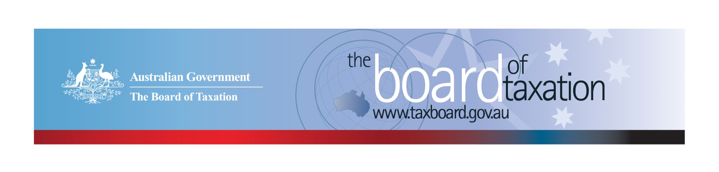
CEO Update – August 2018
Dear Stakeholders,
The Board of Taxation (the Board) recently held a board meeting in Adelaide – hosted by the partners and staff of Grant Thornton. Our thanks to Grant Thornton for hosting the Board. We greatly appreciate the effort that went into organising stakeholder discussions over lunch.
At the Board’s meeting, we discussed the progress of our current projects, including the outcomes of the Board’s initial consultations on the small business tax concessions and the fringe benefits tax (FBT) compliance cost review.
The Board met with stakeholders over lunch, where the Board outlined its work program, encouraged participation in its ongoing reviews, and sought feedback on issues facing the business community and tax profession.
Some further details are set out below.

Overview of current agenda
The Board discussed the scope and direction of its current work program, including:
- A review of small business tax concessions;
- A review of FBT compliance costs;
- Further consultation on aspects of the Board’s review of residency rules for individuals;
- Tax Transparency Measures;
- The Chair’s ongoing involvement in the implementation of a whole of government response to the black economy initiatives; and
- Improvements to the ‘Sounding Board’ channel for ideas for tax system improvements.
Please contact the Board if you would like to share your views on any of these projects.

Review of Small Business Tax Concessions
The Board’s self-initiated review into small business tax concessions was established in response to feedback from the business community that there is scope for significantly improving the way these tax concessions can help small business and contribute to the broader economy.
The Board is delighted with the level of engagement on this review to date. The review team has consulted widely, holding a number of round-table discussions with tax professionals and industry representatives, as well as three round-table hearings with small business owners. The Board has also received 37 written submissions from stakeholders.
To date, the key themes emerging from the Board’s consultation activities include:
- The range of concessions are not widely known and are generally thought to be complex. The exception is the $20,000 instant asset write-off which has strong support;
- The (tax and regulatory) compliance burden is significant and has a disproportionate impact on small business owners. Many business owners feel like de-facto tax collectors;
- Business owners are dissuaded from hiring new employees – concerns include costs of setting up appropriate systems for PAYG withholding, superannuation, associated insurance costs, and dealing with payroll tax (once the exemption threshold is exceeded);
- The different definitions (thresholds) of a ‘small business’ across the regulatory environment leads to too much complexity and confusion; and
- Overall the tax concessions are heavily skewed towards the end of the business life-cycle and business owners need more support earlier in the crucial start-up and survival phases to be successful. There is also some evidence of abuse of the CGT concessions and conflicting views on whether they are achieving their policy intent.
While the closing date for written submissions has now passed, if you have something to share, please contact the Board to discuss other ways you can provide feedback on the Board’s review.

FBT Compliance Cost Review
The Board has commenced a review of the compliance costs associated with obligations under the FBT legislation. The Board is currently working to finalise two surveys to collect quantitative and qualitative data on the comparative compliance burden of the FBT regime. One is a targeted survey of random taxpayers, the other a public survey for stakeholders to complete on a voluntary basis. Examples from international experiences are also being investigated for comparison and possible benchmarks in lowering compliance costs.
A link to the public survey will be shared via the next CEO Update. It will also be available through our website at www.taxboard.gov.au. Please register with us to receive email updates. Your feedback will inform the Board’s recommendations to Government, and we encourage broad participation.

Review of Residency rules for individuals
The Board has commenced consultation on these issues. We have received alot of registered interest to date and would like to thank those stakeholders that have expressed interest in participating in the Board’s further consultation. We will contact you shortly, if we have not already. A Consultation Guide is being developed and will be released shortly (via our website) with further details. Stay tuned! If you would like to be involved, please let us know via email to taxboard@treasury.gov.au.

Tax Transparency Developments
The Board noted the take-up of the Voluntary Tax Transparency Code (the Code). As at 20 August 2018, there were 142 signatories to the Code, of which 120 have published at least one tax transparency report. The Board is conducting a review of the Code to identify areas for improvement and in light of the various developments in tax transparency both in Australia and overseas. For example:
- Work is currently being undertaken by the ‘Global Reporting Initiative’ (GRI) on improvements to tax transparency reporting standards - new disclosures of tax and payments to governments, to be considered as part of the GRI Standards. The proposed standard is currently in draft form.
- The Extractive Industry Transparency Initiative (EITI) Standard is being reviewed against the Australian adapted model developed by the Australian 2014 EITI pilot;
- Global investor interest in tax transparency as part of a responsible investment approach – see for example, the Principles for Responsible Investment Association; and
- Financial reporting developments (that are yet to commence) may have an impact on tax transparency, including:
- Implementation of the new Reporting Conceptual Framework in Australia; and
- Implementation of Australia Accounting Standards Board Interpretation 23 Uncertainty over Income Tax Treatments.
A number of published reports do not meet the minimum standard of the Code. The Board welcomes views from the business and broader community on global developments that may be considered to streamline and enhance the Code.
The Board continues to encourage you to adopt the Code and support and assist your clients to adopt it. It is as simple as sending us an email setting out your groups’ intentions! For further information on the Code or to register your intention to adopt it, please contact us at taxboard@treasury.gov.au.

Sounding Board
The Board is currently in the process of reviewing the Sounding Board platform. Sounding Board is the place to contribute ideas for tax system improvement (including care and maintenance ideas that were part of the ATO’s former Tax Issues Entry System (TIES). This platform is a transparent forum to progress your ideas to improve the tax system and to view or comment on the ideas of others. We are looking for ideas that reduce red-tape, result in compliance savings and/or remove ambiguity and uncertainty (e.g. streamlining tax registration thresholds, re-drafting complex provisions to ensure clarity and removing unnecessary sections from tax returns).
It is not designed to progress big policy changes, but rather ideas that:
- Are not time critical;
- Are non-contentious or sensitive;
- do not require significant policy, law design or drafting resources to progress,
- Have very little or no ‘revenue’ impact.
We hope to provide further details shortly. The Sounding Board can be accessed at https://taxboard.ideascale.com.

Other Discussions
There was a discussion over lunch and at the Board meeting on the application of the central management and control test for companies and whether the current rules reflect modern board practice.

Thank You!
Thank you to all our stakeholders and advisory panel members who continue to support the Board’s work.
Our next Board meeting will be held in Sydney on 13 September 2018, hosted by PwC.
Stay in touch. You can keep up to date with the latest news from the Board on our website, twitter and via LinkedIn. For those who are on LinkedIn, follow the Board of Taxation here.
Kind regards
Karen Payne
 | Karen Payne  Chief Executive Officer  Board of Taxation | phone: +61 2 6263 2122  mobile: 0405 843 880  email: karen.payne@treasury.gov.au
Treasury Building, Langton Crescent, PARKES ACT 2600 • Telephone: 02 6263 4366 • Email: taxboard@treasury.gov.au
Website: taxboard.gov.au • Sounding Board: taxboard.ideascale.com

