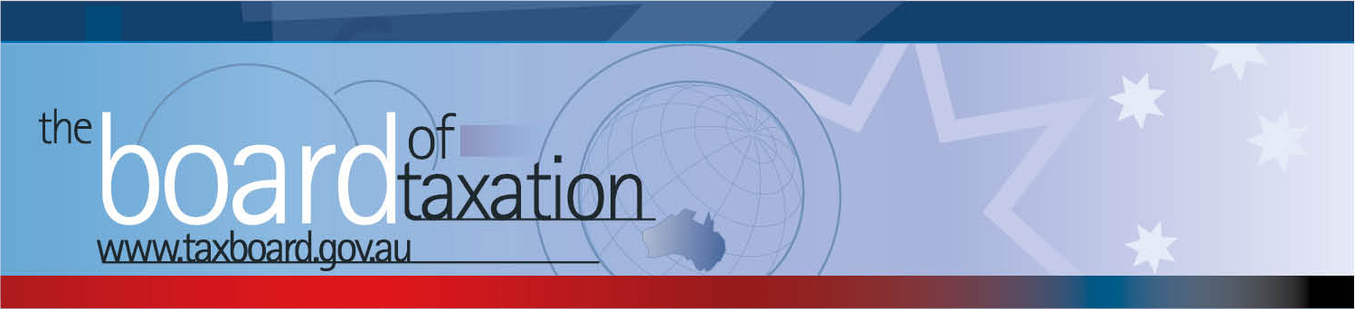

CEO Update – March 2018
Dear Stakeholders,
The Board of Taxation (the Board) held its first meeting for 2018 on Thursday 15 February at the ATO in Melbourne, Docklands. We thank the ATO for their hospitality and their ongoing partnership with the Board.
The Board welcomed our newest member, Mrs Rosheen Garnon and congratulated others on their re-appointments - the Chair (two years) and both Dr Mark Pizzacalla and Mr Craig Yaxley (three years).
At the Board’s meeting, we discussed the progress and direction of our current projects and what is shaping up to be a very busy 2018 with the newly established agenda of work. The Board also welcomed the Chair and CEO of the Australian Accounting Standards Board (AASB), Ms Kris Peach, for an update on accounting developments and received an update on the additional accounting guidance to support the Tax Transparency Code (the Code).
The Board met with various stakeholders and its advisory panel over lunch to provide an update on our projects and to hear about taxation issues affecting the business community and tax profession. Some further details are set out below.

Agenda of work
The Board discussed the scope and content of a number of projects and assignments, including:
- Post implementation review of contingent consideration rules (earn out arrangements);
- A review of small business tax concessions;
- A comparison of the taxing rights for real property under Australia’s double tax agreements and domestic laws;
- A review of tax measures to promote ASX listings of innovation companies;
- Reviewing fringe benefits tax (FBT) compliance costs, including international comparisons;
- Taxation and the digital economy; and
- Reviewing aspects of the taxation of the not-for-profit sector.
Many of these reviews are at the planning stage. Please contact the Board if you would like to share your views or be involved in any of these projects. We have already received some expressions of interest from stakeholders and we keep a register of your interest so that we can contact you at the appropriate time.

Contingent consideration
The Working Group continues to progress this project and anticipates their work will be provided to Government for their consideration in the first half of 2018. The Working Group is grateful to the stakeholder engagement that has assisted to progress this work.

Sounding Board
The Board discussed new ideas recently posted to Sounding Board and a number of ideas that are currently under consideration by the Board. Please see the Sounding Board site to make comments on existing ideas or to post your own new ideas – https://taxboard.ideascale.com/. The Sounding Board continues to be a standing agenda item at every Board meeting.

Release of the Board of Taxation's report on Bare Trusts
The Board of Taxation’s report on Bare Trusts was published on the Board of Taxation’s website this month. See: http://taxboard.gov.au/consultation/tax-treatment-of-bare-trusts/. The report identifies opportunities to simplify arrangements where the trustee has no or only minor powers of active management.
In her press release, Minister O’Dwyer noted that the Government will look to progress the recommendations to streamline arrangements for bare trusts as part of the regulatory reform program. Treasury will undertake further consultation to progress these reforms.
The Board thanks again the stakeholders involved in contributing to this important piece of work.
A reminder to our community, a recent Sounding Board contributed by Michael Flynn QC raised the tax uncertainty arising from absolute entitlement. We encourage the tax profession and community to add your comments especially in relation to Bare Trusts.

Annual Report
The Board’s 2016-17 Annual Report has now been published.
See: http://taxboard.gov.au/publications-and-media/publication/

AASB Update
Kris Peach, CEO and Chair of the Australian Accounting Standards Board (AASB) provided an update for the Board on various developments. This included a discussion on:
- the AASB Guidance on the Tax Transparency Code and the reporting of Effective Tax Rate under accounting standards;
- A new leasing standard (AASB 16) that will require both finance and operating leases to be brought on balance sheet;
- A new revenue recognition standard which has been developed jointly with the USA;
- Valuation standards both internationally and domestically; and
- Financial reporting generally.

 | Tax Transparency Code
The Board continues to discuss the take-up of the Voluntary Tax Transparency Code (the Code). As at 5 February 2018, there were 126 signatories to the Code and 99 signatories have published a tax transparency report.
As new signatories sign up to the Code, the Board will provide an introductory guide to assist companies understand the “best practice” for the preparation and publication of their entities Code.
The Board encourages you to adopt the Code and support and assist your clients to adopt it. It is as simple as sending us an email setting out your groups’ intentions! For further information on the Code or to register your intention to adopt it, please contact us at taxboard@treasury.gov.au.
 | Our meeting dates for 2018
The Board intends to meeting on the following dates and locations for their meetings in 2018.
Any updates will be reflected on the Board’s website.
22 March – Sydney 5 July – Melbourne 18 October – Perth
19 April – Brisbane 9 August – Adelaide 15 November – Melbourne
25 May – Canberra 13 September – Sydney 14 December – Sydney
 | Thank You and Stay in Touch!
Thank you for your continued support. A list of the organisation that the Board has presented to and prepared articles for in 2017 has been uploaded on our website.
Our next Board meeting will be held in Sydney on 22 March 2018.
Don’t forget, the Board is live on LinkedIn! You can follow TaxBoard for those of you who are on LinkedIn.

 |  | Karen Payne  Chief Executive Officer  Board of Taxation | phone: +61 2 6263 2122  mobile: 0405 843 880  fax: +61 2 6263 2617  email: karen.payne@treasury.gov.au
 |  | C/- The Treasury  100 Market Street, Sydney NSW 2000 | website: www.taxboard.gov.au  The Board of Taxation Secretariat  Langton Crescent, Parkes ACT 2600 Australia

