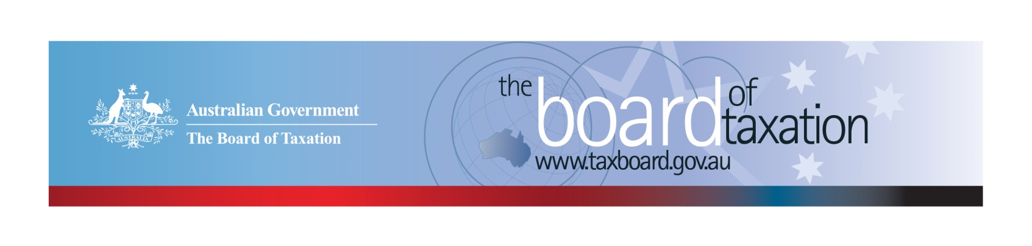
CEO Update – November 2019
Dear Stakeholders,
The Board recently met in Sydney for its November meeting, and we would like to thank Baker McKenzie for generously hosting the meeting and the stakeholder lunch that followed.
Once again, our review of the corporate tax residency rules was a popular lunch-time discussion topic amongst stakeholders. It was really helpful to the Board’s review to hear directly from stakeholders on their actual experiences with the current rules as well as their reform preferences. These reform preferences are explored in our soon to be released Reform Options Consultation Paper. More information on the progress of our Corporate Residency Project is discussed below.
During the Board meeting, we heard from the Chair of the Tax Practitioner’s Board, Mr Ian Klug AM. Thank you, Ian for an interesting discussion on the current and planned work of the Tax Practitioner’s Board.
The Board has received a number enquiries on the availability of its finalised reports. We understand stakeholder’s eagerness to see the Board’s reports particularly, if the stakeholder has contributed to the review process. The Board’s reports are prepared for the Government and so the timing of any report must be determined by the Government. Whilst there is no set timeframe for when reports will be released, we do endeavour to notify interested stakeholders as reports are made available (including through this newsletter). All of the Board’s publicly released reports are available from the Board’s website.

Review of the corporate tax residency rules
Following on from our first round of consultation on the corporate tax residency rules, the Board is currently in the process of finalising a Reform Options Consultation Paper. The paper will provide a summary of the submissions and feedback that the Board has received to date, and set out the primary reform options identified by the Board for further stakeholder consideration.
The Board established a Reference Group to “road test” the reform options and consultation questions. We expect to hear back from the Reference Group shortly and intend to release the Reform Options Consultation Paper for public consultation in early December 2019. The paper will be available on the Board’s website, and written submissions will be accepted until the end of January 2020. Stakeholders are encouraged to take this opportunity to share their perspectives on:
- whether the reform options discussed will sufficiently address the current issues and concerns highlighted by stakeholders throughout the consultation process; and
- integrity issues that could arise in the event that significant changes are made to the corporate residency rules.

Granny Flat Arrangements
The Board has now submitted its report from the review into granny flat arrangements to the Government. The Board’s review considered the tax consequences of making legally enforceable ‘granny flat arrangements’, which at their simplest involve older Australians transferring their home, or proceeds from the sale of their home (and/or other assets) to their adult children or other trusted persons in return for the promise of ongoing housing and care.
The Board would like to thank all those who participated in our consultation sessions, particularly members of the Elder Law and Succession Law Committee of the Law Council of Australia for their valuable assistance during the course of the review. We learned a great deal from them. We also thank the Department of Social Services, Department of Human Services, the Australian Taxation Office and the Treasury for their collaborative approach to this review.

Sounding Board: Superannuation and deceased estates
There has been some interesting discussions on Sounding Board over the last couple of weeks, thank you to our Sounding Board community members, Ian Raspin, Peter McCullough and Trudy Taftiana for your thoughtful ideas on superannuation and the taxation of deceased estates. I look forward to discussing these ideas with the Board at our December Board meeting in Melbourne.
If you have an interest in superannuation or deceased estates I encourage you to take a look at these recent ideas and to share your perspective. The Board monitors the activity generated by ideas to identify any hot button issues. You can show your support for an idea by either leaving a comment or by using the voting button.
If you have your own suggestion for tax law simplification or regulatory reform you can submit them to the Sounding Board using the link below.
https://taxboard.ideascale.com/

Voluntary Code
Since my last update, a further two organisations have published their initial report under the Voluntary Code. This brings the coverage of the Voluntary Code to 174 signatories, with 163 of those organisations having published at least one report. A full list of signatories and more information about the Code can be found on the Board’s website. Links to published reports can be found on data.gov.au.
To sign up to the Voluntary Code simply email taxboard@treasury.gov.au stating the name of your organisation and the financial year you intend to first publish a tax transparency report. Your organisation will be listed on our Register of Signatories as having committed to applying the principles and details of the Voluntary Code.
The ATO is responsible for the centralised hosting of published reports by businesses who have adopted the Voluntary Code. Businesses wishing to advise the ATO of the links to their published reports can do so by emailing ttc@ato.gov.au. Please don’t forget to email the ATO with the link to your new report each year.

2019 Meeting Dates
The upcoming Melbourne Board meeting on 13 December will be the Board’s final meeting for 2019 (and 199th meeting in total!).

2020 Meeting Dates
The Board’s meetings dates for next year are as follows:

- 21 February – Melbourne
- 27 March – Sydney
- 30 April – Brisbane
- 5 June – Canberra
- 10 July – Sydney
- 14 August – Adelaide
- 18 September – Melbourne
- 5 November – Perth
- 11 December - Sydney

Thank you!
The Board thanks you for your ongoing support and thank you again to Baker McKenzie for hosting our November meeting along with all those who attended our stakeholder lunch at Baker McKenzie.
You can keep up to date with the latest from the Board via our website or follow us on LinkedIn. You can also contact me on the details below. As always, we value your feedback, so please stay in touch.

Kind regards
Lynn Kelly
 | Lynn Kelly  Interim Chief Executive Officer  Board of Taxation | phone: +61 2 6263 3279  email: lynn.kelly@treasury.gov.au
Treasury Building, Langton Crescent, PARKES ACT 2600 • Telephone: 02 6263 4366 • Email: taxboard@treasury.gov.au
Website: taxboard.gov.au • Sounding Board: taxboard.ideascale.com

