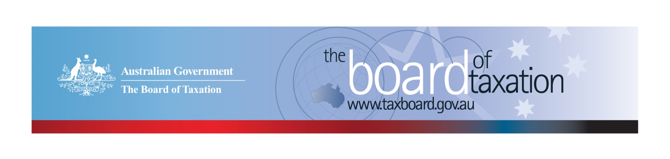
CEO Update – October 2019
Dear Stakeholders,
This month the Board held our meeting in Perth, we would like to thank KPMG for generously hosting the meeting. We would also like to thank both KPMG and the Tax Institute of Australia for facilitating lunch discussions with stakeholders. These provided a great opportunity for the Board to hear from the Perth business and tax community on tax issues important to them and to provide an update on our work.
As you may be aware, the Board has now finalised and submitted to the Government our reviews on:
- The Voluntary Transparency Code; and
- FBT compliance cost and International Practice.
We are also now in the process of finalising our Review of Granny Flat Arrangements. I would like to thank all our stakeholders and working group members who have volunteered their time towards these projects.
The Board has finalised its meeting schedule for 2020, I have included the meeting dates below along with an update of our current work.

Review of the corporate tax residency rules
The Board has now completed the initial stage of consultation on its corporate residency project. We would like to thank the stakeholders who provided written submissions and participated in roundtable consultations. In total, we received 14 written submissions and met with over 40 participants across Melbourne, Sydney and Perth.
Our review is focused on ensuring Australia’s corporate tax residency rules are operating appropriately, in light of modern, international, commercial board practices and international tax integrity rules. This first stage of consultation provided the Board with valuable insights on modern board and governance practices across many sectors and business sizes, as well as practical tax residency issues facing both inbound and outbound multinationals.
In the next phase of this project, the working group will be considering potential reform options, in response to the feedback gathered from the consultation process.
If the corporate tax residency rules affect you but you were not able to participate in our first round of consultation, you will have a further opportunity to share your perspective. The Board is aiming to release a consultation paper on potential reform proposals later this year. I’ll provide further details via my CEO Updates and on the Board’s website.

Sounding Board
The Sounding Board is a public forum run by the Board where stakeholders can submit ideas for tax law simplification and regulatory reform. It is useful platform for the Board to hear from the tax and business community on ideas for tax system improvement – the Board discusses new ideas submitted at each Board meeting.
To contribute your own suggestions and to view ideas currently listed on Sounding Board please visit: https://taxboard.ideascale.com/.

Voluntary Code
Adoption of the Voluntary Code continues to increase. There are currently 174 signatories to the Voluntary Code, with 161 of those organisations having published at least one report. A full list of signatories and more information about the Code can be found on the Board’s website. Links to published reports can be found on data.gov.au.
To sign up to the Voluntary Code simply email taxboard@treasury.gov.au stating the name of your organisation and the financial year you intend to first publish a tax transparency report. Your organisation will be listed on our Register of Signatories as having committed to applying the principles and details of the Voluntary Code.
The ATO is responsible for the centralised hosting of published reports by businesses who have adopted the Voluntary Code. Businesses wishing to advise the ATO of the links to their published reports can do so by emailing ttc@ato.gov.au. Please don’t forget to email the ATO with the link to your new report each year.

2019 Meeting Dates
The Board’s meetings for the remainder of 2019 are as follows:
- 21 November – hosted by Baker McKenzie (Sydney)
- 13 December – hosted by BDO (Melbourne)

2020 Meeting Dates
The Board’s meetings dates for next year are as follows:

- 21 February – Melbourne
- 27 March – Sydney
- 30 April – Brisbane
- 5 June – Canberra
- 10 July – Sydney
- 14 August – Adelaide
- 18 September – Melbourne
- 5 November – Perth
- 11 December - Sydney

Thank you!
The Board thanks you for your ongoing support and thank you again to KPMG for hosting our October meeting along with all those who attended our stakeholder lunches at KPMG and the Tax Institute of Australia.
You can keep up to date with the latest from the Board via our website or follow us on LinkedIn. You can also contact me on the details below. As always, we value your feedback, so please stay in touch.

Kind regards
Lynn Kelly
 | Lynn Kelly  Interim Chief Executive Officer  Board of Taxation | phone: +61 2 6263 3279  email: lynn.kelly@treasury.gov.au
Treasury Building, Langton Crescent, PARKES ACT 2600 • Telephone: 02 6263 4366 • Email: taxboard@treasury.gov.au
Website: taxboard.gov.au • Sounding Board: taxboard.ideascale.com

