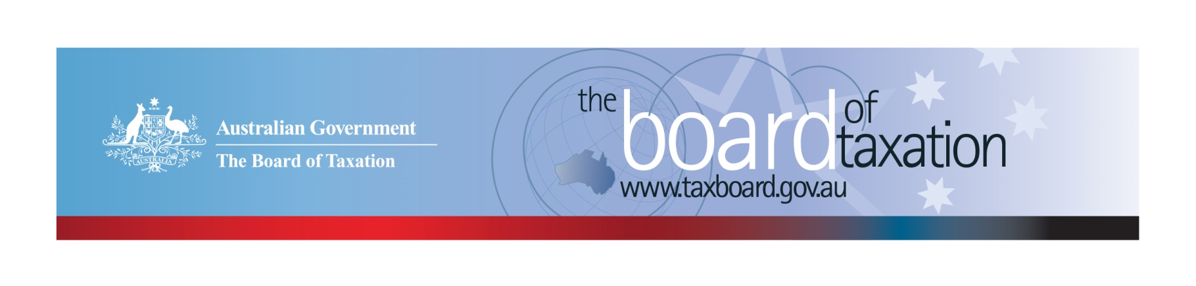
CEO Update – September 2019
Dear Stakeholders,
The Board recently met in Sydney for its September Board meeting. We would like to thank Deloitte for their kind hospitality in hosting the meeting and lunch discussions with stakeholders. We value the feedback we received over the lunch and were encouraged by the support expressed for the Board’s latest project on the operation of Australia’s corporate tax residency rules.
During the meeting the Board heard updates from Treasury on their work as part of the OECD process to address the tax challenges arising from the digitalisation of the economy, and from former Board Member and CEO, Karen Payne on the work she is now undertaking as the Inspector General of Taxation. Thank you to both Treasury and the Inspector General of Taxation for what were fascinating discussions.
Following the meeting, the Board is now finalising our reviews of the Voluntary Code and the Fringe Benefits Tax (FBT) Compliance Cost and International Practice Review and turning our minds to our corporate residency project and other future work.
More on the Board’s work is discussed below.

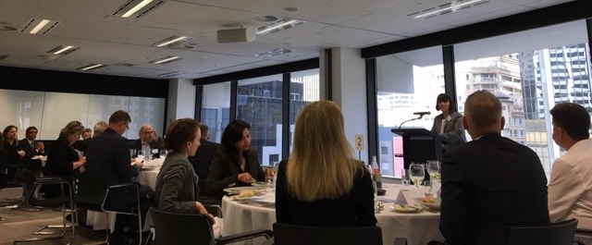
Julianne Jaques (Acting Chair) addressing stakeholders at the Sydney Lunch

Review of the corporate tax residency rules
I shared with you last month that The Treasurer had written to the Board requesting that we undertake a review of the operation of Australia’s corporate tax residency rules to ensure these rules are operating appropriately, in light of modern, international, commercial board practices and international tax integrity rules.
The Board released a consultation paper on 6 September 2019 to seek feedback from stakeholders regarding the current corporate tax residency rules. The consultation paper is available through the Board’s website. All written submissions (by email or post) will be accepted until 4 October 2019.
The Board will also be conducting roundtable consultations in Melbourne, Sydney and Perth in the upcoming weeks. The roundtable sessions are as follows:
- Melbourne, Wednesday 2 October 2019 (Registrations close on 30 September at 5:00pm)
  - Roundtable 1: 1:30pm to 3:00pm
  - Roundtable 2: 3:30pm to 5:00pm
- Sydney, Thursday 3 October 2019 (Registrations close on 1 October at 5:00pm)
  - Roundtable 1: 9:30am to 11:00am
  - Roundtable 2: 11:30am to 1:00pm
- Perth, Wednesday 16 October 2019 (Registrations close on 14 October at 5:00pm)
  - Roundtable: 2:00pm to 3:30pm
We have received a high number of registered interest to date. Registrations are still being accepted for all sessions but time is running out. To submit your written submission or register your interest in attending one of the roundtables, please email corporateresidency@taxboard.gov.au or call +61 2 6263 4366.

Review into granny flat arrangements
The Board has been progressing its review into granny flat arrangements in consultation with the Department of Social Services, Centrelink as well as the ATO and the Treasury to understand how potential reforms would impact on the practical interactions between the tax and transfer system.
It is working towards a draft report that will form the basis for a final round of targeted consultations on potential recommendations.

Voluntary Code
There are currently 172 signatories to the Voluntary Code, with 158 of those organisations having already published at least one report. A full list of signatories and more information about the Code can be found on the Board’s website. Links to published reports can be found on data.gov.au.
To sign up to the Voluntary Code simply email taxboard@treasury.gov.au stating the name of your organisation and the financial year you intend to first publish a tax transparency report. Your organisation will be listed on our Register of Signatories as having committed to applying the principles and details of the Voluntary Code.
The ATO is responsible for the centralised hosting of published reports by businesses who have adopted the Voluntary Code. Businesses wishing to advise the ATO of the links to their published reports can do so by emailing ttc@ato.gov.au.

Sounding Board
Sounding Board is a public platform where users can submit ideas for tax law simplification and regulatory reform. All ideas submitted on Sounding Board are reviewed as a standing item on the agenda at each Board meeting.
The Board values the contributions users make to Sounding Board, it is an important channel from which the Board can hear from the community and take into account issues raised in the projects it undertakes. For example, issues around FBT compliance costs have been rasied via Sounding Board and taken into account in the Board’s about to be finalised review of FBT Compliance Cost and International Practice.
To contribute your own suggestions and to view ideas currently listed on Sounding Board please visit: https://taxboard.ideascale.com/.

2019 Meeting Dates
The Board’s meetings for the remainder of 2019 are as follows:
- 17 October – hosted by KPMG (Perth)
- 21 November – hosted by Baker McKenzie (Sydney)
- 13 December – hosted by BDO (Melbourne)

Thank you!
Once again, the Board would like to thank Deloitte for hosting our September meeting along with all those who attended our stakeholder lunch.
You can keep up to date with the latest from the Board via our website or follow us on LinkedIn. You can also contact me on the details below. As always, we value your feedback, so please stay in touch.

Kind regards
Lynn Kelly
 | Lynn Kelly  Interim Chief Executive Officer  Board of Taxation | phone: +61 2 6263 3279  email: lynn.kelly@treasury.gov.au
Treasury Building, Langton Crescent, PARKES ACT 2600 • Telephone: 02 6263 4366 • Email: taxboard@treasury.gov.au
Website: taxboard.gov.au • Sounding Board: taxboard.ideascale.com

