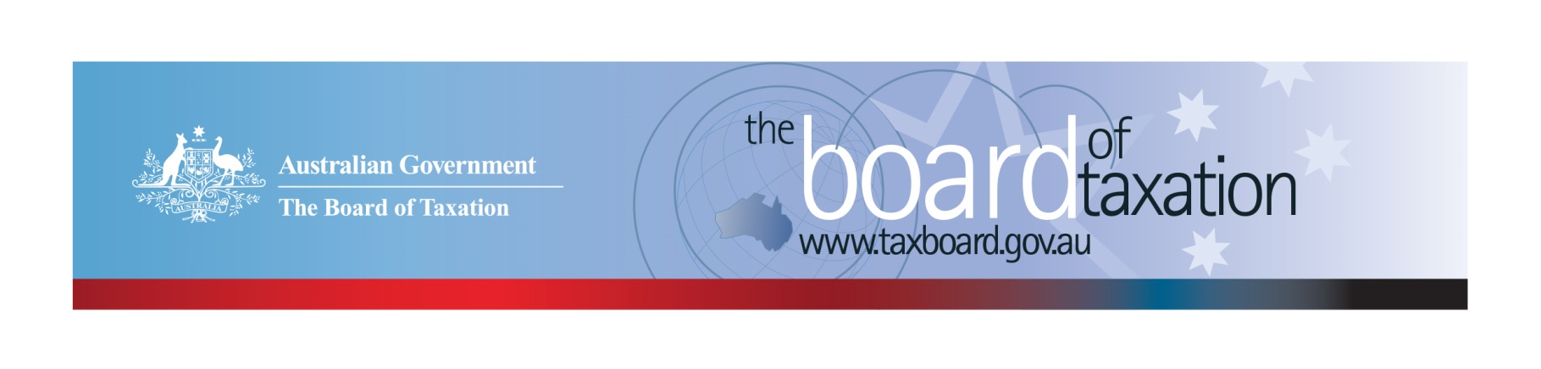
CEO Update – June 2019
Dear Stakeholders,
A lot has happened since our last update. The Federal Election has been and gone and the Board of Tax (the Board) has farewelled our inaugural CEO Karen Payne - we congratulate Karen on her new position as Inspector-General of Taxation and Taxation Ombudsman. With Karen’s departure the Board has asked me to act as interim CEO, joining the Board for their most recent meetings hosted respectively by EY Brisbane and the Treasury in Canberra.
By way of introduction, my name is Lynn Kelly and I have been a member of the tax community for 25 years. My career has spanned advisory roles at top tier accounting firms, corporate roles in diverse industries such as media and financial services, and most recently at Treasury as the Chief Advisor, Corporate and International Tax. I am very much looking forward to working with the Board and tackling some of the important projects we have coming up. Feel free to reach out to me if you have any input, feedback or comments in relation to the Board’s work.
During the recent caretaker period, the Board was able to reflect upon its current projects as well as discuss and prioritise a number of possible projects (to be confirmed with the Minister) that will deliver on our mission – to contribute a business and community perspective to improving the design and operation of taxation laws. We are interested in your feedback on future topics that you would like the Board to consider.

Our current projects
A number of projects have now been finalised and submitted to the Government for consideration, including:
- Review of small business tax concessions; and
- Reforming Individual Tax Residency Rules – A Model for Modernisation.
The Board is also progressing a number of other current projects in relation to:
- FBT compliance cost and international practice review;
- Review of the Voluntary Tax Transparency Code;
- Review into granny flat arrangements; and
- New ideas posted to Sounding Board.
Further information on the status of some of these projects is set out below for your information

FBT compliance cost and international practice review
The Board has undertaken a comprehensive study of FBT compliance costs and is now in the process of finalising its report, which is expected to be provided to Government early in the new financial year. This report will provide an invaluable tool for policy-makers seeking to reduce red tape and simplify the operation of the FBT law, as well as help shape the future direction of the FBT system.
The Board’s research has been extensive with data collected through focus groups, surveys, in-depth case study interviews of both FBT taxpayers and tax advisers as well as international comparisons on the taxation of non-cash benefits.
The Board thanks all those who have participated in the research initiatives and provided their support for the FBT compliance cost review.

Review of the Voluntary Tax Transparency Code
As many of you know, the Board is undertaking a post-implementation review of the Voluntary Tax Transparency Code (the Code). The Board is now incorporating the recent feedback received from our February Consultation Paper and refining our recommendations to Government. Thank you again to all of our stakeholders who contributed written submissions to the February Consultation Paper.
We continue to monitor take-up of the Code and it is pleasing to report that as at 1 June 2019, the signatories to the Code have increased to 166, with 149 of those having already published at least one report. The full register of signatories can be found on the Board’s website. Links to published reports are available on data.gov.au.
It is important that as a tax community we maintain the momentum behind the Code, it plays a key role in the Australian tax transparency landscape and reflects a real desire for greater public disclosure of tax information by businesses. The Board encourages all of our stakeholders to consider adopting the Code, and to work with your clients to assist in their adoption of the Code. For further information on the Code or to register your intention to adopt it, please contact us at taxboard@treasury.gov.au.

Review into granny flat arrangements
The Board is continuing our review of the tax implications of granny flat arrangements. We have been meeting with stakeholders from both Government and the private sector as we research market and industry practices and the impact of tax considerations on these family arrangements.
If you have views or experiences in relation to the capital gains tax consequences of granny flat arrangements, we encourage you to get in touch with us at: taxboard@treasury.gov.au.

Sounding Board
It has been great to see an increase in the number of Sounding Board ideas posted since the last CEO Update as well as a number of user comments and interactions discussing the topics. To view these ideas and others, and join the discussion, please visit: https://taxboard.ideascale.com/ .
As a reminder, Sounding Board allows you to share your ideas for tax law simplification and regulatory reform, which is a continuing focus for the Board. Your ideas are reviewed at each Board meeting and several ideas generated from from Sounding Board are being considered as either part of our current projects or our future work pipeline.

2019 Meeting Dates
The Board’s meetings for the remainder of 2019 are as follows:
- 4 July – hosted by PwC Melbourne | - 21 November – hosted by Baker McKenzie Sydney
- 8 August – hosted by Deloitte Adelaide | - 13 December – hosted by BDO Melbourne
- 12 September – hosted by Deloitte Sydney
- 17 October – hosted by KPMG Perth

Thank You!
The Board would like to once again thank the Treasury for hosting our May Board meeting and the EY partners and staff in Brisbane for hosting our April Board meeting and lunch with stakeholders.
You can keep up to date with the latest from the Board via our website or follow us on LinkedIn. You can also contact me on the details below. As always, we value your feedback, so please stay in touch.

Kind regards
Lynn Kelly
 | Lynn Kelly  Interim Chief Executive Officer  Board of Taxation | phone: +61 2 6263 3279  email: lynn.kelly@treasury.gov.au

