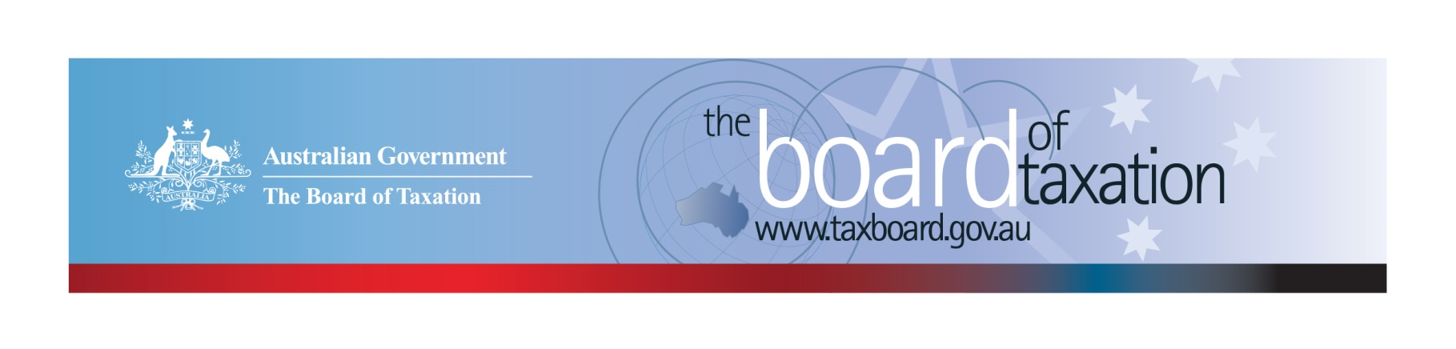
CEO Update – December 2019
Dear Stakeholders,
Last week the Board met in Melbourne for its 199th meeting, we would like to thank BDO for generously hosting the meeting.
The focus of the Board’s meeting was to review our current work program, including the progress of our corporate tax residency rules review and our new referral from the Government – a review of the CGT roll-over rules. More information on our new review and ongoing projects is discussed below.
This edition of the CEO update will be my final one for 2019, I wanted to take this opportunity to thank you for your support and contributions to our work this year and to wish you a happy (and restive) festive season. We look forward to working with you again in 2020.

Year in Review
It has been a big year for the Board, we farewelled our inaugural CEO Karen Payne in May and then shortly afterwards we were deeply saddened by the passing of our Chair, Michael Andrews AO. Notwithstanding these real losses, the Board has delivered five reports to the Government during 2019 as well as progressing a number of other reviews. I am pleased to note that on 12 December 2019, the Government announced the release of four Board reports:
- Reforming Individual Tax Residency Rules: a model for modernisation
- Review of Small Business Tax Concessions
- Introducing Asset Merger Rollover Relief
- Income Tax Treatment of Certain Forms of Deferred Consideration
A huge thank you to all our stakeholders for your contribution to our reviews. All of the above released reports are available from the Board's website. The Board is very interested in any feedback or other observations on our final reports and plans to discuss any comments received at the Board’s next meeting in February 2020.

Review of the corporate tax residency rules
The Board published a Reform Options Consultation Paper as part of its second phase review on 6 December 2019. The paper provides a summary of the submissions and feedback that the Board has received to date, and sets out the primary reform options identified by the Board for further stakeholder consideration. The consultation paper is now available on the Board’s website, and written submissions will be accepted until 31 January 2020. All stakeholders are encouraged to take this opportunity to share their perspectives on:
- whether the reform options discussed will sufficiently address the current issues and concerns highlighted by stakeholders throughout the consultation process; and
- integrity issues that could arise in the event that significant changes are made to the corporate residency rules.
Submissions can be made to CorporateResidency@taxboard.gov.au or addressed to Treasury via mail.
I am also pleased to note that the ATO released an update to its Practical Compliance Guideline PCG 2018/9 on 13 December 2019 which includes an extension of the transitional compliance approach period and further clarification to the principles set out in Taxation Ruling TR 2018/5. Requests to extend the transitional approach were consistently raised through the first stage of our consultations and I commend the ATO for acting so quickly on this.

Review of CGT roll-overs
On 12 December 2019, the Minister for Housing and Assistant Treasurer, the Hon Michael Sukkar MP announced that the Board would undertake a review of capital gains tax (CGT) roll-over rules. The purpose of the review is to identify and evaluate opportunities to rationalise the existing CGT rollovers and associated provisions into a simplified set that have a substantially similar practical effect, but are easier to use and interpret. The Board is expected to provide its report to the Government by 30 November 2020.
The Board has established a working group for the review, comprising Craig Yaxley (Chair), Ann-Maree Wolff and Mark Pizzacalla along with representatives from the tax profession, academia, Treasury and the ATO.
A series of public roundtable consultations will be held on the following dates in 2020:
- Melbourne – Thursday 20 February 2020
- Sydney – Thursday 26 March 2020
- Perth – Date TBC
- Brisbane – Thursday 30 April 2020
If you would like to register your interest in attending one of the roundtables, please email CGTrollovers@taxboard.gov.au or contact the Board’s Secretariat on +61 6263 4366.
A consultation guide will be published on the Board’s website in due course to provide further detail.

Voluntary Code
As at 18 December 2019, there were 179 signatories, with 168 of those organisations having published at least one report. A full list of signatories and more information about the Code can be found on the Board’s website. Links to published reports can be found on data.gov.au.
To sign up to the Voluntary Code simply email taxboard@treasury.gov.au stating the name of your organisation and the financial year you intend to first publish a tax transparency report. Your organisation will be listed on our Register of Signatories as having committed to applying the principles and details of the Voluntary Code.
The ATO is responsible for the centralised hosting of published reports by businesses who have adopted the Voluntary Code. Businesses wishing to advise the ATO of the links to their published reports can do so by emailing ttc@ato.gov.au. Please don’t forget to email the ATO with the link to your new report each year.

Sounding Board
The Board of Taxation uses Sounding Board as an important channel to hear directly from the community. Ideas posted on Sounding Board are discussed at every Board meeting and taken into account in the reviews the Board undertakes and in formulating future projects for the Board. We are particularly interested in ideas that reduce red-tape, result in compliance savings and/or remove ambiguity and uncertainty in the law.
One such example is an idea posted three years ago by Paul Suppree of the Corporate Tax Association, on the issue of the high compliance costs associated with Fringe Benefits Tax (FBT). This idea was part of the genesis behind the Government asking the Board to conduct our review into the compliance costs associated with FBT and the taxation of fringe benefits in comparable countries. In delivering this report to Government earlier this year the working group considered other FBT ideas submitted through the Sounding Board including an extension of the taxi travel FBT concession to ride sharing services. Even as the Board was working on its FBT report, Government was preparing draft legislation to effect this change, which was recently introduced in to parliament.
A special thanks to Paul Suppree, Anita Wildman, and Mark.Caldwell85 for sharing their FBT ideas on the Sounding Board.

2020 Meeting Dates
The Board’s meetings dates for next year are as follows:

- 21 February – Melbourne
- 27 March – Sydney
- 30 April – Brisbane
- 5 June – Canberra
- 10 July – Sydney
- 14 August – Adelaide
- 18 September – Melbourne
- 5 November – Perth
- 11 December - Sydney

Thank you and Happy Holidays!
The Board would like to once again thank all our stakeholders for supporting us over the past year, and all the firms and organisations that have kindly hosted the Board meetings and stakeholder lunches. Your continued support and feedback are important to us.
You can keep up to date with the latest from the Board via our website or follow us on LinkedIn. You can also contact me on the details below. As always, we value your feedback, so please stay in touch.
We wish you all a safe and relaxing holiday, and look forward to working with you again in 2020.

Kind regards
Lynn Kelly
 | Lynn Kelly  Interim Chief Executive Officer  Board of Taxation | phone: +61 2 6263 3279  email: lynn.kelly@treasury.gov.au
Treasury Building, Langton Crescent, PARKES ACT 2600 • Telephone: 02 6263 4366 • Email: taxboard@treasury.gov.au
Website: taxboard.gov.au • Sounding Board: taxboard.ideascale.com

