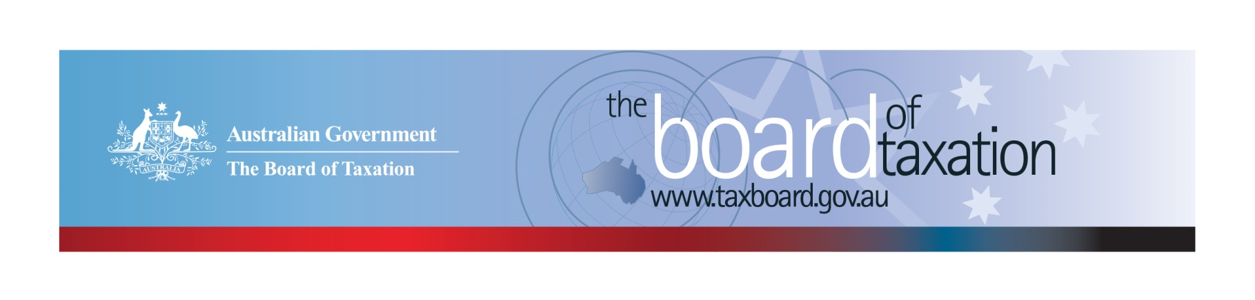
CEO Update – April 2020
Dear Stakeholders,
This year is proving to be a challenging one for Australians – after a devastating bush fire season, we are all now adjusting to a business environment significantly impacted by the COVID-19 pandemic. In these challenging times, the role of the Board of Taxation (the Board) - to bring a business and broader community perspective to the design of taxation laws, becomes even more important as we seek to cushion the economic impact of the virus on business and the broader community, and prepare for recovery.
I am very pleased to note the Government’s announcement that Rosheen Garnon will be leading the Board through these times as the new permanent Chair of the Board. Rosheen is an existing Board member and a prominent figure in the tax and business community, with significant experience domestically and abroad. I would like to acknowledge and thank Julianne Jaques for her immense support and leadership as Acting Chair.
The Board also has the privilege of welcoming Chris Vanderkley as a new Board member. Chris has over 30 years of tax and commercial experience and contributes a deep understanding of the financial sector to the Board.

The impact of Coronavirus on the way the Board works
The Board continues to provide advice to the Government on tax policies and tax law design, however, to safeguard the wellbeing of stakeholders, the Board and Secretariat (and in accordance with Government requirements), have implemented some changes to the way in which we will work over the coming months. These include:
- The Board conducted its first virtual meeting in March and will continue with our scheduled Board meetings virtually for the time being;
- Our team is largely working remotely;
- Unfortunately, we have had to cancel our monthly stakeholder lunches for now, but we look forward to being able to re-start these when it is safe to do so;
- We have similarly had to defer our face-to-face consultations and are exploring alternative ways to hold our roundtable consultations, including over video-conferencing. However, we are also very conscious that many of our stakeholders have competing priorities as you work through the impact of Coronavirus on your business, staff and personal working arrangements, and therefore we will be extending the timeframes for our current consultations.
We place great importance on maintaining open communication with our stakeholders and hope you will stay in contact with us notwithstanding the current challenges, I have set out the different ways you can contact us near the end of this newsletter.

Review of the corporate tax residency rules
The Board’s review of the corporate tax residency rules, which is close to completion, was the subject of extensive discussion at the March Board meeting. Several important considerations were raised during the course of discussion, including evolving corporate board practices and how to balance providing certainty whilst maintaining integrity. The Board expects to finalise its report shortly.

In the interim, the Board welcomes the information published on the ATO’s website around the impact of COVID-19 on director travel and central management and control.

Review of CGT roll-overs
The Board conducted two round table consultations in Melbourne during February. We thank stakeholders for sharing valuable insights that will assist us in identifying and evaluating opportunities to rationalise the CGT roll-overs into a simplified set.
As noted above, we have had to postpone our consultations scheduled in Sydney, Brisbane and Perth over March and April. We have also extended the closing date for making written submissions to 31 May 2020.
The Board recognises the importance of being flexible during these uncertain times. We are monitoring the situation as it develops and revisiting our project plan to ensure we remain sensitive to our stakeholders while still collecting the vital feedback.
We continue to accept written submissions and encourage those interested in this review to register their details. The Consultation Guide for this project is available from the Board’s website and you can register your interest by emailing CGTrollovers@taxboard.gov.au or calling the Board’s Secretariat on +61 6263 4366.
We will continue to keep you informed of developments with respect to the consultation process via this newsletter and our website.

Sounding Board
The Sounding Board is a public forum run by the Board where stakeholders can submit ideas for tax law simplification and regulatory reform. It is a useful platform for the Board to hear from the tax and business community on ideas for tax system improvement – the Board discusses any new ideas submitted at the next Board meeting.
The Government is interested in ideas to reduce red tape within the taxation system. The Board welcomes you to contribute your own suggestions and to view ideas currently listed on Sounding Board. Please visit: https://taxboard.ideascale.com/.

2020 Meeting Dates
The Board’s meetings dates for the remainder of 2020 are as follows:

- 30 April – Video Conferencing
- 5 June – Canberra*
- 10 July – Sydney*
- 14 August – Adelaide*
- 18 September – Melbourne*
- 5 November – Perth*
- 11 December – Sydney*

*While social distancing requirements remain in place, the Board will be conducting meetings via video conferencing.

Voluntary Code
As at 9 April 2020, there were 179 signatories, with 170 of those organisations having published at least one report. A full list of signatories and more information about the Code can be found on the Board’s website. Links to published reports can be found on data.gov.au.
To sign up to the Voluntary Code simply email taxboard@treasury.gov.au stating the name of your organisation and the financial year you intend to first publish a tax transparency report. Your organisation will be listed on our Register of Signatories as having committed to applying the principles and details of the Voluntary Code.
The ATO is responsible for the centralised hosting of published reports by businesses who have adopted the Voluntary Code. Businesses wishing to advise the ATO of the links to their published reports can do so by emailing ttc@ato.gov.au. Please don’t forget to email the ATO with the link to your new report each year.

Contact options

Thank you
The Board would like to thank PricewaterhouseCoopers and Deloitte for offering to host the Board’s March and April meetings and the preparation that had gone into these events prior to their cancellation. We hope that we will have the opportunity to pick these lunches up again in the not too distant future.
Please stay safe and keep in touch.

Kind regards
Lynn Kelly
 | Lynn Kelly  Interim Chief Executive Officer  Board of Taxation | phone: +61 2 6263 3279  email: lynn.kelly@treasury.gov.au
Treasury Building, Langton Crescent, PARKES ACT 2600 • Telephone: 02 6263 4366 • Email: taxboard@treasury.gov.au
Website: taxboard.gov.au • Sounding Board: taxboard.ideascale.com

